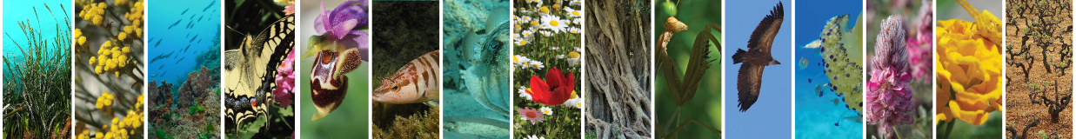

***Deliverable 2.4: Data Services***

|  |  |
| --- | --- |
| Document Title | Deliverable 2.4: Data Services |
|  |  |
| Due date | 31/10/2015 |
| Date of submission |  |
|  |  |
| Lead beneficiary | Hellenic Centre for Marine Research |
| Responsible | FORTH/ICS/ISL |
| Dissemination Level*1 | RE |
| Nature | Deliverable |
| Status of the Document | Final Version |
| Version | 2.0 |
|  |  |
|  |  |

|  |  |
| --- | --- |
| **\*1 Dissemination Level** |  |
| **PU** | Public |
| **PP** | Restricted to other programme participants (including Commission services) |
| **RE** | Restricted to a group specified by the consortium (including Commission services) |
| **CO** | Confidential, only for members of the consortium (including Commission services) |

|  |  |  |  |
| --- | --- | --- | --- |
| **Editor(s):** | **Name** | **Organisation** | **Email** |
|  | Chrysoula Bekiari | FORTH | bekiari@ics.forth.gr |
|  | Martin Doerr | FORTH | martin@ics.forth.gr |
|  | Nikos Minadakis | FORTH | minadakn@ics.forth.gr |
|  | Yiannis Marketakis | FORTH | marketak@ics.forth.gr |
|  | Panagiotis Papadakos | FORTH | papadak@ics.forth.gr |
|  | Athina Kritsotaki | FORTH | athinak@ics.forth.gr |
|  |  |  |  |
| **Contributor(s):** | Christos Arvanitidis | HCMR | arvanitidis@hcmr.gr |
|  | Nicolas Bailly | HCMR | nbailly@hcmr.gr |
|  | Alexandros Gougousis | HCMR | agougousis@hcmr.gr |
|  | Eva Chatzinikolaou | HCMR | evachatz@hcmr.gr |
|  | Sarah Faulwetter | HCMR | sarifa@hcmr.gr |
|  | Niki Keklikoglou | HCMR | keklikoglou@hcmr.gr |
|  | Dimitra Mavraki | HCMR | dmavraki@hcmr.gr |
|  | Matina Nikolopoulou | HCMR | snikolo@hcmr.gr |
|  | Emmanouela Panteri | HCMR | emmipan@hcmr.gr |
|  |  |  |  |
|  |  |  |  |

Table of Contents

Executive Summary 8

Introduction 9

1. Motivation 11

2. Functional Requirements 12

3. Data Analysis & Modelling 14

3.1 Collection & Analysis of Biodiversity Domain Datasets 14

3.2 Collection of Competency Queries 16

3.3 Identification of Main Metadata Categories 17

3.4 Creation of the Metadata Catalogue 18

3.5 Selection of Semantic Models 21

3.6 Schema Mappings 23

3.7 Modelling Examples 24

3.8 Creation of Metadata Templates 35

3.9 Fundamental Categories for Efficient Querying 37

3.10 Fundamental Queries 39

4. Architecture 41

4.1 Directory Service 42

4.2 Metadata Repository 45

4.3 Content Storage 46

4.4 Mapping Mechanism Tool 47

4.5 Policies 47

5. Back-end Products 50

5.1 Data Services API 50

5.2 Web Services 52

6. Quality Refinement Services 87

6.1 Data Quality Instructions 87

6.2 Biovel’s Data Refinement Workflow 91

7. Morphological Characteristics Annotation Service 94

7.1 Example of a Stored Morphological JSON-LD Annotation 94

7.2 Description of Services 95

8. Fundamental Querying Interface 101

8.1 Materialization Details 101

8.2 Configuration and Implementation 102

8.3 Usage 102

9. Data Services Web Application 104

9.1 Data Publishing 104

9.2 Data Updating 107

9.3 Data Searching 108

9.4 Morphological Characteristics Data Annotation 116

9.5 Data Refinement 116

9.6 Administrator Actions 118

9.7 Documentation 119

10. Usage and Evaluation 120

10.1 Population 120

10.2 Integration Testing 120

10.3 Performance Testing 124

10.4 Synergies 124

11. Progress Report 126

Table of Figures

Figure 1: Example of data sources various distribution and format 11

Figure 2: Examples of sub-events included in an expedition dataset. 12

Figure 3: Lifewatch Greece Infrastructure Mockups 12

Figure 4: Data Flow Diagram 14

Figure 5: Examples of collected datasets 15

Figure 6: Part of dataset analysis report 15

Figure 7: Taxonomy Modelling Example 24

Figure 8: Scientific Naming Modeling Example 25

Figure 9: Identification Modelling Example 26

Figure 10: Specimen Measurement Modelling Example 27

Figure 11: Environmental Measurement Modelling Example 28

Figure 12: Occurrence Event Modelling Example 29

Figure 13: Occurrence Statistics Modelling Example 30

Figure 14: Sampling Event – Detailed Representation 31

Figure 15: Sampling Event - Simplified 32

Figure 16: Specimen Modelling Example 32

Figure 17: Micro CT Scanning Modelling Example 33

Figure 18: Sampling and Sequencing Modelling Example 34

Figure 19: Fundamental Relationships 38

Figure 20: Connection Between the 3 Components Contents 41

Figure 21: Lifewatch Greece Infrastructure Architecture 42

Figure 22: Directory Service Schema 43

Figure 23 : Source Records Tranformation and Ingestion using x3ml Engine Diagram 47

Figure 24: Data Publishing Abstract Diagram 48

Figure 25: The Architecture of Lifewatch Data Services 50

Figure 26: Taxonomic Quality Control Diagram 88

Figure 27: Special Quality Control Diagram 89

Figure 28: Station Information Quality Control 89

Figure 29: Date Quality Control Diagram 90

Figure 30: First Window of Interaction – Biovel’s DRW 92

Figure 31: Quality Improvement Service Design 93

Figure 32: Quality Service User Scenario 93

Figure 33: Example of a Morphological Annotation targeting http://dbpedia.org/page/Yellowfin_tuna 97

Figure 34: FQI Main Menu 102

Figure 35: Selection of Fundamental Relationship 103

Figure 36: Things that have met Greece FQI results 103

Figure 37: LW Portal – Data Services Link 104

Figure 38: Web Application Menu 104

Figure 39: Dataset Description Form. 105

Figure 40: Data Description Template Upload Form 105

Figure 41: Metadata Templates 106

Figure 42: Dataset Metadata Uploading Form 106

Figure 43: Add Dataset Metadata Form 107

Figure 44: Update Dataset Description Form 107

Figure 45: Directory Search Form 108

Figure 46: Directory Search Results 109

Figure 47: Directory Search Result Complete Information 109

Figure 48: Occurrences Search Form 110

Figure 49: Occurrence Search Results 110

Figure 50: Occurrence Result Complete Information 110

Figure 51: Identification Search Form 111

Figure 52: Micro CT Scanning Results 112

Figure 53: Taxonomic Information Results 113

Figure 54: Browsing the Semantic Graph Result 114

Figure 55: Browse the Semantic Graph Form 114

Figure 56: Fundamental Querying Interface in the Portal 115

Figure 57: Textual Description Example 115

Figure 58: SPARQL endpoint 116

Figure 59: Biovel’s DRW – refinement selection 118

Figure 60: System Configuration Form 119

Figure 61: Recovery Actions 119

Figure 62: Biodiversity Datasets Linking 121

Figure 63: Selection of Occurrences of Species in the Mediterranean Sea 122

Figure 64: Occurrences in the Mediterranean Sea Search Results 122

Figure 65: Occurrence’s Complete Information List 123

Figure 66: Polycirrus_aurantiacus_1981_15 browsing page 123

Figure 67: Transformation of Polycirrus_aurantiacus_1981_15 event 123

Figure 68: Scanning of Polycirrus_aurantiacus_1981_15’s specimen 124

# Executive Summary

This document is the report of the first version of the ***Deliverable 2.4: Data Services*** that is a part of the project “Construction and Operation of the National LifeWatch Research Infrastructure”. Its purpose is to describe the whole process from the collection of the requirements to the development of the Web Services that are used to implement the Data Services of the LifeWatch Greece Infrastructure.

The first part of the report describes the collection of the functional requirements, the collection of the datasets and the competency queries from the community and the data analysis that took place. The result of the data analysis was the identification of the main metadata categories that the expected metadata can be classified to and the creation of a metadata catalogue that contains in details the metadata that is expected for each category.

The next step was the selection and extension of the semantic models that will be used as the centralized schemata of the infrastructure. This task was followed by the creation of a number of metadata templates and the mappings between some of the expected metadata schemata and the semantic models. The last outcome of the data analysis was the identification of the fundamental categories that cover the specific domain.

The second part of the report describes the main components of the Architecture of the infrastructure as it was designed to fulfill the functional requirements and the developed services. Specifically a Java API was developed to implement the functionalities of the components and a number of Web Services that use the API, and that are described into details, was created and deployed. Furthermore, the Quality Refinement Service, the Morphological Characteristics Service and the Fundamental Queries Interface are described.

The last part of the report describes the Data Services Web Application that has been integrated in the LW Greece’s Portal and the usage and evaluation of the API and the Web Services that were developed.

# Introduction

One of the main characteristics of biodiversity data is its cross-disciplinary character and the extremely broad range of data types, structures, and semantic concepts which encompasses. Even if we focus on the data of a specific area (i.e. Greece), they remain widely distributed and unconnected. For this purpose in the framework of LifeWatch Greece we designed and implemented a set of data services that aim to: i) support cataloguing and publishing all the relevant meta-data information of the Greek biodiversity domain, ii) integrate data from heterogeneous sources by supporting the definitions of appropriate models, iii) efficiently discover biodiversity data of interest and enable the answering of complex queries that could not be answered from the individual sources.

The aforementioned services allow the providers to express their metadata in a schema agnostic way; the provider is able to submit metadata according to their local format (e.g. Darwin Core) and these are automatically transformed with respect to the underlying centralized schemata of the infrastructure for gaining the advantages that semantic models offer. Particular focus was given on the architecture and the contents of the infrastructure for being able to serve clients, even if some of its parts are temporarily inaccessible.

This document is a report for the ***Deliverable 2.2 : Data Services*** providing details for the design, development and evaluation of the Data Services.

Section 1 of this document describes the motivation and the main idea behind the LifeWatch Greece Data Services.

Section 2 is about the collection of the functional requirements of the Data Services and the design of the data-flow workflow.

Section 3 describes in details the process of the data analysis and modelling. Specifically Section 3.1 is about the collection of the datasets from the community, Section 3.2 is about the collection of the competency queries, Section 3.3 presents the identified metadata categories that came out after the analysis of the datasets and Section 3.4 is about the metadata catalogue. Section 3.5 describes the semantic models that were selected and Section 3.6 is about the mapping process, containing some mapping examples. Section 3.7 refers to the metadata templates that were created and Sections 3.8 and 3.9 are about the fundamental categories/queries of the biodiversity domain.

The Architecture of the main components of the infrastructure is described in Section 4. Section 4.1 describes in details the Directory Service, Section 4.2 is about the Metadata Repository, Section 4.3 is about the Content Storage and a brief description of the Mapping Tool is in Section 4.4. Section 4.5 describes the policies that have been defined in the context of Lifewatch Greece data services.

Section 5 is about the back-end products that consist of the developed Data Services API and Web Services. In Section 5.1 the Data Services API is described, and Section 5.2 is dedicated on the detailed description of the SOAP Web Services.

The data quality services are described in Section 6. Section 7 is about the Morphological Characteristics Annotation service and Section 8 descibes the Fundamental Queries Interface.

The Data Services Web Application is described in details in Section 9 and Section 10 focuses on the evaluation and usage of the Data Services.

# Motivation

Biodiversity data is characterized by its cross-disciplinary character, the extremely broad range of data types and structures, and the variety of semantic concepts that it encompasses. Moreover biodiversity data remains widely distributed and unconnected among different sources.

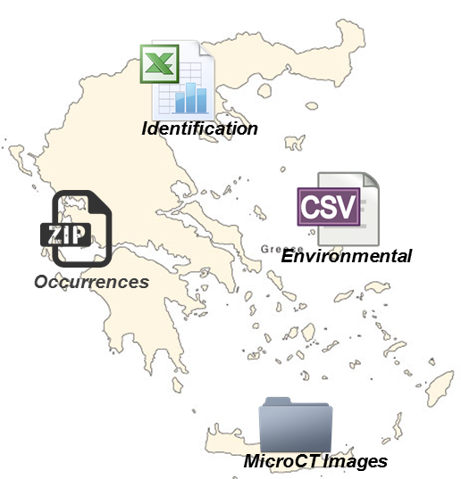

Figure 1: Example of data sources various distribution and format

Our goal in the context of LW Greece is to support cataloguing and publishing of all the relevant meta-data information  of the Greek biodiversity domain, to integrate data from heterogeneous sources by supporting the definitions of appropriate models, to efficiently discover biodiversity data of interest and enable the answering of complex queries that could not be answered from the individual sources.

Towards this direction we applied our idea to exploit the events’ information that is explicitly or implicitly contained in the datasets, model the different concepts and entities of the biodiversity domain and take advantage of the semantic graph’s capabilities to navigate efficiently through the different contents and discover data of interest. This approach provides the capability of making high level, abstract, queries without having full knowledge about the domain, the schema or even the presence of the data, and discovering data resources that contain (or are about) the results of such queries.

For example an expedition dataset contains information about a number of sub-events such as occurrence or identification events. So, except the metadata of the dataset that can be stored in a registry, information about the sub-events can be extracted, modeled and used to assist the discovery of data resources.

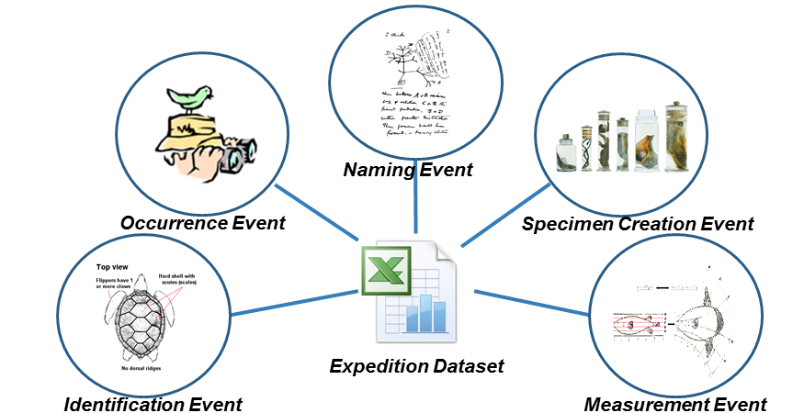

Figure 2: Examples of sub-events included in an expedition dataset.

# Functional Requirements

The first step of the Lifewatch Data Services design and development process was to define the functional requirements of the infrastructure. For this purpose a draft document, that contained a description of the desired functionalities and some initial mockups, was created and circulated to the consortium.

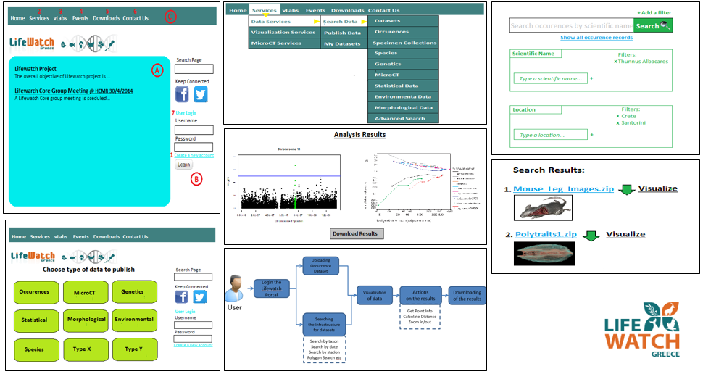

Figure 3: Lifewatch Greece Infrastructure Mockups

After the collection and the analysis of the requirements it was clear that there was the need of creating a number of e-Services that will assist the Data Providers to submit their metadata and data to the Lifewatch Greece Infrastructure. Particularly, these e-Services provide the following main functionalities:

* **Transformation** of the metadata from the provider’s schema to the centralized semantic schema of the infrastructure.
* **Ingestion** of the metadata and data to Lifewatch Greece Infrastructure.
* **Publishing** the datasets by providing information on how to access the datasets and how to communicate with the datasets’ creator/curator.
* **Querying** in order to gain information on how to access the datasets and how to communicate with the curator/creator.
* Optional **quality improvement** of the datasets that the Data providers will publish to the infrastructure.

The next step was to design the data-flow workflow. This design is described in details in the ***Deliverable 2.3: Data Flow[1].*** A brief description of the workflow follows:

1. Data and Service Providers declare themselves as providers.
2. Providers declare the kind of data they wish to provide.
3. They define and provide the metadata.
4. They provide their data.
5. All metadata are mapped to a unified and normalized XML schema.
6. All metadata are transformed and stored in the metadata repository.
7. Raw data are stored in the content storage.
8. End user queries the data/metadata by using predefined queries or by writing and executing their own custom queries.

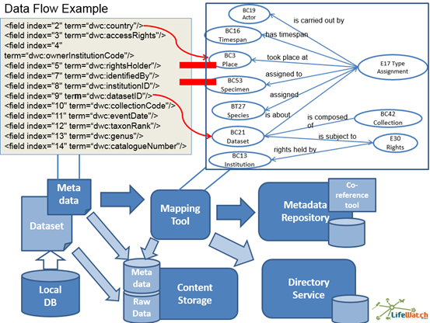

Figure 4: Data Flow Diagram

# Data Analysis & Modelling

During the first LifeWatchGreece Data Management workshop - which gathered Data Managers representing Research Institutes and Universities from all over Greece - an extended and detailed discussion took place regarding “data collection” and their entry into the LWG repository. One of the tasks discussed and approved was that each Data Manager shall prepare by the end of September 2014, a list of datasets which are going to be stored at LWG RI. To this extent a Data Policy and Sharing Agreement legal document is prepared, highlighting the copyright issues, as well as the duties and rights, both of data providers and LifeWatchGreece RI.

As an outcome of this procedure, a significant number of metadata, datasets and competency queries was collected by the Greek biodiversity community and analyzed in order to conclude on which metadata is mandatory to keep in the national catalogue and to define the main metadata categories.

## Collection & Analysis of Biodiversity Domain Datasets

To realize the requirements of the biodiversity domain it was essential to collect and analyze a significant number of datasets coming from the community. More than 50 datasets coming from different sections of the broader biodiversity domain were collected. These datasets contain information about taxonomies, occurrences, identifications, genetics, specimen collections, environmental data, statistical and morphological data etc. The main provider institutions were HCMR[2] and NHMC[3] while the formats of the datasets were mainly xls, dwc-A and csv.

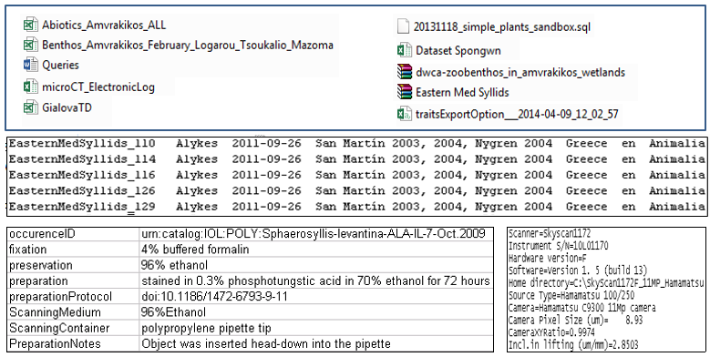

Figure 5: Examples of collected datasets

The collected datasets were analyzed, categorized and the mandatory metadata were identified and extracted. Also, the analysis combined with a significant number of meetings between the partners, assisted on the identification of the main events of interest and the information that should be kept for each event.

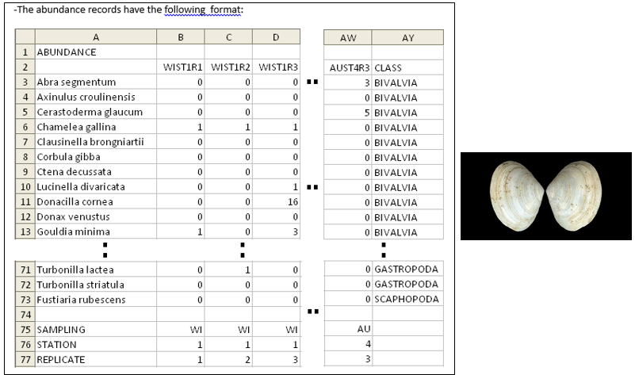

Figure 6: Part of dataset analysis report

## Collection of Competency Queries

The step that followed the collection and analysis of the datasets was the collection of the competency queries. These queries that come from the domain experts express the final goals of the system and define the main functional requirements. They are essential for the design and the evaluation of the ontology and the definition of the main scientific questions that should be answered. More than 70 competency queries were collected from the domain experts.

Specifically for occurrences and identifications, some indicative competency queries are:

1. *Which species have been originally described from Greece?*
2. *Which species have been originally described from the Mediterranean / Greece / Aegean Sea and afterwards have never been recorded again?*
3. *What is the recorded depth range for each polychaete species found so far in Greek waters?*
4. *Find all taxonomic names and their associated authorities that have ever been placed in genus X (even if now they are in another genus), preferably including the bibliographic reference of the original description, and deliver also their geographic distribution, including information on the locality, habitat and depth / elevation of the type specimen for each of those species*

For MicroCT some indicative competency queries are the following:

1. *Find all scans depicting marine species*
2. *Find all scans depicting polychaetes*
3. *Find all scans depicting specimens of 5mm length*
4. *Find all scans depicting specimens stained with Iodine*

For genetics, some indicative competency queries are:

1. *How many/Which samples have been sequenced with e.g. Illumina HiSeq?*
2. *How many/Which samples have been analyzed with e.g. Qiime?*

Some indicative competency queries for environmental parameters are:

1. *How many stations have pH x ?*
2. *Which lagoon has salinity x psu ?*
3. *Find the species that were found in salinity x Psu*

Each query was analyzed and expressed in SPARQL. The selected semantic schemata were extended to cover any new concept of interest.

## Identification of Main Metadata Categories

The analysis of the Greek biodiversity community’s datasets and metadata led to the ***identification of fourteen (14) main metadata categories*** than can cover the full set of metadata that should be kept in the metadata catalogue:

1. ***Occurrences***

This category includes information that are about occurrence events, which are the events of finding an individual of a species at a particular place (water area, country etc) at a particular time, such as the date of the event, the person and the individual that was observed.

1. ***Identifications***

This category includes information that are about identification events, which are the events of the taxonomic determination of organisms, such as the date of the event, the person and the individual that was observed.

1. ***Taxonomy***

This category includes information about taxonomic classification of an organism.

1. ***Naming***

This category includes information about scientific assignment events, such as the date and the authorship that assigned the name, information about the common name of a species, such as the country that it is used, the language etc, and information about synonyms.

1. ***MicroCT Scannings***

This category includes information about the micro-ct scanning events of a specimen, such as the device that was used or the date of scanning, information about the reconstruction event that followed the scanning, information about the postprocessing event that follows the reconstruction and information about the specimen that was scanned.

1. ***Environmental***

This category includes information about the environmental parameters measurement event, such as the dimension that was measured, the person that carried out the measurement etc.

1. ***Specimens***

This category includes information about the transformation event of an individual to a specimen, such as the method that was used, the person that carried out the activity etc.

1. ***Specimen Collections***

This category includes information about collections of specimens, such as information about the creation event of the collection, information about the curator of the collection, the keeper etc.

1. ***Data Collections***

This category includes information about data collections (eg datasets), such as information about the creation event of the collection, the publication event of the collection, the curator of the collection, the owner, the keeper, the publisher, the contributors etc.

1. ***Genetics***

This category contains information about the DNA sampling events and the DNA sequencing events, such as the device that was used, the place of the sampling etc.

1. ***Morphometrics***

This category contains information about measurement events of specimens or individuals, such as the dimension that was measured, the person that carried out the measurement etc.

1. ***Morphological Characteristics***

This category contains information about the attribute assignment events of morphological characteristics to species.

1. ***Statistical***

This category contains information about the statistical analysis event of data.

1. ***Occurrence Statistics***

This category contains information about the statistics of an occurrence.

## Creation of the Metadata Catalogue

For each metadata category a set of the mandatory metadata that should be kept was created. In order to document every mandatory metadata a Metadata Catalogue was created. The catalogue is continuously evolving and expanded according to the new types of metadata and datasets that are collected by the community. For the moment (April 2015) it contains more than200 metadata fields descriptions, 300 examples, and more than 100 mappings to the semantic models.

Metadata Catalogue is described in details in ***Deliverable 2.2: Metadata Catalogue[4]***. For example the description of the Occurrence Event Metadata follows:

**Occurrence Event Metadata**

Occurrence event is the event that someone found an individual of a species at a specific place (water area, country etc). Below, we present the table with the related metadata, their definition, some examples related to metadata of the occurrence event and the mapping to Cidoc – CRM family models (Table 1).

| **Metadata** | **Definition** | **Example(s)** | **CRM family models** |
| --- | --- | --- | --- |
| occurrenceEvent ID | The ID of the occurrence event that took place. | “urn:catalog:IOL:POLY:Sphaerosyllis-levantina-ALA-IL-7-Oct.2009 “ | S19 Encounter Event.  P48 has preferred identifier: E42 Identifier |
| dataset ID | The ID of the dataset that contains records that refer to this occurrence event. | "d50024ac-5268-477e-8559-933779553b34"  "EasternMedSyllids" | S19 Encounter Event. P67B is referred to by:  BC21 Data Set |
| individualID | The ID of the species’ individual that was found during the occurrence event. | “urn:lsid:zoobank.org:act:9CEE8F90-9596-49F6-AA22-BB79C0E816D9” | S19 Encounter Event.  O19 has found object:  E18 Physical Thing |
| actor | The person that carried out the occurrence event. | "Sarah Faulwetter" | S19 Encounter Event.  P14 carried out by:  E39 Actor (BT9 Actor Type, BC8 Actor) |
| time-span | The date of the occurrence event. | "22/10/2012" | S19 Encounter Event.  P4 has time-span :  E52 Time-span |
| country | The country that the event took place in. Recommended best practice is to use a controlled vocabulary such as the Getty Thesaurus of Geographic Names. | "Greece " "Israel" | S19 Encounter Event.  P7 took place at:  E53 Place |
| water area | The water area that the occurrence event took place in. Recommended best practice is to use a controlled vocabulary such as the Getty Thesaurus of Geographic Names | "IonianSea" "MediterraneanSea | S19 Encounter Event. P7 took place at:  E53 Place.  P89 falls within: BC15 Water Area |
| habitat | The type of the ecosystem environment that the occurrence event took place. | "coastallagoon" "rockysubstrate” | BT7 Ecosystem Type |
| locality | The verbatim location of the event that took place. | "AmvrakikosKolpos - Rodia lagoon" "AmvrakikosKolpos - Logarou lagoon"  "Alykes" "Elounda" | S19 Encounter Event.  O21 has found at:  E53 Place |
| locationRemarks | Remarks of the location of the event that occurred | "Notes" | S19 Encounter Event.  P7 took place at:  E53 Place.  P3 has note:  E62 String |
| locationID | An identifier for the set of location information. May be a global unique identifier or an identifier specific to the data set | http://www.marineregions.org/gazetteer.php?p=details&id=3666 | S19 Encounter Event. O21 has found at:  E53 Place.  P1 is identified by:  E42 Identifier |
| equipmentType | The type of the equipment that was used during the occurrence | "WA265/SS21" "Van Veen Grab" | S19 Encounter Event.  P125 used object of type:  BT11 Equipment Type |
| latitude | The geographic latitude of the place that the occurrence event took place | "390.767.777.778" "390.539.722.222"7 | S19 Encounter Event.  P7 took place at:  E53 Place.  P87 is identified by:  E47 Spatial Coordinates |
| longitude | The geographic longitude of the place that the occurrence event took place | "2.081.125" "20.913" | S19 Encounter Event. P7 took place at:  E53 Place.  P87 is identified by: E47 Spatial Coordinates |
| maximumDepth | The maximum depth that the occurrence event took place | "3" "0,5" | S19 Encounter Event.  P7 took place at: E53 Place.  P3 has note:  E62 String |
| minimumDepth | The minimum depth that the occurrence event took place | "20" "45" | S19 Encounter Event.  P7 took place at:  E53 Place.  P3 has note:  E62 String |
| samplingProtocol | The method or protocol that used during this event | "box corer. 0.03 square meters"  "doi: 10.4067/S0717-65382003000200004Β" | S19 Encounter Event . P33 used specific technique:  E29 Design or Procedure |
| geodeticDatum | The spatial reference system that related to event | "EPSG:4326"12 | S19 Encounter Event.  P7 took place at:  E53 Place.  P87 is identified by:  E47 Spatial Coordinates:  P2 has type.  E55 Type:  BC29Spatial Coordinate Reference System |
| Coordinates  UncertaintyInMeters | The uncertainty of the position of the event , the uncertainty of longitude and latitude | "7071" | S19 Encounter Event.  P7 took place at.  E53 Place:  P87 is identified by.  E47 Spatial Coordinates:  P3 has note.  E62 String |
| minimumelevation | The minimum elevation that the occurrence took place | "1600" | S19 Encounter Event.  P7 took place at: E53 Place.  P3 has note:  E62 String |
| maximumelevation | The maximum elevation that the occurrence took place | "2000" | S19 Encounter Event.  P7 took place at: E53 Place.  P3 has note:  E62 String |
| verbatimCoordinates | The verbatim original spatial coordinates of the Location that the event took place | "Channel: 39Β°04'36.4'' N; 20Β°48'40.5" "IN: 39Β°03'14.3'' N;20Β°54'46.8" "OUT: 39Β°02'09.7'' N; 20Β°53'22.9" | S19 Encounter Event.  P7 took place at:  E53 Place.  P87 is identified by:  E47 Spatial Coordinates |
| bibliographicCitation | A bibliographic reference to occurrence event. | "Odontosyllisfulgurans (IMBG-NaGISA-CALB-20B_07)" | S19 Encounter Event.. P67B is referred to by:  BC27 Publication |

Table 1: Metadata about Occurrence Event

## Selection of Semantic Models

For the purposes of integrating data from the different sources it was necessary to use a semantic model. This model is based on CIDOC CRM[5] and its extensions CRM dig, CRM sci, CRM geo and MarineTLO[6]. Furthemore the semantic model is continuously being extended according to the requirements that are coming out from the analysis of the community’s provided data and metadata, the competency queries and the Metadata Catalogue. A description of the selected semantic models follows:

#### CIDOC - CRM

The CIDOC Conceptual Reference Model (CRM) (<http://www.cidoc-crm.org/>) provides definitions and a formal structure for describing the implicit and explicit concepts and relationships used in cultural heritage documentation.

The CIDOC CRM is intended to promote a shared understanding of cultural heritage information by providing a common and extensible semantic framework that any cultural heritage information can be mapped to. It is intended to be a common language for domain experts and implementers to formulate requirements for information systems and to serve as a guide for good practice of conceptual modelling. In this way, it can provide the "semantic glue" needed to mediate between different sources of cultural heritage information, such as that published by museums, libraries and archives.

#### MarineTLO

Marine TLO (<http://www.ics.forth.gr/isl/MarineTLO/>) is a top-level ontology for the marine domain. It was created to tackle the need for having integrated sets of facts about marine species, and thus to assist research about species and biodiversity. It provides a unified and coherent core model for schema mapping which enables formulating and answering queries which cannot be answered by any individual source.

Marine TLO is inspired by ISO 21121, OBOE, INSPIRE, DwC[7] and others. It follows the event pattern where things, people and ideas meeting in space and time. Marine TLO defines the underlying semantics of database schemata used in marine domain in terms of a formal ontology. It does not define any of the terminology typically appearing as data in the respective data structures. Furthermore MatineTLO enables semantic interoperability, facilitates the knowledge sharing, information exchange integration, between heterogeneous sources found distributed across various infrastructures by providing a common understanding of the concepts and entities and relationships holding between them.

#### CRM Digital

CRM*dig* is an ontology specifically designed to encode metadata about the steps and methods of production ("provenance") of digitisation products and synthetic digital representations such as 2D, 3D or even animated models created by various technologies (Theodoridou et al. 2010). CRM Digital is fully compliant with other, widely used, provenance models such as *PROV-O* but it is more detailed since it completely includes the initial physical measurement processes and their parameters.

#### CRM Scientific

The “Scientific Observation Model” is a formal ontology intended to be used as a global schema for integrating metadata about scientific observation, measurements and processed data in descriptive and empirical sciences such as biodiversity, geology, geography, archaeology, cultural heritage conservation and others in research IT environments and research data libraries. Its primary purpose is facilitating the management, integration, mediation, interchange and access to research data by description of semantic relationships, in particular causal ones. It is not primarily a model to process the data themselves in order to produce new research results, even though its representations offer themselves to be used for some kind of processing.

#### Semantic Model & DwC

A significant big number of biodiversity community members are using Darwin Core (<http://rs.tdwg.org/dwc/>) to describe their data. The Darwin Core is body of standards which includes a glossary of terms (in other contexts these might be called properties, elements, fields, columns, attributes, or concepts) intended to facilitate the sharing of information about biological diversity by providing reference definitions, examples, and commentaries. The Darwin Core is primarily based on taxa, their occurrence in nature as documented by observations, specimens, samples, and related information.

The decision to use a semantic model as the centralized schema of the infrastructure was taken due to the following reasons:

1. DwC can be translated without loss into Semantic Model.
2. Semantic Model can be reduced to DwC.
3. Semantic Model supports easy addition of features for increased precision (data tolerances, modalities etc.).
4. DwC often leaves the interpretation of the relationships between the whole record and one of its fields to the intuition of the human reader (it cannot be used to draw logical conclusion without human intervention) - No reasoning can be applied.
5. Complex events causally related cannot be described in DwC.
6. Fields like prey of and predator of are missing. Extensions by adding fields without property subsumption cause a proliferation of queries to collect related information.
7. A well-defined ontology - a formal definition of relationships between concepts in this domain and between its disciplines can solve this problem without increasing complexity.
8. Shorter queries to are needed to retrieve the same kind of information than with DwC

## Schema Mappings

The step that followed the selection of the semantic models was the mappings between the source’s schemata and the centralized schema of the infrastructure. Two different approaches were followed, the first was the implementation of hardwired mappings and the second one was the usage of the **x3ml language[8]**. The process is described in details in the ***Deliverable 2.3 : Data Flow.*** For the mappings that have not been defined during the projects the users can use the x3ml framework that has been created and is being maintained by FORTH. An example of a high level mapping between DwC and the central semantic model of the infrastructure follows:

|  |  |
| --- | --- |
| **DwC** | **Lifewatch Semantic Model** |
| occurrence ID | S19 Encounter Event.  S19 Encounter Event.  P48 has preferred identifier: E42 Identifier |
| recordedBy | S19 Encounter Event.  P14 carried out by:  E39 Actor (BT9 Actor Type, BC8 Actor)S19 Encounter Event.  P14 carried out by:  E39 Actor (BT9 Actor Type, BC8 Actor) |

Table 2: Mapping DwC to semantic models example

The users can use the 3M editor graphical user interface in order to map their own schema with the LW Greece centralized shema, and this process will produce an x3ml file. This x3ml file with the input records can be provided as input to the x3ml engine and the outcome of this process will be the Lifewatch Greece Infrastructure format records which can be imported in the Infrastructure’s databases.

## Modelling Examples

The datasets that were provided by the partners were analyzed. The different concepts were recognized and were used to extent the semantic model to be able to support such concepts. Afterwards, modelling examples of some meaningful biodiversity concepts were created in order to test the expressivity of the semantic models and to .

#### Taxonomy

Taxonomy is one of the most important biodiversity concepts. In the example that was created the classification of the species was represented. An example of a species taxonomy is shown below:

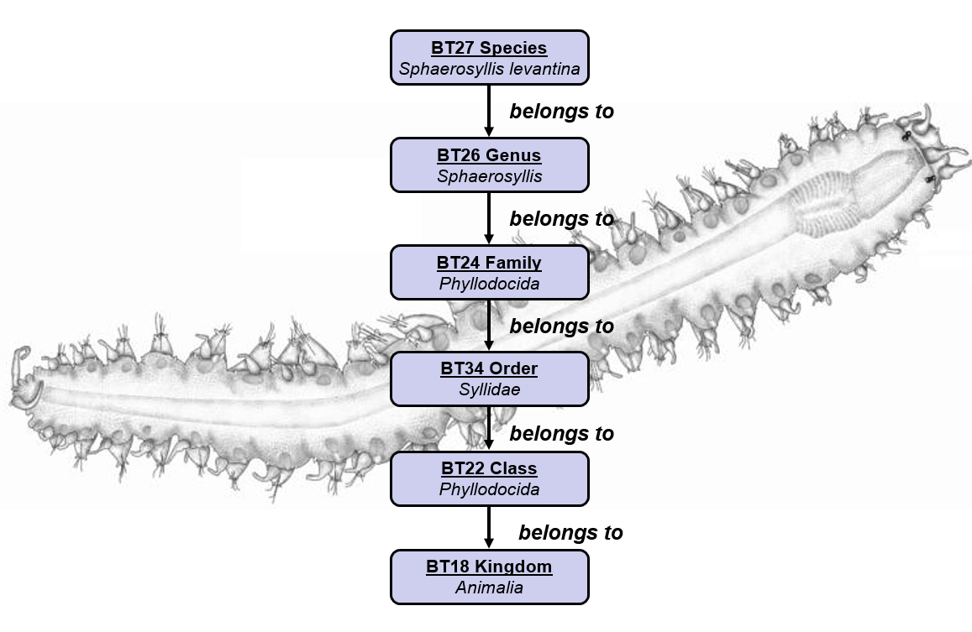

Figure 7: Taxonomy Modelling Example

#### Scientific Name Creation

The scientific name creation process refers to the case that a new species is found and a (new) scientific name is assigned to this species. This process can be represented by two events, a type creation one that is the activity of creating a new type (eg ”Thunnus Albacares”) and an identifier assignment that followed, which is the activity of assigning this type to the specific species. A modelling example of a scientific name creation is shown below:

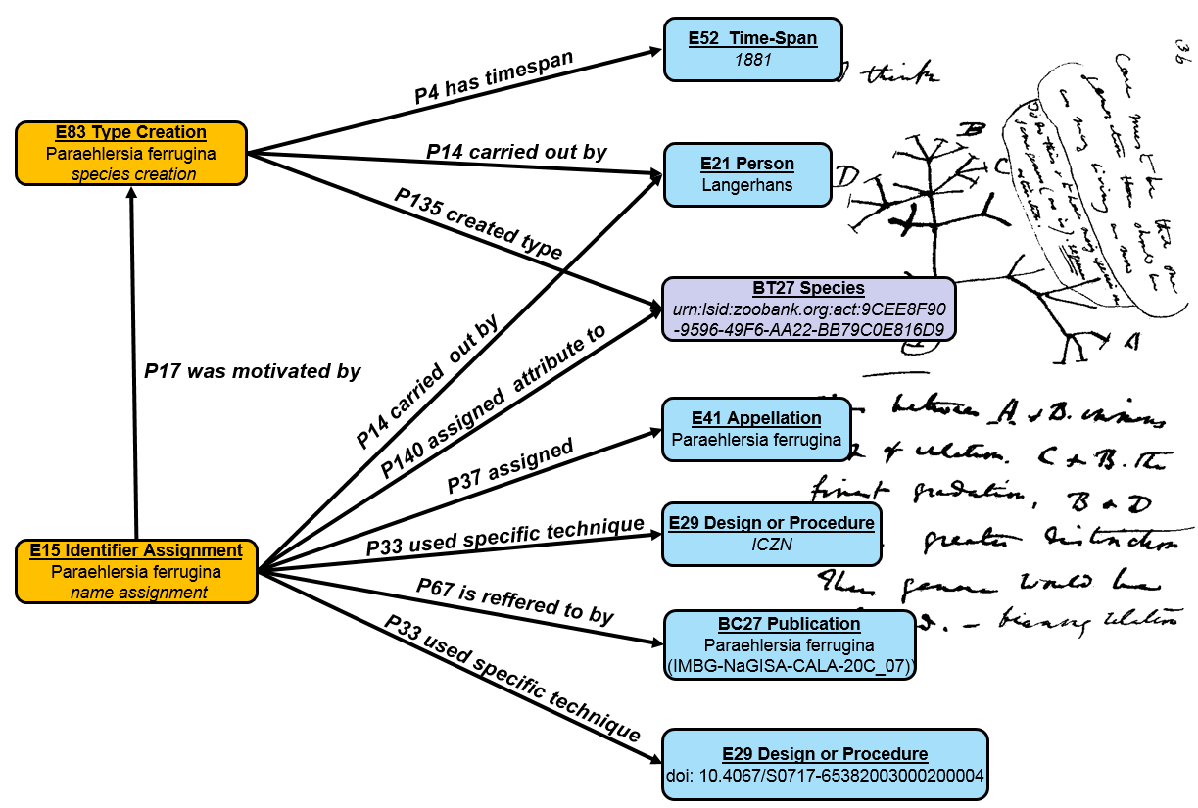

Figure 8: Scientific Naming Modeling Example

#### Species Identification

Identification is the process of a specimen’s classification according to a taxonomy. This process is a type assignment activity, that assigns a type (eg species) to a specific indicudal (organism). A modelling example of a species identification is shown below:

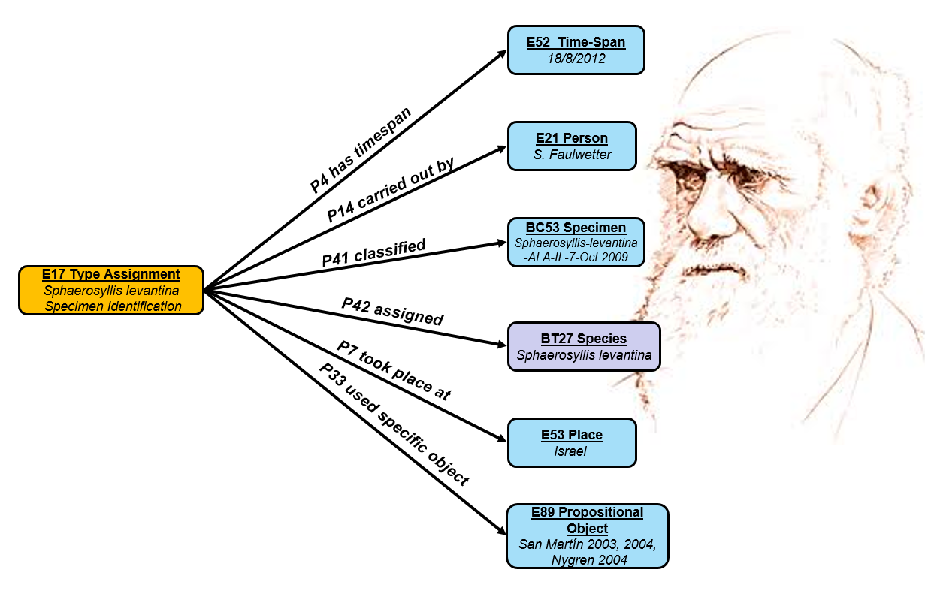

Figure 9: Identification Modelling Example

#### Specimen Measurement

Specimen measurement is the process of measuring a specimen’s dimensions (eg length, weight etc). This is represented as a measurement event that observed a specific dimension of a specimen and assigned the corresponding value and unit. A modelling example of a measurement is shown below:

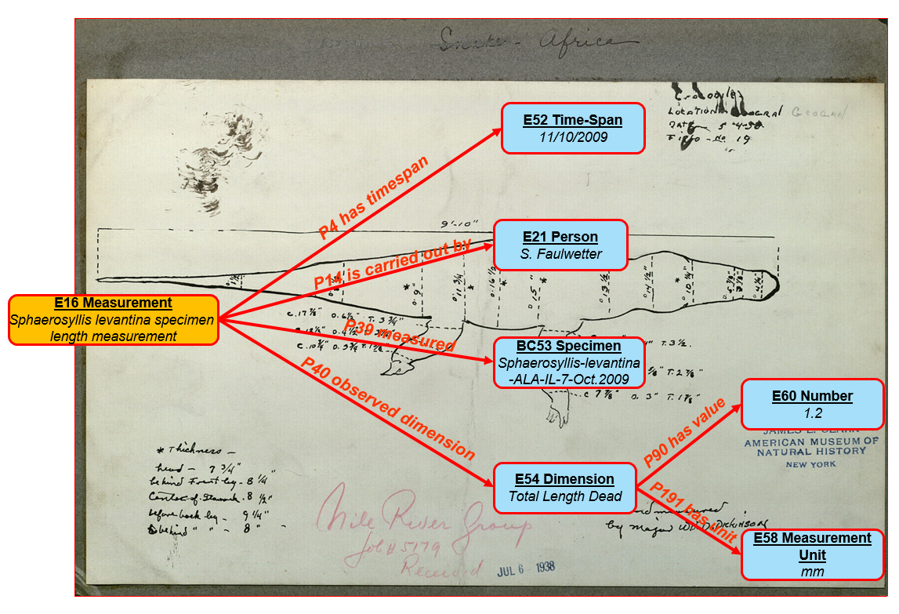

Figure 10: Specimen Measurement Modelling Example

#### Environmental Measurement

Environmental measurement is the process of measuring a specific environmental parameter (eg salinity, temperature).This is represented as a measurement event that observed a specific dimension of a place and assigned the corresponding value and unit. A modelling example of an environmental measurement is shown below:

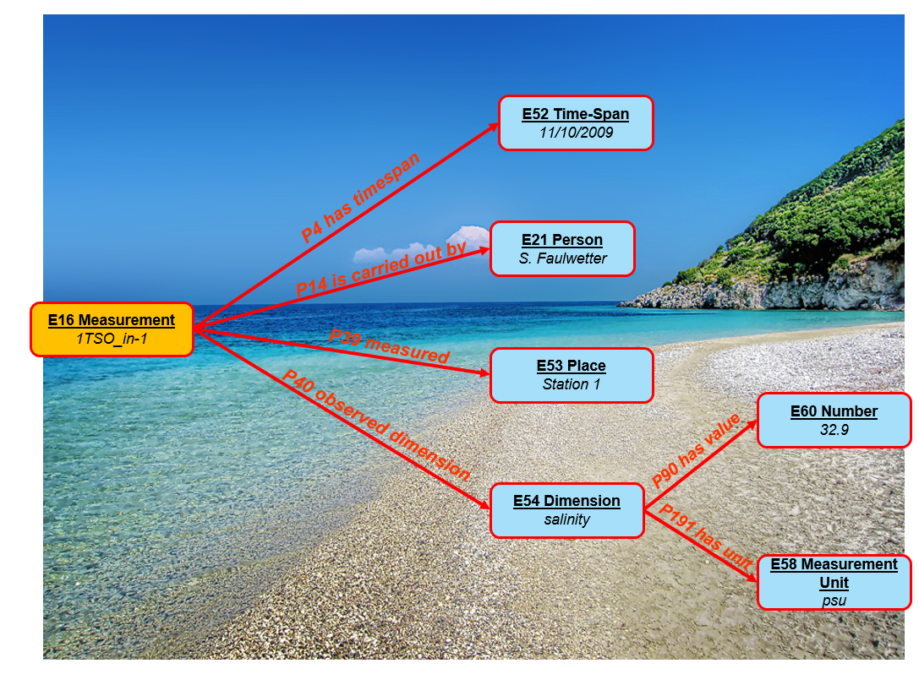

Figure 11: Environmental Measurement Modelling Example

#### Occurrence

Occurrence is the observation of a species’ individual. It is modeled as an encounter event of a biotic element (organism) with the observer. A modelling example of an occurrence is shown below:

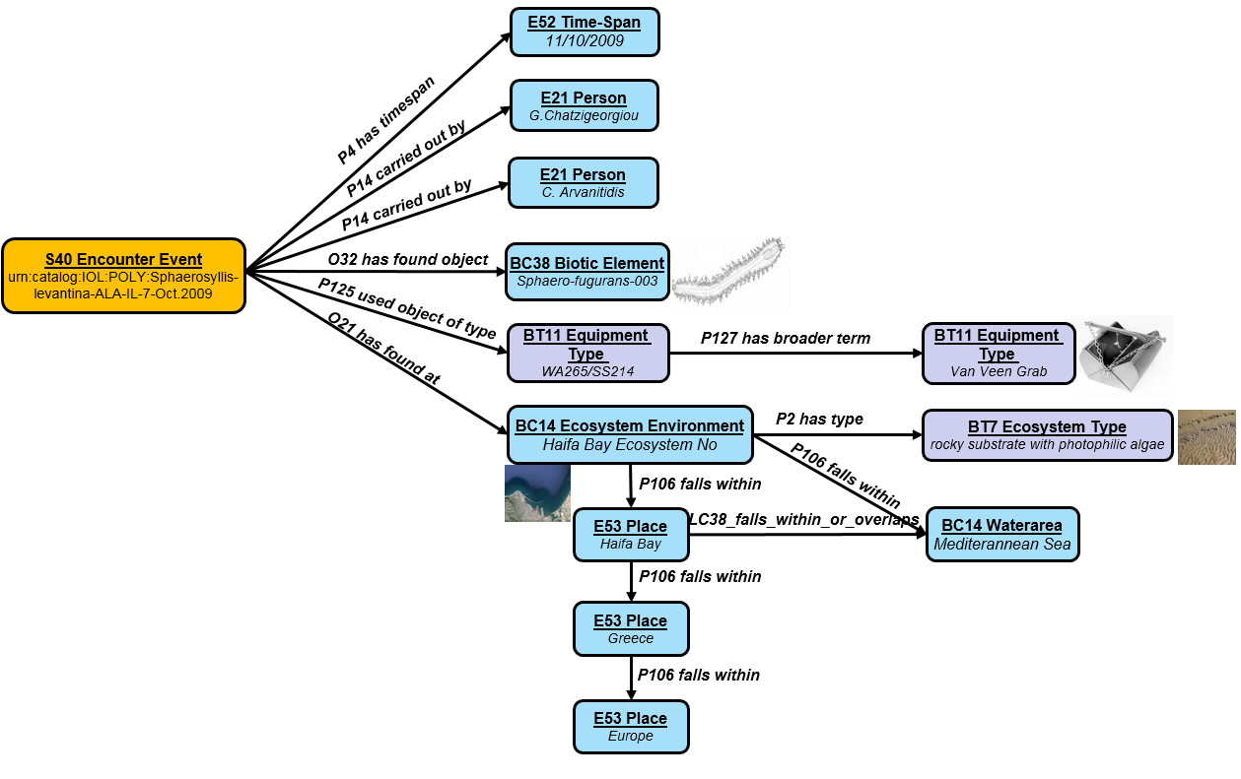

Figure 12: Occurrence Event Modelling Example

#### Occurrence Statistics

Occurrence is the observation of a species’ individual. In many cases the during this event a sample is extracted (eg water sample) that contains a number of individuals that belong to various species. In such cases collections of individuals of the same species are created. We call these collections temporary aggregates, because after the observation they are dismantled. We model this this kind of observations as follows:

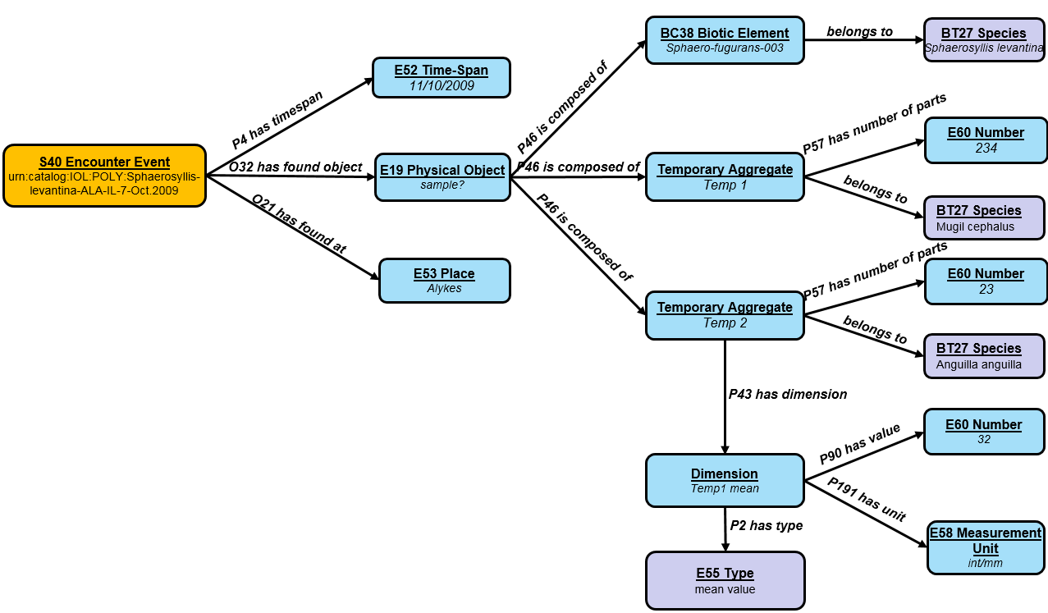

Figure 13: Occurrence Statistics Modelling Example

#### Sampling Activity

This example was created to model the encounter events that take place in the ocean. During this process a number of sub-events takes place in order to calculate the position of the encounter event. The first of this events is the measurement of the coordinates that is followed by a min-depth and a max-depth measurement. In the end a bottom measurement takes places. By combining these measurement the place of the encounter event can be calculated.

A detailed and a simplified representation example follow:

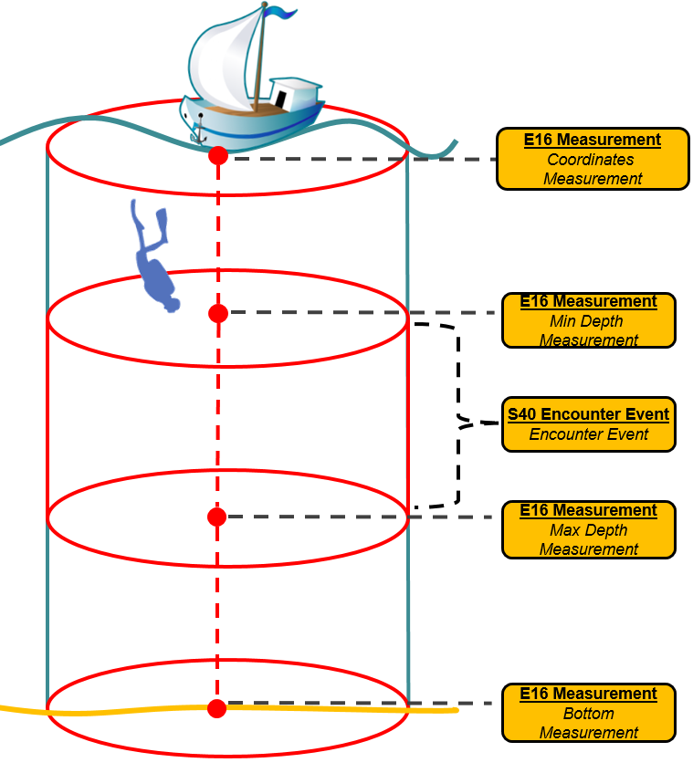

Figure 14: Sampling Event – Detailed Representation

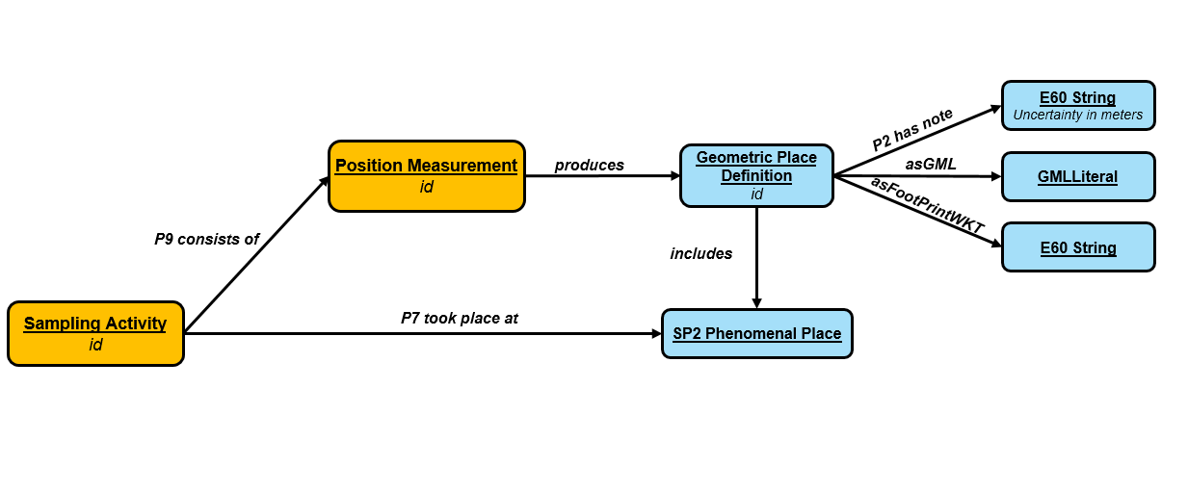

Figure 15: Sampling Event - Simplified

#### Specimen Info

The modelling example that follows is showing general information about specimens  
such as, the individual it came out from, the collection is belongs, the rights owner of this collection etc:

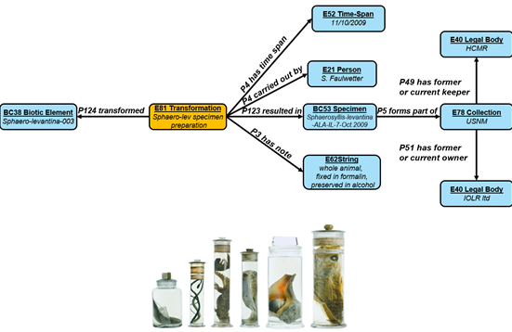

Figure 16: Specimen Modelling Example

#### Micro-CT Scanning

The micro-CT scanning is the process of providing a specimen (or a part of it) as input to a Micro Computed Tomograph and the acquisition of the images that can be used to produce a 3D visualization of the specimen. It is a combination of events that follow each other. Firstly the preparation event of the specimen takes place, and is followed by the scanning event. The scanning event is followed by a reconstruction event of images and finally a post processing event takes place to produce the final images:

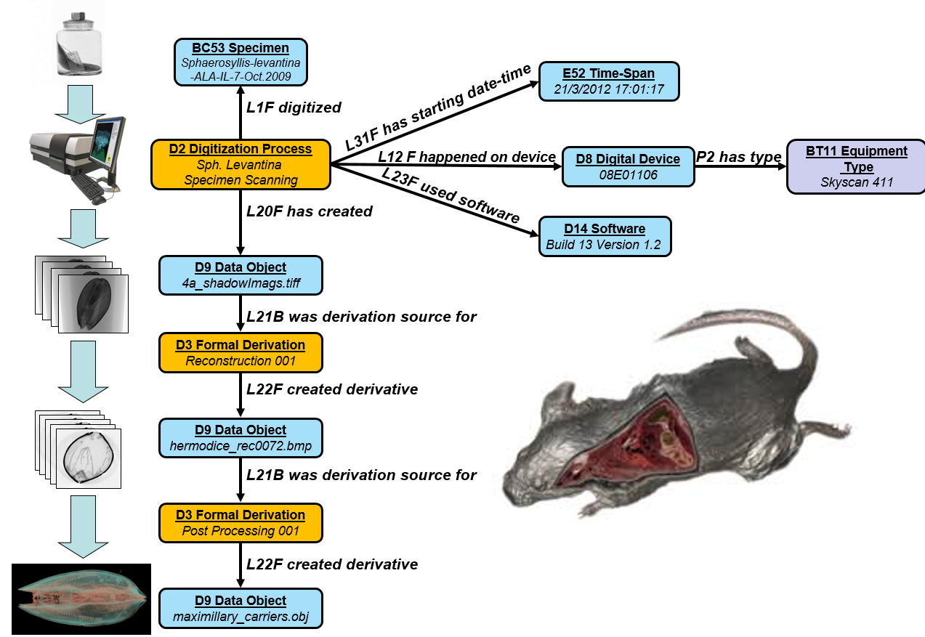

Figure 17: Micro CT Scanning Modelling Example

#### Sampling and Sequencing

Sampling and sequencing refers to the processes of collecting samples from a place or a specimen, extracting genetic information of it, and analyzing this data to come to some results:

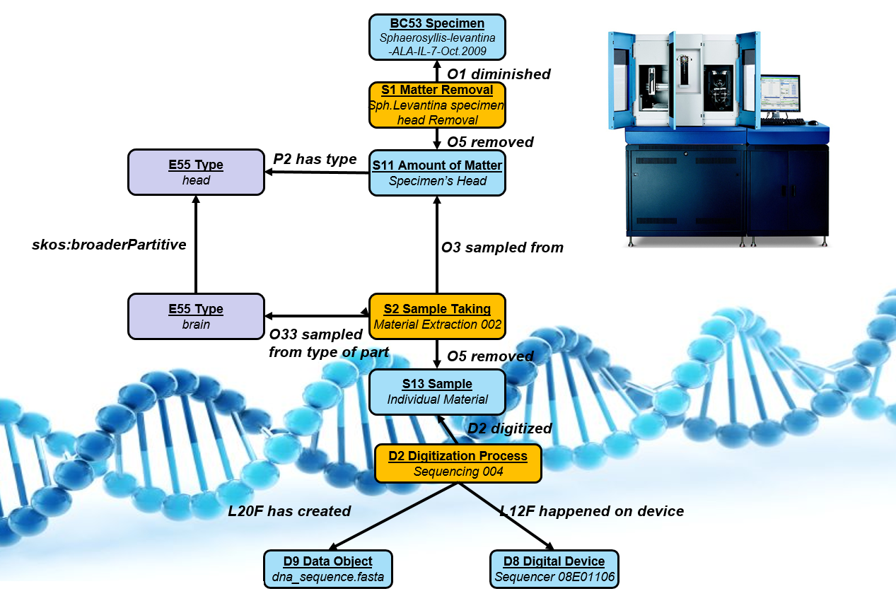

Figure 18: Sampling and Sequencing Modelling Example

## Creation of Metadata Templates

A number of metadata templates was created in order to standardize the metadata files importing process. These templates, that are based on the metadata catalogue, are in csv formats and are briefly presented below along with some examples:

* Occurrence Metadata Template

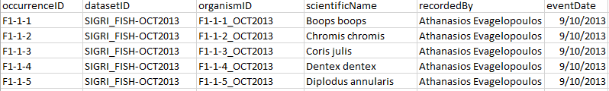

* Taxonomy Information Template

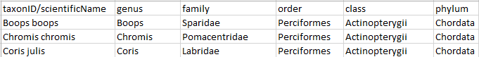

* Data Collection Metadata Template



* Environmental Metadata Template

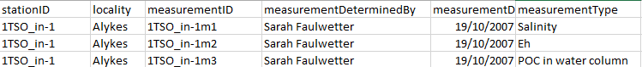

* Specimen Measurement Metadata Template

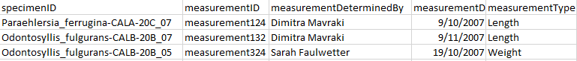

* Specimens Collection Metadata Template



* Specimen Metadata Template



* Identification Metadata Template

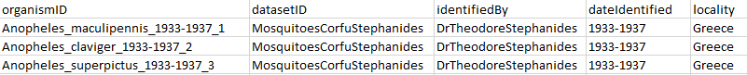

* A Micro CT Scanning Metadata Template

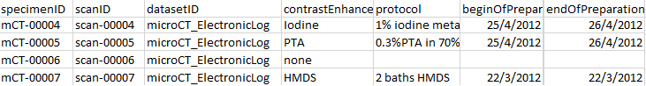

* A Micro CT Reconstruction Metadata Template

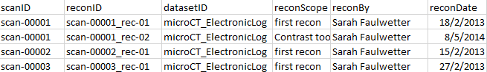

* A Micro CT Post processing Metadata Template

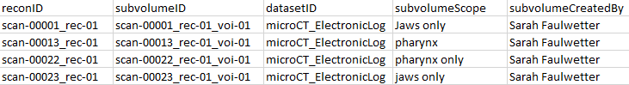

* A Scientific Names Template

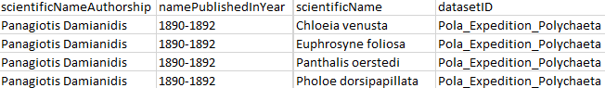

* A Common Names Template

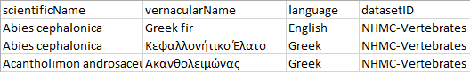

* A Synonyms Template

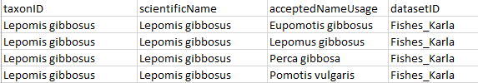

* A Morphometrics Metadata Templates

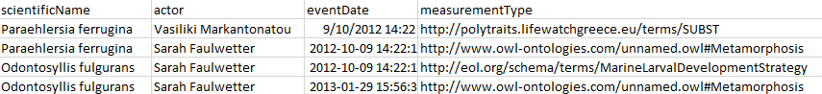

## Fundamental Categories for Efficient Querying

In rich semantic networks, where the information is constructed using a schema of high complexity, useful deductions are created. In such semantic networks that provide a great level of detail a keyword based querying system or a system based on explicitly defined relationships would be insufficient. Using a specific keyword or just a flat relationship for querying would result in low recall rates, as the system would ignore all the essential information that is hidden behind deductions of relationships linking and reasoning.

The proposal is not to simplify the schema for construction the semantic network, but the schema for querying the complex semantic network. To realize this, we model the world in 5 fundamental categories and we define certain generic fundamental relationships:

***1. Thing*** *(Specimens,Individuals,Publications etc)*

***2. Actor*** *(Scientists,Authors,Institutions ect)*

***3. Place*** *(EcosystemEnvironment,Country,WaterArea etc)*

***4. Event*** *(Identification,Occurrence,Scanning etc)*

***5. Dimension*** *(Length,Weight,Salinity etc)*

The following table contains all the Fundamental Queries and Relationships:

|  |  |  |  |  |  |
| --- | --- | --- | --- | --- | --- |
|  | Thing | Actor | Place | Event | Dimension |
| Thing | refers to has part from has met | from by · observed by · created by · published by · identified by has met (encountered) | from · is native at · introduced at has met (was encountered in) | refers to from by | has |
| Actor | has met · encountered · identified · measured is owner or creator of · holds rights on · keeps · curates · discovered refers to | is member of | has met from | refers to has met | measured |
| Place | has met | has met | is part of has part borders or overlaps with | has met | has |
| Event | is referred by has met · created · digitized · modified · encountered · discovered · identified | by has met | from | has met | has measured |
| Time | is origin of | is origin of | is origin of | is origin of | has |
| Dimension | of | by | of | of by |  |

Figure 19: Fundamental Relationships

## Fundamental Queries

Based on the fundamental categories that were mentioned in the previous section 30 fundamental queries were formulated and implemented in SPARQL. These queries are:

1. *Actor has met place*
2. *Actor has met thing*
3. *Actor is owner or creator of thing*
4. *Actor measured dimension*
5. *Actor refers to event*
6. *Actor refers to thing*
7. *Dimension by actor*
8. *Dimension by event*
9. *Dimension of place*
10. *Dimension of thing*
11. *Event by actor*
12. *Event from place*
13. *Event has met actor*
14. *Event has met thing*
15. *Event measured dimension*
16. *Place has dimension*
17. *Place has met thing*
18. *Place has part place*
19. *Thing by actor*
20. *Thing by event*
21. *Thing from actor*
22. *Thing from event*
23. *Thing from place*
24. *Thing from thing*
25. *Thing has dimension*
26. *Thing has met actor*
27. *Thing has met place*
28. *Thing has met thing*
29. *Thing refers to event*

An indicative example of a fundamental query is: ***“Return the Things that have met Greece”*** which returns results such as:

• Specimens that come from Greece

• Individuals that have been observed in Greece

• DNA samples from animals that come from Greece

The SPARQL template expression of an indicative fundamental query (thing has met place) is shown below (a part of it):

*SELECT distinct ?thing ?dataset  
WHERE  
{  
{  
?OccurrenceEventURI <http://www.w3.org/1999/02/22-rdf-syntax-ns#type> <http://www.ics.forth.gr/isl/CRMsci/S19_Encounter_Event> .  
?OccurrenceEventURI <http://www.ics.forth.gr/isl/CRMsci/O21_has_found_at> ?locality .  
?OccurrenceEventURI <http://www.ics.forth.gr/isl/CRMsci/O32_has_found_object> ?thing .  
?dataset <http://www.cidoc-crm.org/cidoc-crm/P67_refers_to> ?OccurrenceEventURI .  
?dataset <http://www.w3.org/1999/02/22-rdf-syntax-ns#type> <http://www.ics.forth.gr/isl/ontology/MarineTLO/BC21_Dataset> .  
FILTER regex(?locality,<[!TEMPLATE_1!]>  
)  
UNION  
{   
 ?IdentificationEventIDURI <http://www.w3.org/1999/02/22-rdf-syntax-ns#type> <http://www.cidoc-crm.org/cidoc-crm/E17_Type_Assignment> .  
?IdentificationEventIDURI <http://www.cidoc-crm.org/cidoc-crm/P7_took_place_at> ?locality .  
?IdentificationEventIDURI <http://www.cidoc-crm.org/cidoc-crm/P41_classified> ?thing .   
?dataset <http://www.cidoc-crm.org/cidoc-crm/P67_refers_to> ?IdentificationEventIDURI .  
?dataset <http://www.w3.org/1999/02/22-rdf-syntax-ns#type> <http://www.ics.forth.gr/isl/ontology/MarineTLO/BC21_Dataset> .  
FILTER regex(?locality,<[!TEMPLATE_1!]>)  
}  
}*

# Architecture

The main scientific goal of the data services of the infrastructure is the discovery of registered resources within an information community and the return information that allows a user to locate and access the resource and its curator/creator. This is a tricky task since a lot of issues may be faced such the fact that the resources may not be available online (technical failure/access rights/data policies), may be widely distributed/stored or the information of how to access the dataset/collection or where it is stored may be incomplete. In order to achieve the main scientific goal, to fulfill the functional requirements and to overcome such issues a new prototypical 3 Main Components Architecture was designed and implemented.

The 3 Main Components are the Directory Service, the Metadata Repository and the Content Storage that are described in details in the next sections. These 3 components can operate independently of each other, and provide different levels of querying capabilities. They are decoupled and are contented exclusively by the URI of the results achieving and the same time conceptual and semantic linking and functionality independence. Also, by adopting this architecture we achieve separation of domain specific from domain-independent information, ability to answer queries even if one of the components fail and ability to re-create in case of failure.

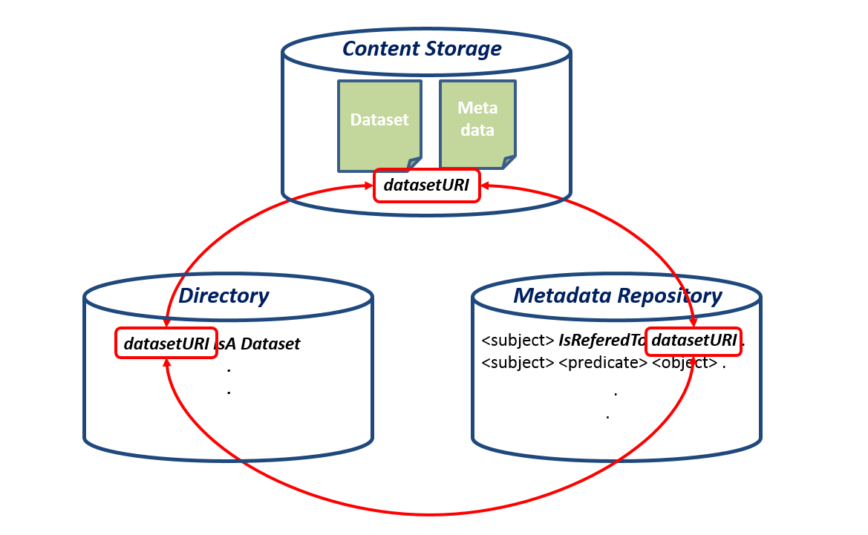

Figure 20: Connection Between the 3 Components Contents

In practice, the data providers provide their metadata (and data) by using the ingest tool, the metadata are mapped to the centralized schema of the infrastructure and are stored in the metadata repository. Information about the way to access the datasets and communicate with the creators/curators is stored into the directory and both data and metadata are stored into the content storage. When all the metadata are stored in the infrastructure the users can execute queries to gain information on how to access the datasets. These queries are handled by the query manager while access manager is responsible for providing access to the metadata repository and the directory. The Architecture is displayed in the figure below and a description of each component follows.

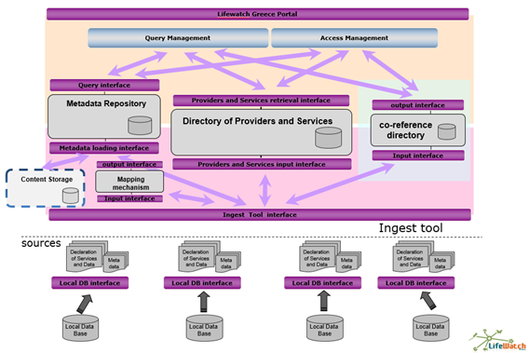

Figure 21: Lifewatch Greece Infrastructure Architecture

### 

## Directory Service

The role of the Directory Service is to support the discovery of registered resources within an information community and return information that allows a user to locate and access the resource and its curator/creator. Specifically it provides means to create, edit, update, search information about providers, collections (datasets) and the means to communicate and access with them. The directory service is independent of the domain.

We focused on retrieving information about the actors. We don’t focus only to how to access the datasets or where they are stored but also to whom to communicate with. The information of how to access the dataset/collection or where it is stored is incomplete without the data that has to do with the curator/creator of it.

Some Indicative queries that can be answered by the Directory Service are the following:

* Which institution hosts the dataset with title “Thunnus Occurences” and how can I have access to it?
* Return all the datasets that have been created from HCMR.

The schema of the directory service has been defined by using the semantic models’ concepts. The data is stored as triples in a Virtuoso triple store and the Data Services API is used for the importing/updating/searching actions. The shema of the directory follows:

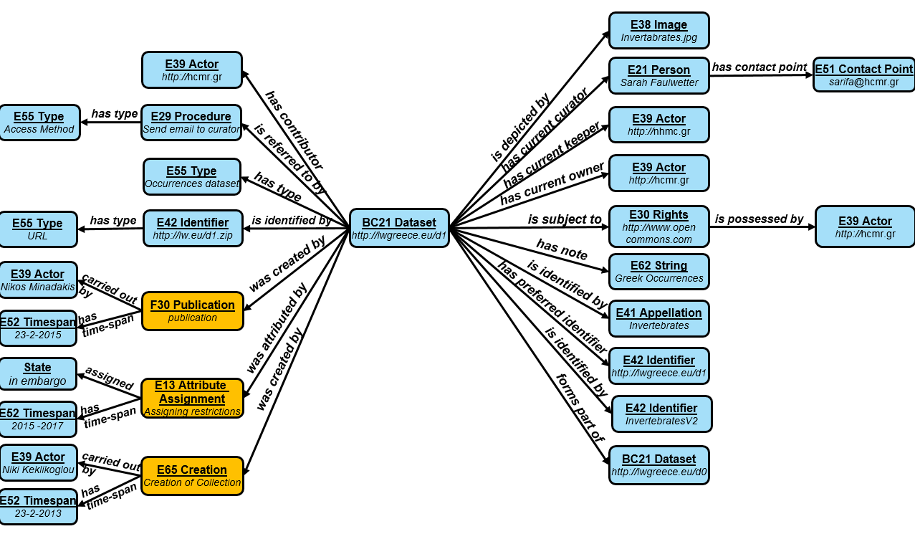

Figure 22: Directory Service Schema

A description of each metadata field follows:

* ***dataset*:** the dataset or the digital collection of datasets that is identified by a unique dataset identifier
* ***forms part of->Dataset:***the digital collection that the dataset belongs to*. eg. Mediterranean Syllidae*
* ***has current owner->Actor:***the organization or person that owns the dataset. *eg. HCMR*
* ***has contributor->Actor:***the actors that contributed data to the dataset. eg*. NHMC*
* ***has current keeper->Actor:***the organization which hosts the dataset. *eg. HCMC*
* ***is subject to->Rights:*** the rights to the dataset.*eg. http://www.opendatacommons.org/licenses/by/1.0/*
* ***Rights-possessed by->Actor:***The organization that possesses the intellectual rights *eg. HCMR*
* ***has current curator->Person:***the person that manages the dataset. *eg. Sarah Faulwetter*
* ***Person-has contact point->Contact Point:***the actual contact point of the curator. *eg sarifa@hcmr.gr*
* ***has note->String:***the description of the collection.
* ***is referred to by->Procedure:***the way to access the digital dataset. *eg send an email to sarifa@hcmr.gr*
* ***is identified by->Appellation:***the title of the dataset
* ***has preferred identifier->Identifier:***the produced identifier for the dataset *eg. prefix+type+id*
* ***is identified by->Identifier***: the original identifier of the dataset
* ***has type->Type*:** the type of the dataset. *eg. Occurrence Records Dataset*
* ***is identified by->Identifier-has type->URL:***the url that the dataset is located at*.*
* ***was created by->Publication:***the publication event of the dataset.
* ***Publication-carried out ->Actor:***the publisher of the dataset.
* ***Publication-has timespan->Time Span:***the publication time.
* ***was attributed by->Attribute Assignment:*** the event that restricted the access to the dataset
* ***Attribute Assignment-assigned->State:***The current state of the dataset. *eg. In Embargo*
* ***Attribute Assignment-has timespan->Time Span:***The timespan that the dataset has the assigned state.
* ***was created by->Creation:*** the event that created the dataset
* ***Creation-carried out by->Actor:***The creator of the dataset.
* ***Creation-has timespan->Time Span:***The creation time.
* ***is depicted by->Image:***The logo of the dataset.

Regarding the Versioning of the datasets, three types of versioning are have been identified:

• **Correction:** The new version contains corrected information  
e.g. syntactic corrections on scientific names

• **Inference:** The new version contains information that was inferred by the previous one.  
e.g. species abundances produced by species occurrence records

• **Extension:** The new version is a superset of the previous version.  
e.g. addition of occurrence records in an occurrence dataset

The combination of correction and extension allows us to keep information for **continuing resources** which are “*resources issued over time with no predetermined conclusion”.*

There are currently a JAVA API and a number of SOAP web services that implement the LifeWatch Greece Directory. There is also a Web Application for testing the functionalities. A first version of the directory’s web interface in the LifeWatch Greece Portal will be ready in June 2015. Directory Service has been designed by taking into account the LifeWatch Reference Model and Orchestra Reference Model.

## Metadata Repository

The Metadata Repository is domain dependent and Assists dataset discovery by modelling in a rich semantically way part of them, and is responsible for storing, updating and querying of the metadata that the providers would like to be public. It aids information integration and inference. All the metadata that are provided by the data providers are stored into the metadata repository, after they are mapped to the centralized schema of the infrastructure. Furthermore, the semantic models, the inferred triples, the materialization rules products and the instance matching products are stored in the metadata repository. The queries that are executed by the users exploit the metadata repository and return the datasets that contain the related information. Some indicative queries that can be answered by the metadata repository are:

* Find all datasets about scans depicting marine species
* Find all datasets about species that have been originally described from Greece
* Find all datasets about samples have been analyzed with Qiime?

The metadata repository uses Virtuoso Triple Store, and by using the Data Services API or the Virtuoso SPARQL endpoint the users can execute SPARQL Queries to retrieve the information of interest. For example a SPARQL query that returns the datasets about *Paraehlersia ferrugina* = species and the curators contact point is:

*SELECT distinct ?dataset_name ?contact_point*

*WHERE {*

*?species rdfs:label 'Paraehlersia ferrugina' .*

*?encounter_event crmsci:has_found_object ?individual .*

*?id_event crm:classified ?individual.*

*?id_event crm:assigned_attribute_to_type ?species .*

*?dataset crm:refers_to ?encounter_event .*

*?dataset rdfs:label ?dataset_name .*

*?dataset crmo:has_curator ?curator .*

*?curator crm:has_contact_point> ?contact*_point

*}*

The result as it comes out from the Virtuoso Endpoint:

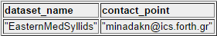

## Content Storage

The data storage stores any raw data / datasets that the Data Providers will upload to the system. (Datasets, Images, DNA sequence files, Analysis Products). The raw data are linked with the metadata into the metadata repository and the directory entries by the dataset’s URI.

The data storage is currently central but is can be federated among different insitutions. The following requirements are mandatory for the content storage:

1. *Access control and Authentication*
2. *Management of Data Capabilities*
3. *Link with the Metadata Repository*
4. *Compatibility*
5. *Efficiency*
6. *Access control and Authentication*
7. *Management of Data Capabilities*
8. *Link with the Metadata Repository*
9. *Compatibility*

We selected iRODS that fulfills the above requirements and gives the possibilities of either implementing a centralized content storage or a federated one. More detailed information about the functionality of the content storage are contained in the next section.

## Mapping Mechanism Tool

The mapping mechanism provides the mechanism for mapping the metadata from the data files described in various formats (ISO 21127, Dublin Core, DwC) to the unique format accepted by the metadata repository. The users can use ***x3ml language***, ***3M editor*** and ***x3ml engine*** for this purpose or the Data Services API transformation functions.

A brief summary of the mapping and transformation process using the **x3ml engine** is depicted in the following picture:

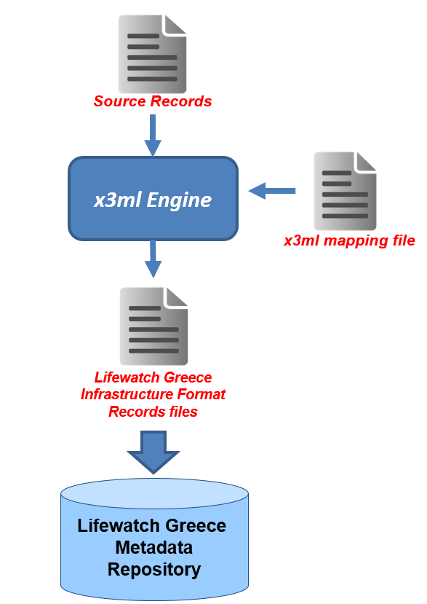

Figure 23 : Source Records Tranformation and Ingestion using x3ml Engine Diagram

## Policies

In this section a number of policies that we used in the infrastructure regarding some important processes such as updating, recovering from failures etc are presented. Most of these policies are designed from scratch for the needs of LW Greece and are applied for the first time in the project.

#### Publishing

The publishing of data in the infrastructure consists of main 3 steps. The first step of data publishing is the importing of information for the data resource (curator, access method, type) in the Directory. This can be done either by filling a form in the Portal’s Web Application or by uploading a .csv file with the information. In both cases a URI is being created for the data resource, a folder is created for the resource in the content storage and the csv file (in the case of the form it is automatically created) is stored in the content storage with a minimal set of metadata (creator, date, URI, type). The csv file is also being replicated in the Recovery Folder of the content storage. The csv contents are transformed in triples and are stored in the Directory’s triple store.

The second step is the publishing of metadata about the data resource. This can be done by filling and uploading the related templates that correspond to different semantic concepts. These templates that are in csv format are stored in the content storage folder of the data resource with a minimal set of metadata, are transformed in triples and are stored in the Metadata Repository’s triple store.

The third step of the publishing, is the publishing of the exact data resourse. This can be done by a form from the portal or by using the data services API. The data resource is being saved in the data resource folder in the content storage with a minimal set of metadata.

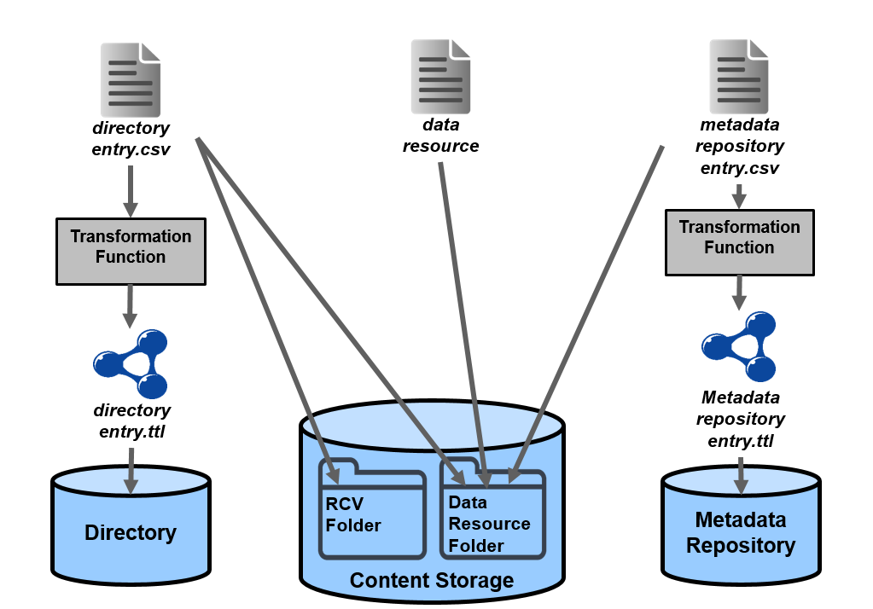

Figure 24: Data Publishing Abstract Diagram

#### Updating

The updating in LW Greece infrastructure is not a trivial task because of the complexity of updating a semantic graph contents. To update the directory service contents that are related with a data resource, the csv file that is stored in the content storage is being replaced, and the related contents of the directory triple store are deleted until a defined depth (that in the most cases is set to 1) and reimported from the csv file.

To update the contents of the metadata repository, the related csv files are replaces in the content storage and the related contents of the metadata repository triple store are deleted until a defined depth (which is again set to 1 for most of the cases) and the data is reimported in the triple store.

To update the content storage contents (eg. upload a new file), the previous file has to be deleted and replaced with new one. Each new dataset is seen as a new data resource and not as a new version of the previous one.

#### Versioning

Versioning of files is achieved in the content storage by keeping information on the importing date of the file. The versioning is applied in the metadata files (directory metadata, metadata repository files) and not to the datasets because each new dataset is seen as a new data resource and not as a new version of the previous one.

#### URI creation

Regarding the URI creation policy of the infrastructure it was decided that the URIs should be human readable, and to provide information on the type of the entity that they identify. The format of the URIs that are automatically created is:

[**www.lifewatchgreece.eu/entity/**](http://www.lifewatchgreece.eu/entity/) **+ entityType/ + entityID_trimed_inLowerCase**

For example the produced URI for Lake Carla is:

[**http://www.lifewatchgreece.eu/entity/waterArea/lake_karla**](http://www.lifewatchgreece.eu/entity/waterArea/lake_karla)

#### Recovery

In cases of system failure or data corruption it was mandatory to define a number of recovery-of-failure policies/mechanisms. The recovery mechanisms of the infrastructure are divide in the Directory Service recovery and the Metadata Repository Recovery.

Regarding the recovery of Directory Service, a RCV_Directory folder has been created in the content storage. Every csv file that is either produced by the portal’s form entry or directly uploaded by the users is saved in this folder. In case of failure the Directory’s triple store is being erased and the files of the RCV_Directory folder are transformed and imported, reconstructing the directory’s graph.

The recovery of the Metadata Repository is a more complex process. All the metadata repository’s csv files are stored in the content storage under the data resource folder that they describe. In case of Metadata Repository corruption, all the data resource folders are accessed and the csv metadata files contents that they contain are transformed and imported, reconstructing the metadata repository’s graph.

# Back-end Products

This sections describes the main back-end products of the implementation phase of the LifeWatch Greece Data Services which are the Data Services API and the SOAP Web Services. These products are the basis of the front-end implementation of the data services infrastructure and are being used for the development of the data services web application of the LW Greece portal and by a number of other e-services and v-labs of the infrastructure. They are publicly available to users and developers and can be reused for the creation of new applications and infrastructures, and also be exploited by the other partners of the LifeWatch Europe Project.



Figure 25: The Architecture of Lifewatch Data Services

## Data Services API

Considering the functional requirements that were collected, the functionality of the main architecture components and the implementation need of the infrastructure in general a JAVA API has been developed. The Data Services API has also been used to create the SOAP web services that have been exposed. The Data Services API is available at <https://github.com/isl/LifeWatch_Greece>. The main functionalities that are provided by the API are presented in the next sections.

#### Semantic Repository Actions

The Data Services API offers the functions to:

1. connect to a semantic triple store
2. import data to the triple store
3. update the triple store contents
4. delete data from the triple store
5. query the triple store

The triple store that the API has been extendedly used is Openlink’s Virtuoso, but it has also been tested with ontotext’s OWLIM.

#### Biodiversity Data Transformations

The Data Services API contains a number of functions that transform biodiversity data from csv format to turtle format (rdf). The code takes as input specific csv templates that are filled with biodiversity data, and transforms it to rdf format based on CRM family event centric semantic models. The produced triples can be imported to a triple store. The biodiversity data that can be transformed belongs to the categories below:

* Data Collection metadata
* Occurrences Events data
* Identification Events data
* Occurrences Statistics
* Statistical data
* Morphometrics data
* Morphological Characteristics data
* Micro CT Scanning data
* Micro CT Specimen data
* Micro CT Recostruction data
* Micro CT Post Processing data
* DNA sampling and sequencing data
* Scientific Naming data
* Common Naming data
* Synonyms data
* Taxonomy data
* Environmental data

#### Biodiversity Data Querying

The Data Services API, except the generic semantic graph querying functionalities, includes a number of biodiversity domain specific querying functions that return biodiversity data that is stored in triple stores and belongs to one of the categories that were mentioned in the previous section (see 5.1.2). Furthermore, offset and limit can be used to limit the number of returned results enabling for example paging implementations.

#### URIs creation

The API offers three different functions for URI creation. These functions can create URIs that are a concatenation of the prefix, the type of the entity and the id of the entity, or a concatenation of the prefix and the id of the entity, or a hash code.

#### Browsing Semantic Graphs

Two functions for browsing the semantic graphs have been created. The one returns all the outgoing nodes, and their types, of an entity and the other all the incoming nodes, and their types, to an entity. Similar to the querying functions the offset and limit option is provided to limit the number of the returned results.

#### Updating Semantic Graphs

The updating of a semantic graph is a complicated task because almost all of the contents are connected with each other. For this reason the Data Services API offers a function that updates the entities that are connected with a central entity (or a list of entities) until a defined depth.

#### Materialization Rules Execution

In many cases the contents of a semantic graph need to be materialized based on a number of rules. For this reason the Data Services API offers a materialization function that takes as input the SPARQL rules from an external folder and executes them importing the materialized triples to the triple store.

#### Textual Description Production

The Data Services API contains a function that takes as input a Scientific Name of a species and by using standard templates, produces a textual (wikipage like) description, integrating information coming from different datasets and providers.

## Web Services

The web services that were developed to expose the infrastructure functionalities. The services has been packaged into a middleware (the DataServices-middleware) that contains three main services and a number of sub-services. The services use SOAP as a protocol for exchanging messages with clients. The services are:

* Directory Web Service
* Metadata Repository Web Service
* Fundamental Categories Web Service

Below we will describe these services in detail and provide their documentation.

#### Directory Web Service

The service is responsible for all the operations that are related to the Directory. It consists of a number of sub-services that perform the following actions in the Directory.

1. searching [***DirectoryService_Search***]
2. adding [***DirectoryService_Insert***]
3. updating [***DirectoryService_Update***]
4. deleting [***DirectoryService_Delete***]

##### DirectoryService_Search

This sub-service is responsible for searching for information from the Directory of the LifeWatch Greece infrastructure. It contains a set of operations that are described below.

|  |  |
| --- | --- |
| **Operation name** | ***searchDataset*** |
| **Input** | * String datasetName * String ownerName * String datasetURI * String datasetType * String repositoryGraph |
| **Output** | * List<DirectoryStruct> |
| **Description** | The method takes some descriptive parameters and searches on the Directory for datasets containing the particular information. The results are returned in a list containing DirectoryStruct elements. DirectoryStruct is a simple structure (in the form of a POJO[9]) and each dataset is returned as a single instance of a DirectoryStruct. Apart from the repositoryGraph parameter, that should be provided explicitly all the other parameters are optional and the user can also provide only a part of them (i.e. “dataset” instead of “http://www.ics.forth.gr/isl/dataset” for datasetURI). |

|  |  |
| --- | --- |
| **Operation name** | ***searchDatasetWithinRange*** |
| **Input** | * String datasetName * String ownerName * String datasetURI * String datasetType * int limit * int offset * String repositoryGraph |
| **Output** | * List<DirectoryStruct> |
| **Description** | The method takes some descriptive parameters and searches on the directory registry for datasets containing the particular information. The method searches over a specific range defined by the parameters offset (the index denoting the starting point for searching), and limit (that denotes the total number of datasets that should be searched). The results are returned in a list containing DirectoryStruct elements. DirectoryStruct is a simple structure (in the form of a POJO[10]) and each dataset is returned as a single instance of a DirectoryStruct. Apart from the repositoryGraph parameter, that should be provided explicitly all the other parameters are optional and the user can also provide only a part of them (i.e. “dataset” instead of “http://www.ics.forth.gr/isl/dataset” for datasetURI). |

|  |  |
| --- | --- |
| **Operation name** | ***searchLiteral*** |
| **Input** | * String literalValue * String repositoryGraph |
| **Output** | * List<Triple> |
| **Description** | The method takes some descriptive parameters and searches for triples (<s, p, o>) containing the given literal value. Practically literals can only be found in the object part (o) of a triple. The method returns a list of triples containing the given literal value (or a part of it), in the given repository graph. |

|  |  |
| --- | --- |
| **Operation name** | ***searchResource*** |
| **Input** | * String resourceURI * String repositoryGraph |
| **Output** | * List<Triple> |
| **Description** | The method takes some descriptive parameters and searches for triples (<s, p, o>) containing the given resource URI. Practically the given resource is being searched either in the subject (s) or in the object (o) of the triples. The method returns a list of triples containing the given resource URI, in the given repository graph. |

##### DirectoryService_Insert

This sub-service is responsible for adding new information about datasets to the Directory of the LifeWatch Greece infrastructure. It contains one operation that is described below.

|  |  |
| --- | --- |
| **Operation name** | ***insertDataset*** |
| **Input** | * DirectoryStruct struct * String repositoryGraph |
| **Output** | * boolean |
| **Description** | The method takes as input a DirectoryStruct that contains various information about a dataset and adds it to the Directory. The method returns a boolean value reporting if the addition was successful or not. |

##### DirectoryService_Update

This sub-service is responsible for updating existing information about datasets from the Directory of the LifeWatch Greece infrastructure. It contains a set of operations that are described below.

|  |  |
| --- | --- |
| **Operation name** | ***updateLiteral*** |
| **Input** | * String originalLiteral * String newLiteral * String repositoryGraph |
| **Output** | * boolean |
| **Description** | The method takes as input a literal value, it searches for triples containing that value and replaces all the occurrences with a new literal value. The method returns a boolean value reporting if the update was successful or not. |

|  |  |
| --- | --- |
| **Operation name** | ***updateResource*** |
| **Input** | * String originalResource * String newResource * String repositoryGraph |
| **Output** | * boolean |
| **Description** | The method takes as input a resource URI, it searches for triples containing that URI (either in the subject or the object of the triple) and replaces all the occurrences with a new resource URI. The method returns a boolean value reporting if the update was successful or not. |

|  |  |
| --- | --- |
| **Operation name** | ***updateProperty*** |
| **Input** | * String originalProperty * String newProperty * String repositoryGraph |
| **Output** | * boolean |
| **Description** | The method takes as input a property URI, it searches for triples containing that URI (in the predicate of the triple) and replaces all the occurrences with a new property URI. The method returns a boolean value reporting if the update was successful or not.  **CAUTION:** This method should be used carefully since it updates schema resources and might cause other methods malfunction. |

##### DirectoryService_Delete

This sub-service is responsible for deleting existing information about datasets from the Directory of the LifeWatch Greece infrastructure. It contains a set of operations that are described below.

|  |  |
| --- | --- |
| **Operation name** | ***deleteTriples*** |
| **Input** | * String subject * String predicate * String object * String repositoryGraph |
| **Output** | * boolean |
| **Description** | The method takes as input the values of a triple <s, p, o>), it searches for that triple and removes it. The method returns a boolean value reporting if the deletion was successful or not.  **CAUTION:** This method should be used carefully since it removes explicit triples might cause other methods malfunction. |

|  |  |
| --- | --- |
| **Operation name** | ***deleteTriplesHavingLiteral*** |
| **Input** | * String literalValue * String repositoryGraph |
| **Output** | * boolean |
| **Description** | The method takes as input a literal value, it searches for triples containing that literal value and removes all the occurrences of these triples. The method returns a boolean value reporting if the deletion was successful or not.  **CAUTION:** This method should be used carefully since it removes explicit triples might cause other methods malfunction. |

|  |  |
| --- | --- |
| **Operation name** | ***deleteTriplesHavingResource*** |
| **Input** | * String resourceURI * String repositoryGraph |
| **Output** | * boolean |
| **Description** | The method takes as input a resource URI, it searches for triples containing that URI (in the subject or the object of the triple) and removes all the occurrences of these triples. The method returns a boolean value reporting if the deletion was successful or not.  **CAUTION:** This method should be used carefully since it removes explicit triples might cause other methods malfunction. |

|  |  |
| --- | --- |
| **Operation name** | ***deleteTriplesHavingProperty*** |
| **Input** | * String propertyURI * String repositoryGraph |
| **Output** | * boolean |
| **Description** | The method takes as input a property URI, it searches for triples containing that URI (in the predicate of the triple) and removes all the occurrences of these triples. The method returns a boolean value reporting if the deletion was successful or not.  **CAUTION:** This method should be used carefully since it removes explicit triples might cause other methods malfunction. |

#### Metadata Repository Web Service

This service is responsible for all the operations that are related to the Metadata Repository. It consists of a number of sub-services that perform the following actions.

1. searching [***MetadataRepository_Search***]
2. adding [***MetadataRepository _Insert***]
3. updating [***MetadataRepository _Update***]
4. deleting [***MetadataRepository _Delete***]
5. browsing [***MetadataRepository _Select***]
6. producing text [***MetadataRepository _Text***]

##### MetadataRepository_Search

This sub-service is responsible for searching for information from the Metadata Repository of the LifeWatch Greece infrastructure. It contains a set of operations that are described below.

|  |  |
| --- | --- |
| **Operation name** | ***searchCommonName*** |
| **Input** | * String speciesName * String commonName * String place * String language * String datasetURI * String repositoryGraph |
| **Output** | * List<CommonNameStruct> |
| **Description** | The method takes some descriptive parameters and searches on the metadata repository for metadata information about datasets as regards common name. The results are returned in a list containing CommonNameStruct elements. Apart from the repositoryGraph parameter, that should be provided explicitly all the other parameters are optional and the user can also provide only a part of them (i.e. “dataset” instead of “http://www.ics.forth.gr/isl/dataset” for datasetURI). |

|  |  |
| --- | --- |
| **Operation name** | ***searchCommonNameWithinRange*** |
| **Input** | * String speciesName * String commonName * String place * String language * String datasetURI * int offset * int limit * String repositoryGraph |
| **Output** | * List<CommonNameStruct> |
| **Description** | The method takes some descriptive parameters and searches on the metadata repository for metadata information about datasets as regards common name. The method searches over a specific range defined by the parameters offset (the index denoting the starting point for searching), and limit (that denotes the total number of entries that should be searched). The results are returned in a list containing CommonNameStruct elements. Apart from the repositoryGraph parameter, that should be provided explicitly all the other parameters are optional and the user can also provide only a part of them (i.e. “dataset” instead of “http://www.ics.forth.gr/isl/dataset” for datasetURI). |

|  |  |
| --- | --- |
| **Operation name** | ***searchEnvironmental*** |
| **Input** | * String dimension * String place * String datasetURI * String repositoryGraph |
| **Output** | * List<EnvironmentalStruct> |
| **Description** | The method takes some descriptive parameters and searches on the metadata repository for metadata information about datasets as regards environmental parameters. The results are returned in a list containing EnvironmentalStruct elements. Apart from the repositoryGraph parameter, that should be provided explicitly all the other parameters are optional and the user can also provide only a part of them (i.e. “dataset” instead of “http://www.ics.forth.gr/isl/dataset” for datasetURI). |

|  |  |
| --- | --- |
| **Operation name** | ***searchEnvironmentalWithinRange*** |
| **Input** | * String dimension * String place * String datasetURI * int offset * int limit * String repositoryGraph |
| **Output** | * List< EnvironmentalStruct > |
| **Description** | The method takes some descriptive parameters and searches on the metadata repository for metadata information about datasets as regards environmental parameters. The method searches over a specific range defined by the parameters offset (the index denoting the starting point for searching), and limit (that denotes the total number of entries that should be searched). The results are returned in a list containing EnvironmentalStruct elements. Apart from the repositoryGraph parameter, that should be provided explicitly all the other parameters are optional and the user can also provide only a part of them (i.e. “dataset” instead of “http://www.ics.forth.gr/isl/dataset” for datasetURI). |

|  |  |
| --- | --- |
| **Operation name** | ***searchGenetics*** |
| **Input** | * String speciesName * String sample * String place * String device * String datasetURI * String repositoryGraph |
| **Output** | * List<GeneticsStruct> |
| **Description** | The method takes some descriptive parameters and searches on the metadata repository for metadata information about datasets as regards genetics parameters. The results are returned in a list containing GeneticsStruct elements. Apart from the repositoryGraph parameter, that should be provided explicitly all the other parameters are optional and the user can also provide only a part of them (i.e. “dataset” instead of “http://www.ics.forth.gr/isl/dataset” for datasetURI). |

|  |  |
| --- | --- |
| **Operation name** | ***searchGeneticsWithinRange*** |
| **Input** | * String speciesName * String sample * String place * String device * String datasetURI * int offset * int limit * String repositoryGraph |
| **Output** | * List< GeneticsStruct > |
| **Description** | The method takes some descriptive parameters and searches on the metadata repository for metadata information about datasets as regards genetics parameters. The method searches over a specific range defined by the parameters offset (the index denoting the starting point for searching), and limit (that denotes the total number of entries that should be searched). The results are returned in a list containing GeneticsStruct elements. Apart from the repositoryGraph parameter, that should be provided explicitly all the other parameters are optional and the user can also provide only a part of them (i.e. “dataset” instead of “http://www.ics.forth.gr/isl/dataset” for datasetURI). |

|  |  |
| --- | --- |
| **Operation name** | ***searchGensSample*** |
| **Input** | * String speciesName * String device * String sample * String datasetURI * String repositoryGraph |
| **Output** | * List<GensSampleStruct> |
| **Description** | The method takes some descriptive parameters and searches on the metadata repository for metadata information about datasets as regards genetics sample parameters. The results are returned in a list containing GensSampleStruct elements. Apart from the repositoryGraph parameter, that should be provided explicitly all the other parameters are optional and the user can also provide only a part of them (i.e. “dataset” instead of “http://www.ics.forth.gr/isl/dataset” for datasetURI). |

|  |  |
| --- | --- |
| **Operation name** | ***searchGensSampleWithinRange*** |
| **Input** | * String speciesName * String device * String sample * String datasetURI * int offset * int limit * String repositoryGraph |
| **Output** | * List< GensSampleStruct > |
| **Description** | The method takes some descriptive parameters and searches on the metadata repository for metadata information about datasets as regards genetics samples parameters. The method searches over a specific range defined by the parameters offset (the index denoting the starting point for searching), and limit (that denotes the total number of entries that should be searched). The results are returned in a list containing GensSampleStruct elements. Apart from the repositoryGraph parameter, that should be provided explicitly all the other parameters are optional and the user can also provide only a part of them (i.e. “dataset” instead of “http://www.ics.forth.gr/isl/dataset” for datasetURI). |

|  |  |
| --- | --- |
| **Operation name** | ***searchIdentification*** |
| **Input** | * String speciesName * String date * String actor * String place * String individual * String datasetURI * String repositoryGraph |
| **Output** | * List<IdentificationStruct> |
| **Description** | The method takes some descriptive parameters and searches on the metadata repository for metadata information about datasets as regards identification information. The results are returned in a list containing IdentificationStruct elements. Apart from the repositoryGraph parameter, that should be provided explicitly all the other parameters are optional and the user can also provide only a part of them (i.e. “dataset” instead of “http://www.ics.forth.gr/isl/dataset” for datasetURI). |

|  |  |
| --- | --- |
| **Operation name** | ***searchIdentificationWithinRange*** |
| **Input** | * String speciesName * String date * String actor * String place * String individual * String datasetURI * int offset * int limit * String repositoryGraph |
| **Output** | * List< IdentificationStruct > |
| **Description** | The method takes some descriptive parameters and searches on the metadata repository for metadata information about datasets as regards identification information. The method searches over a specific range defined by the parameters offset (the index denoting the starting point for searching), and limit (that denotes the total number of entries that should be searched). The results are returned in a list containing IdentificationStruct elements. Apart from the repositoryGraph parameter, that should be provided explicitly all the other parameters are optional and the user can also provide only a part of them (i.e. “dataset” instead of “http://www.ics.forth.gr/isl/dataset” for datasetURI). |

|  |  |
| --- | --- |
| **Operation name** | ***searchMeasurement*** |
| **Input** | * String specimen * String speciesName * String dimension * String datasetURI * String repositoryGraph |
| **Output** | * List<MeasurementStruct> |
| **Description** | The method takes some descriptive parameters and searches on the metadata repository for metadata information about datasets as regards measurements. The results are returned in a list containing MeasurementStruct elements. Apart from the repositoryGraph parameter, that should be provided explicitly all the other parameters are optional and the user can also provide only a part of them (i.e. “dataset” instead of “http://www.ics.forth.gr/isl/dataset” for datasetURI). |

|  |  |
| --- | --- |
| **Operation name** | ***searchMeasurementWithinRange*** |
| **Input** | * String specimen * String speciesName * String dimension * String datasetURI * int offset * int limit * String repositoryGraph |
| **Output** | * List< MeasurementStruct > |
| **Description** | The method takes some descriptive parameters and searches on the metadata repository for metadata information about datasets as regards measurements. The method searches over a specific range defined by the parameters offset (the index denoting the starting point for searching), and limit (that denotes the total number of entries that should be searched). The results are returned in a list containing MeasurementStruct elements. Apart from the repositoryGraph parameter, that should be provided explicitly all the other parameters are optional and the user can also provide only a part of them (i.e. “dataset” instead of “http://www.ics.forth.gr/isl/dataset” for datasetURI). |

|  |  |
| --- | --- |
| **Operation name** | ***searchMicroCTPostProcessing*** |
| **Input** | * String speciesName * String specimen * String input * String datasetURI * String repositoryGraph |
| **Output** | * List<MicroCTPostProcessingStruct> |
| **Description** | The method takes some descriptive parameters and searches on the metadata repository for metadata information about datasets as regards MicroCT post processing information. The results are returned in a list containing MicroCTPostProcessingStruct elements. Apart from the repositoryGraph parameter, that should be provided explicitly all the other parameters are optional and the user can also provide only a part of them (i.e. “dataset” instead of “http://www.ics.forth.gr/isl/dataset” for datasetURI). |

|  |  |
| --- | --- |
| **Operation name** | ***searchMicroCTPostProcessingWithinRange*** |
| **Input** | * String speciesName * String specimen * String input * String datasetURI * int offset * int limit * String repositoryGraph |
| **Output** | * List< MicroCTPostProcessingStruct > |
| **Description** | The method takes some descriptive parameters and searches on the metadata repository for metadata information about datasets as regards MicroCT post processing information. The method searches over a specific range defined by the parameters offset (the index denoting the starting point for searching), and limit (that denotes the total number of entries that should be searched). The results are returned in a list containing MicroCTPostProcessingStruct elements. Apart from the repositoryGraph parameter, that should be provided explicitly all the other parameters are optional and the user can also provide only a part of them (i.e. “dataset” instead of “http://www.ics.forth.gr/isl/dataset” for datasetURI). |

|  |  |
| --- | --- |
| **Operation name** | ***searchMicroCTReconstruction*** |
| **Input** | * String speciesName * String specimen * String input * String datasetURI * String repositoryGraph |
| **Output** | * List<MicroCTReconstructionStruct> |
| **Description** | The method takes some descriptive parameters and searches on the metadata repository for metadata information about datasets as regards MicroCT reconstruction information. The results are returned in a list containing MicroCTReconstructionStruct elements. Apart from the repositoryGraph parameter, that should be provided explicitly all the other parameters are optional and the user can also provide only a part of them (i.e. “dataset” instead of “http://www.ics.forth.gr/isl/dataset” for datasetURI). |

|  |  |
| --- | --- |
| **Operation name** | ***searchMicroCTReconstructionWithinRange*** |
| **Input** | * String speciesName * String specimen * String input * String datasetURI * int offset * int limit * String repositoryGraph |
| **Output** | * List< MicroCTReconstructionStruct> |
| **Description** | The method takes some descriptive parameters and searches on the metadata repository for metadata information about datasets as regards MicroCT reconstruction information. The method searches over a specific range defined by the parameters offset (the index denoting the starting point for searching), and limit (that denotes the total number of entries that should be searched). The results are returned in a list containing MicroCTReconstructionStruct elements. Apart from the repositoryGraph parameter, that should be provided explicitly all the other parameters are optional and the user can also provide only a part of them (i.e. “dataset” instead of “http://www.ics.forth.gr/isl/dataset” for datasetURI). |

|  |  |
| --- | --- |
| **Operation name** | ***searchMicroCTScanning*** |
| **Input** | * String deviceName * String specimen * String speciesName * String contrastMethod * String datasetURI * String repositoryGraph |
| **Output** | * List<MicroCTScanningStruct> |
| **Description** | The method takes some descriptive parameters and searches on the metadata repository for metadata information about datasets as regards MicroCT scanning information. The results are returned in a list containing MicroCTScanningStruct elements. Apart from the repositoryGraph parameter, that should be provided explicitly all the other parameters are optional and the user can also provide only a part of them (i.e. “dataset” instead of “http://www.ics.forth.gr/isl/dataset” for datasetURI). |

|  |  |
| --- | --- |
| **Operation name** | ***searchMicroCTScanningWithinRange*** |
| **Input** | * String deviceName * String specimen * String speciesName * String contrastMethod * String datasetURI * int offset * int limit * String repositoryGraph |
| **Output** | * List< MicroCTScanningStruct> |
| **Description** | The method takes some descriptive parameters and searches on the metadata repository for metadata information about datasets as regards MicroCT scanning information. The method searches over a specific range defined by the parameters offset (the index denoting the starting point for searching), and limit (that denotes the total number of entries that should be searched). The results are returned in a list containing MicroCTScanningStruct elements. Apart from the repositoryGraph parameter, that should be provided explicitly all the other parameters are optional and the user can also provide only a part of them (i.e. “dataset” instead of “http://www.ics.forth.gr/isl/dataset” for datasetURI). |

|  |  |
| --- | --- |
| **Operation name** | ***searchMicroCTSpecimen*** |
| **Input** | * String specimen * String collection * String speciesName * String provider * String datasetURI * String repositoryGraph |
| **Output** | * List<MicroCTSpecimenStruct> |
| **Description** | The method takes some descriptive parameters and searches on the metadata repository for metadata information about datasets as regards MicroCT scanning information. The results are returned in a list containing MicroCTSpecimenStruct elements. Apart from the repositoryGraph parameter, that should be provided explicitly all the other parameters are optional and the user can also provide only a part of them (i.e. “dataset” instead of “http://www.ics.forth.gr/isl/dataset” for datasetURI). |

|  |  |
| --- | --- |
| **Operation name** | ***searchMicroCTSpecimenWithinRange*** |
| **Input** | * String specimen * String collection * String speciesName * String provider * String datasetURI * int offset * int limit * String repositoryGraph |
| **Output** | * List< MicroCTSpecimenStruct> |
| **Description** | The method takes some descriptive parameters and searches on the metadata repository for metadata information about datasets as regards MicroCT specimen information. The method searches over a specific range defined by the parameters offset (the index denoting the starting point for searching), and limit (that denotes the total number of entries that should be searched). The results are returned in a list containing MicroCTSpecimenStruct elements. Apart from the repositoryGraph parameter, that should be provided explicitly all the other parameters are optional and the user can also provide only a part of them (i.e. “dataset” instead of “http://www.ics.forth.gr/isl/dataset” for datasetURI). |

|  |  |
| --- | --- |
| **Operation name** | ***searchMorphometrics*** |
| **Input** | * String specimen * String collection * String speciesName * String provider * String datasetURI * String repositoryGraph |
| **Output** | * List<MorphometricsStruct> |
| **Description** | The method takes some descriptive parameters and searches on the metadata repository for metadata information about datasets as regards morphometric information. The results are returned in a list containing MorphometricsStruct elements. Apart from the repositoryGraph parameter, that should be provided explicitly all the other parameters are optional and the user can also provide only a part of them (i.e. “dataset” instead of “http://www.ics.forth.gr/isl/dataset” for datasetURI). |

|  |  |
| --- | --- |
| **Operation name** | ***searchMorphometricsWithinRange*** |
| **Input** | * String specimen * String collection * String speciesName * String provider * String datasetURI * int offset * int limit * String repositoryGraph |
| **Output** | * List< MorphometricsStruct> |
| **Description** | The method takes some descriptive parameters and searches on the metadata repository for metadata information about datasets as regards morphometric information. The method searches over a specific range defined by the parameters offset (the index denoting the starting point for searching), and limit (that denotes the total number of entries that should be searched). The results are returned in a list containing MorphometricsStruct elements. Apart from the repositoryGraph parameter, that should be provided explicitly all the other parameters are optional and the user can also provide only a part of them (i.e. “dataset” instead of “http://www.ics.forth.gr/isl/dataset” for datasetURI). |

|  |  |
| --- | --- |
| **Operation name** | ***searchOccurrence*** |
| **Input** | * String speciesName * String place * String date * String datasetURI * String repositoryGraph |
| **Output** | * List<OccurrenceStruct> |
| **Description** | The method takes some descriptive parameters and searches on the metadata repository for metadata information about datasets as regards occurrence information. The results are returned in a list containing OccurrenceStruct elements. Apart from the repositoryGraph parameter, that should be provided explicitly all the other parameters are optional and the user can also provide only a part of them (i.e. “dataset” instead of “http://www.ics.forth.gr/isl/dataset” for datasetURI). |

|  |  |
| --- | --- |
| **Operation name** | ***searchOccurrenceWithinRange*** |
| **Input** | * String speciesName * String place * String date * String datasetURI * int offset * int limit * String repositoryGraph |
| **Output** | * List< OccurrenceStruct > |
| **Description** | The method takes some descriptive parameters and searches on the metadata repository for metadata information about datasets as regards occurrence information. The method searches over a specific range defined by the parameters offset (the index denoting the starting point for searching), and limit (that denotes the total number of entries that should be searched). The results are returned in a list containing OccurrenceStruct elements. Apart from the repositoryGraph parameter, that should be provided explicitly all the other parameters are optional and the user can also provide only a part of them (i.e. “dataset” instead of “http://www.ics.forth.gr/isl/dataset” for datasetURI). |

|  |  |
| --- | --- |
| **Operation name** | ***searchOccurrenceStatsTemp*** |
| **Input** | * String speciesName * String place * String date * String numberOfParts * String datasetURI * String repositoryGraph |
| **Output** | * List<OccurrenceStatsTempStruct> |
| **Description** | The method takes some descriptive parameters and searches on the metadata repository for metadata information about datasets as regards occurrence stats information. The results are returned in a list containing OccurrenceStatsTempStruct elements. Apart from the repositoryGraph parameter, that should be provided explicitly all the other parameters are optional and the user can also provide only a part of them (i.e. “dataset” instead of “http://www.ics.forth.gr/isl/dataset” for datasetURI). |

|  |  |
| --- | --- |
| **Operation name** | ***searchOccurrenceStatsTempWithinRange*** |
| **Input** | * String speciesName * String place * String date * String numberOfParts * String datasetURI * int offset * int limit * String repositoryGraph |
| **Output** | * List< OccurrenceStatsTempStruct> |
| **Description** | The method takes some descriptive parameters and searches on the metadata repository for metadata information about datasets as regards occurrence stats information. The method searches over a specific range defined by the parameters offset (the index denoting the starting point for searching), and limit (that denotes the total number of entries that should be searched). The results are returned in a list containing OccurrenceStatsTempStruct elements. Apart from the repositoryGraph parameter, that should be provided explicitly all the other parameters are optional and the user can also provide only a part of them (i.e. “dataset” instead of “http://www.ics.forth.gr/isl/dataset” for datasetURI). |

|  |  |
| --- | --- |
| **Operation name** | ***searchScientificNaming*** |
| **Input** | * String speciesName * String date * String actor * String scientificName * String datasetURI * String repositoryGraph |
| **Output** | * List<ScientificNamingStruct> |
| **Description** | The method takes some descriptive parameters and searches on the metadata repository for metadata information about datasets as regards scientific names. The results are returned in a list containing ScientificNamingStruct elements. Apart from the repositoryGraph parameter, that should be provided explicitly all the other parameters are optional and the user can also provide only a part of them (i.e. “dataset” instead of “http://www.ics.forth.gr/isl/dataset” for datasetURI). |

|  |  |
| --- | --- |
| **Operation name** | ***searchScientificNamingWithinRange*** |
| **Input** | * String speciesName * String date * String actor * String scientificName * String datasetURI * int offset * int limit * String repositoryGraph |
| **Output** | * List< ScientificNamingStruct> |
| **Description** | The method takes some descriptive parameters and searches on the metadata repository for metadata information about datasets as regards scientific names. The method searches over a specific range defined by the parameters offset (the index denoting the starting point for searching), and limit (that denotes the total number of entries that should be searched). The results are returned in a list containing ScientificNamingStruct elements. Apart from the repositoryGraph parameter, that should be provided explicitly all the other parameters are optional and the user can also provide only a part of them (i.e. “dataset” instead of “http://www.ics.forth.gr/isl/dataset” for datasetURI). |

|  |  |
| --- | --- |
| **Operation name** | ***searchSpecimen*** |
| **Input** | * String speciesName * String specimen * String collection * String datasetURI * String repositoryGraph |
| **Output** | * List<SpecimenStruct> |
| **Description** | The method takes some descriptive parameters and searches on the metadata repository for metadata information about datasets as regards specimen information. The results are returned in a list containing SpecimenStruct elements. Apart from the repositoryGraph parameter, that should be provided explicitly all the other parameters are optional and the user can also provide only a part of them (i.e. “dataset” instead of “http://www.ics.forth.gr/isl/dataset” for datasetURI). |

|  |  |
| --- | --- |
| **Operation name** | ***searchSpecimenWithinRange*** |
| **Input** | * String speciesName * String specimen * String collection * String datasetURI * int offset * int limit * String repositoryGraph |
| **Output** | * List< SpecimenStruct> |
| **Description** | The method takes some descriptive parameters and searches on the metadata repository for metadata information about datasets as regards specimen information. The method searches over a specific range defined by the parameters offset (the index denoting the starting point for searching), and limit (that denotes the total number of entries that should be searched). The results are returned in a list containing SpecimenStruct elements. Apart from the repositoryGraph parameter, that should be provided explicitly all the other parameters are optional and the user can also provide only a part of them (i.e. “dataset” instead of “http://www.ics.forth.gr/isl/dataset” for datasetURI). |

|  |  |
| --- | --- |
| **Operation name** | ***searchSpecimenCollection*** |
| **Input** | * String collectionName * String ownerName * String datasetURI * String repositoryGraph |
| **Output** | * List<SpecimenCollectionStruct> |
| **Description** | The method takes some descriptive parameters and searches on the metadata repository for metadata information about datasets as regards specimen collection information. The results are returned in a list containing SpecimenCollectionStruct elements. Apart from the repositoryGraph parameter, that should be provided explicitly all the other parameters are optional and the user can also provide only a part of them (i.e. “dataset” instead of “http://www.ics.forth.gr/isl/dataset” for datasetURI). |

|  |  |
| --- | --- |
| **Operation name** | ***searchSpecimenCollectionWithinRange*** |
| **Input** | * String collectionName * String ownerName * String datasetURI * int offset * int limit * String repositoryGraph |
| **Output** | * List< SpecimenCollectionStruct> |
| **Description** | The method takes some descriptive parameters and searches on the metadata repository for metadata information about datasets as regards specimen collection information. The method searches over a specific range defined by the parameters offset (the index denoting the starting point for searching), and limit (that denotes the total number of entries that should be searched). The results are returned in a list containing SpecimenCollectionStruct elements. Apart from the repositoryGraph parameter, that should be provided explicitly all the other parameters are optional and the user can also provide only a part of them (i.e. “dataset” instead of “http://www.ics.forth.gr/isl/dataset” for datasetURI). |

|  |  |
| --- | --- |
| **Operation name** | ***searchStats*** |
| **Input** | * String speciesName * String dimemsion * String datasetURI * String repositoryGraph |
| **Output** | * List<StatsStruct> |
| **Description** | The method takes some descriptive parameters and searches on the metadata repository for metadata information about datasets as regards stats information. The results are returned in a list containing StatsStruct elements. Apart from the repositoryGraph parameter, that should be provided explicitly all the other parameters are optional and the user can also provide only a part of them (i.e. “dataset” instead of “http://www.ics.forth.gr/isl/dataset” for datasetURI). |

|  |  |
| --- | --- |
| **Operation name** | ***searchStatsWithinRange*** |
| **Input** | * String speciesName * String dimemsion * String datasetURI * int offset * int limit * String repositoryGraph |
| **Output** | * List< StatsStruct> |
| **Description** | The method takes some descriptive parameters and searches on the metadata repository for metadata information about datasets as regards stats information. The method searches over a specific range defined by the parameters offset (the index denoting the starting point for searching), and limit (that denotes the total number of entries that should be searched). The results are returned in a list containing StatsStruct elements. Apart from the repositoryGraph parameter, that should be provided explicitly all the other parameters are optional and the user can also provide only a part of them (i.e. “dataset” instead of “http://www.ics.forth.gr/isl/dataset” for datasetURI). |

|  |  |
| --- | --- |
| **Operation name** | ***searchSynonym*** |
| **Input** | * String speciesName * String scientificName * String synonym * String datasetURI * String repositoryGraph |
| **Output** | * List<SynonymStruct> |
| **Description** | The method takes some descriptive parameters and searches on the metadata repository for metadata information about datasets as regards synonym information. The results are returned in a list containing SynonymStruct elements. Apart from the repositoryGraph parameter, that should be provided explicitly all the other parameters are optional and the user can also provide only a part of them (i.e. “dataset” instead of “http://www.ics.forth.gr/isl/dataset” for datasetURI). |

|  |  |
| --- | --- |
| **Operation name** | ***searchSynonymWithinRange*** |
| **Input** | * String speciesName * String scientificName * String synonym * String datasetURI * int offset * int limit * String repositoryGraph |
| **Output** | * List< SynonymStruct> |
| **Description** | The method takes some descriptive parameters and searches on the metadata repository for metadata information about datasets as regards synonym information. The method searches over a specific range defined by the parameters offset (the index denoting the starting point for searching), and limit (that denotes the total number of entries that should be searched). The results are returned in a list containing SynonymStruct elements. Apart from the repositoryGraph parameter, that should be provided explicitly all the other parameters are optional and the user can also provide only a part of them (i.e. “dataset” instead of “http://www.ics.forth.gr/isl/dataset” for datasetURI). |

|  |  |
| --- | --- |
| **Operation name** | ***searchTaxonomy*** |
| **Input** | * String speciesName * String genus * String family * String order * String class * String kingdom * String phylum * String datasetURI * String repositoryGraph |
| **Output** | * List<TaxonomyStruct> |
| **Description** | The method takes some descriptive parameters and searches on the metadata repository for metadata information about datasets as regards taxonomic information. The results are returned in a list containing TaxonomyStruct elements. Apart from the repositoryGraph parameter, that should be provided explicitly all the other parameters are optional and the user can also provide only a part of them (i.e. “dataset” instead of “http://www.ics.forth.gr/isl/dataset” for datasetURI). |

|  |  |
| --- | --- |
| **Operation name** | ***searchTaxonomyWithinRange*** |
| **Input** | * String speciesName * String genus * String family * String order * String class * String kingdom * String phylum * String datasetURI * int offset * int limit * String repositoryGraph |
| **Output** | * List< TaxonomyStruct> |
| **Description** | The method takes some descriptive parameters and searches on the metadata repository for metadata information about datasets as regards taxonomic information. The method searches over a specific range defined by the parameters offset (the index denoting the starting point for searching), and limit (that denotes the total number of entries that should be searched). The results are returned in a list containing TaxonomyStruct elements. Apart from the repositoryGraph parameter, that should be provided explicitly all the other parameters are optional and the user can also provide only a part of them (i.e. “dataset” instead of “http://www.ics.forth.gr/isl/dataset” for datasetURI). |

|  |  |
| --- | --- |
| **Operation name** | ***searchLiteral*** |
| **Input** | * String literalValue * String repositoryGraph |
| **Output** | * List<Triple> |
| **Description** | The method takes some descriptive parameters and searches for triples (<s, p, o>) containing the given literal value. Practically literals can only be found in the object part (o) of a triple. The method returns a list of triples containing the given literal value (or a part of it), in the given repository graph. |

|  |  |
| --- | --- |
| **Operation name** | ***searchResource*** |
| **Input** | * String resourceURI * String repositoryGraph |
| **Output** | * List<Triple> |
| **Description** | The method takes some descriptive parameters and searches for triples (<s, p, o>) containing the given resource URI. Practically the given resource is being searched either in the subject (s) or in the object (o) of the triples. The method returns a list of triples containing the given resource URI, in the given repository graph. |

##### MetadataRepository_Insert

This sub-service is responsible for adding new information to the Metadata Repository of the LifeWatch Greece infrastructure. It contains a set of operations that are described below.

|  |  |
| --- | --- |
| **Operation name** | ***insertCommonName*** |
| **Input** | * CommonNameStruct struct * String repositoryGraph |
| **Output** | * boolean |
| **Description** | The method takes as input a CommonNameStruct that contains various information about common names and adds it to the Metadata Repository. The method returns a boolean value reporting if the addition was successful or not. |

|  |  |
| --- | --- |
| **Operation name** | ***insertEnvironmental*** |
| **Input** | * EnvironmentalStruct struct * String repositoryGraph |
| **Output** | * boolean |
| **Description** | The method takes as input a EnvironmentalStruct that contains various environmental information and adds it to the Metadata Repository. The method returns a boolean value reporting if the addition was successful or not. |

|  |  |
| --- | --- |
| **Operation name** | ***insertGensDataset*** |
| **Input** | * GensDatasetStruct struct * String repositoryGraph |
| **Output** | * boolean |
| **Description** | The method takes as input a GensDatasetStruct that contains various genetics information and adds it to the Metadata Repository. The method returns a boolean value reporting if the addition was successful or not. |

|  |  |
| --- | --- |
| **Operation name** | ***insertGensSample*** |
| **Input** | * GensSampleStruct struct * String repositoryGraph |
| **Output** | * boolean |
| **Description** | The method takes as input a GensSampleStruct that contains various genetics information and adds it to the Metadata Repository. The method returns a boolean value reporting if the addition was successful or not. |

|  |  |
| --- | --- |
| **Operation name** | ***insertIdentification*** |
| **Input** | * IdentificationStruct struct * String repositoryGraph |
| **Output** | * boolean |
| **Description** | The method takes as input a IdentificationStruct that contains various identification information and adds it to the Metadata Repository. The method returns a boolean value reporting if the addition was successful or not. |

|  |  |
| --- | --- |
| **Operation name** | ***insertMeasurement*** |
| **Input** | * MeasurementStruct struct * String repositoryGraph |
| **Output** | * boolean |
| **Description** | The method takes as input a MeasurementStruct that contains various measurement information and adds it to the Metadata Repository. The method returns a boolean value reporting if the addition was successful or not. |

|  |  |
| --- | --- |
| **Operation name** | ***insertMicroCTPostProcessing*** |
| **Input** | * MicroCTPostProcessingStruct struct * String repositoryGraph |
| **Output** | * boolean |
| **Description** | The method takes as input a MicroCTPostProcessingStruct that contains various MicroCT post processing information and adds it to the Metadata Repository. The method returns a boolean value reporting if the addition was successful or not. |

|  |  |
| --- | --- |
| **Operation name** | ***insertMicroCTReconstruction*** |
| **Input** | * MicroCTReconstructionStruct struct * String repositoryGraph |
| **Output** | * boolean |
| **Description** | The method takes as input a MicroCTReconstructionStruct that contains various MicroCT reconstruction information and adds it to the Metadata Repository. The method returns a boolean value reporting if the addition was successful or not. |

|  |  |
| --- | --- |
| **Operation name** | ***insertMicroCTScanning*** |
| **Input** | * MicroCTScanningStruct struct * String repositoryGraph |
| **Output** | * boolean |
| **Description** | The method takes as input a MicroCTScanning that contains various MicroCT scanning information and adds it to the Metadata Repository. The method returns a boolean value reporting if the addition was successful or not. |

|  |  |
| --- | --- |
| **Operation name** | ***insertMicroCTSpecimen*** |
| **Input** | * MicroCTSpecimenStruct struct * String repositoryGraph |
| **Output** | * boolean |
| **Description** | The method takes as input a MicroCTSpecimen that contains various MicroCT specimen information and adds it to the Metadata Repository. The method returns a boolean value reporting if the addition was successful or not. |

|  |  |
| --- | --- |
| **Operation name** | ***insertMorphometrics*** |
| **Input** | * MorphometricsStruct struct * String repositoryGraph |
| **Output** | * boolean |
| **Description** | The method takes as input a MorphometricsStruct that contains various morphometric information and adds it to the Metadata Repository. The method returns a boolean value reporting if the addition was successful or not. |

|  |  |
| --- | --- |
| **Operation name** | ***insertOccurrence*** |
| **Input** | * OccurrenceStruct struct * String repositoryGraph |
| **Output** | * boolean |
| **Description** | The method takes as input an OccurrenceStruct that contains various occurrence information and adds it to the Metadata Repository. The method returns a boolean value reporting if the addition was successful or not. |

|  |  |
| --- | --- |
| **Operation name** | ***insertOccurrenceStatsAbundance*** |
| **Input** | * OccurrenceStatsAbundanceStruct struct * String repositoryGraph |
| **Output** | * boolean |
| **Description** | The method takes as input an OccurrenceStatsAbundanceStruct that contains various occurrence stats abundance information and adds it to the Metadata Repository. The method returns a boolean value reporting if the addition was successful or not. |

|  |  |
| --- | --- |
| **Operation name** | ***insertOccurrenceStatsTemp*** |
| **Input** | * OccurrenceStatsTempStruct struct * String repositoryGraph |
| **Output** | * boolean |
| **Description** | The method takes as input an OccurrenceStatsTempStruct that contains various occurrence stats temp information and adds it to the Metadata Repository. The method returns a boolean value reporting if the addition was successful or not. |

|  |  |
| --- | --- |
| **Operation name** | ***insertScientificNaming*** |
| **Input** | * ScientificNamingStruct struct * String repositoryGraph |
| **Output** | * boolean |
| **Description** | The method takes as input a ScientificNamingStruct that contains various scientific naming information and adds it to the Metadata Repository. The method returns a boolean value reporting if the addition was successful or not. |

|  |  |
| --- | --- |
| **Operation name** | ***insertSpecimen*** |
| **Input** | * SpecimenStruct struct * String repositoryGraph |
| **Output** | * boolean |
| **Description** | The method takes as input a SpecimenStruct that contains various specimen information and adds it to the Metadata Repository. The method returns a boolean value reporting if the addition was successful or not. |

|  |  |
| --- | --- |
| **Operation name** | ***insertSpecimenCollection*** |
| **Input** | * SpecimenCollectionStruct struct * String repositoryGraph |
| **Output** | * boolean |
| **Description** | The method takes as input a SpecimenCollectionStruct that contains various specimen collection information and adds it to the Metadata Repository. The method returns a boolean value reporting if the addition was successful or not. |

|  |  |
| --- | --- |
| **Operation name** | ***insertStats*** |
| **Input** | * StatsStruct struct * String repositoryGraph |
| **Output** | * boolean |
| **Description** | The method takes as input a StatsStruct that contains various stats information and adds it to the Metadata Repository. The method returns a boolean value reporting if the addition was successful or not. |

|  |  |
| --- | --- |
| **Operation name** | ***insertSynonym*** |
| **Input** | * SynonymStruct struct * String repositoryGraph |
| **Output** | * boolean |
| **Description** | The method takes as input a SynonymStruct that contains various synonym information and adds it to the Metadata Repository. The method returns a boolean value reporting if the addition was successful or not. |

|  |  |
| --- | --- |
| **Operation name** | ***insertTaxonomy*** |
| **Input** | * TaxonomyStruct struct * String repositoryGraph |
| **Output** | * boolean |
| **Description** | The method takes as input a TaxonomyStruct that contains various taxonomic information and adds it to the Metadata Repository. The method returns a boolean value reporting if the addition was successful or not. |

##### MetadataRepository_Update

This sub-service is responsible for updating existing information from the Metadata Repository of the LifeWatch Greece infrastructure. It contains a set of operations that are described below.

|  |  |
| --- | --- |
| **Operation name** | ***updateLiteral*** |
| **Input** | * String originalLiteral * String newLiteral * String repositoryGraph |
| **Output** | * boolean |
| **Description** | The method takes as input a literal value, it searches for triples containing that value and replaces all the occurrences with a new literal value. The method returns a boolean value reporting if the update was successful or not. |

|  |  |
| --- | --- |
| **Operation name** | ***updateResource*** |
| **Input** | * String originalResource * String newResource * String repositoryGraph |
| **Output** | * boolean |
| **Description** | The method takes as input a resource URI, it searches for triples containing that URI (either in the subject or the object of the triple) and replaces all the occurrences with a new resource URI. The method returns a boolean value reporting if the update was successful or not. |

|  |  |
| --- | --- |
| **Operation name** | ***updateProperty*** |
| **Input** | * String originalProperty * String newProperty * String repositoryGraph |
| **Output** | * boolean |
| **Description** | The method takes as input a property URI, it searches for triples containing that URI (in the predicate of the triple) and replaces all the occurrences with a new property URI. The method returns a boolean value reporting if the update was successful or not.  **CAUTION:** This method should be used carefully since it updates schema resources and might cause other methods malfunction. |

##### MetadataRepository_Delete

This sub-service is responsible for deleting existing information from the Metadata Repository of the LifeWatch Greece infrastructure. It contains a set of operations that are described below.

|  |  |
| --- | --- |
| **Operation name** | ***deleteTriples*** |
| **Input** | * String subject * String predicate * String object * String repositoryGraph |
| **Output** | * boolean |
| **Description** | The method takes as input the values of a triple <s, p, o>), it searches for that triple and removes it. The method returns a boolean value reporting if the deletion was successful or not.  **CAUTION:** This method should be used carefully since it removes explicit triples might cause other methods malfunction. |

|  |  |
| --- | --- |
| **Operation name** | ***deleteTriplesHavingLiteral*** |
| **Input** | * String literalValue * String repositoryGraph |
| **Output** | * boolean |
| **Description** | The method takes as input a literal value, it searches for triples containing that literal value and removes all the occurrences of these triples. The method returns a boolean value reporting if the deletion was successful or not.  **CAUTION:** This method should be used carefully since it removes explicit triples might cause other methods malfunction. |

|  |  |
| --- | --- |
| **Operation name** | ***deleteTriplesHavingResource*** |
| **Input** | * String resourceURI * String repositoryGraph |
| **Output** | * boolean |
| **Description** | The method takes as input a resource URI, it searches for triples containing that URI (in the subject or the object of the triple) and removes all the occurrences of these triples. The method returns a boolean value reporting if the deletion was successful or not.  **CAUTION:** This method should be used carefully since it removes explicit triples might cause other methods malfunction. |

|  |  |
| --- | --- |
| **Operation name** | ***deleteTriplesHavingProperty*** |
| **Input** | * String propertyURI * String repositoryGraph |
| **Output** | * boolean |
| **Description** | The method takes as input a property URI, it searches for triples containing that URI (in the predicate of the triple) and removes all the occurrences of these triples. The method returns a boolean value reporting if the deletion was successful or not.  **CAUTION:** This method should be used carefully since it removes explicit triples might cause other methods malfunction. |

##### MetadataRepository_Select

This sub-service is responsible for providing the functionalities that are necessary for browsing the contents of the Metadata Repository of the LifeWatch Greece infrastructure. It contains a set of operations that are described below.

|  |  |
| --- | --- |
| **Operation name** | ***selectIncoming*** |
| **Input** | * String resourceURI * String repositoryGraph |
| **Output** | * List<IncomingNodeStruct> |
| **Description** | The method takes as input a resource URI and a repository graph and searches for all the resources that “lead” to the given resource. More specifically it fetches all the subjects of the triple <s, p, o> where o is the given resource. The results are returned as a list of IncomingNodeStructs. |

|  |  |
| --- | --- |
| **Operation name** | ***selectOutgoing*** |
| **Input** | * String resourceURI * String repositoryGraph |
| **Output** | * List<OutgoingNodeStruct> |
| **Description** | The method takes as input a resource URI and a repository graph and searches for all the resources that “leave” from the given resource. More specifically it fetches all the objects of the triple <s, p, o> where s is the given resource. The results are returned as a list of OutgoingNodeStructs. |

##### MetadataRepository_Text

This sub-service is responsible for providing a textual descriptions by fetching various information from the Metadata Repository of the LifeWatch Greece infrastructure. It contains one operation that is described below.

|  |  |
| --- | --- |
| **Operation name** | ***produceText*** |
| **Input** | * String speciesName * String browseURL * String repositoryGraph |
| **Output** | * String |
| **Description** | The method takes as input the scientific name of a species and is responsible for producing a textual description about the species, with as much information as it can locate for that species in the Metadata repository. The text can also contain links to various source so the user apart from reviewing the text can also click on several entities and start browsing over the metadata. |

#### Fundamental Categories Web Service

This service is responsible for all the operations that are related to the fundamental categories querying capabilities. It consists of a number of sub-services that perform the following actions.

1. searching for actors [***FundamentalCategories_SearchActor***]
2. searching for events [***FundamentalCategories_SearchEvent***]
3. searching for things [***FundamentalCategories_SearchThing***]
4. searching for places [***FundamentalCategories_SearchPlace***]
5. searching for dimensions [***FundamentalCategories_SearchDimension***]

##### FundamentalCategories_SearchActor

This sub-service is responsible for searching for information about actors using fundamental categories. It contains a set of operations that are described below.

|  |  |
| --- | --- |
| **Operation name** | ***SearchActorFromPlace*** |
| **Input** | * String place |
| **Output** | * List<SPARQLResultMap> |
| **Description** | The method takes as input a place and returns the actors from this place. The results are returned as a list of SPARQLResultMaps[11]. |

|  |  |
| --- | --- |
| **Operation name** | ***SearchActorFromTime*** |
| **Input** | * String timespan |
| **Output** | * List<SPARQLResultMap> |
| **Description** | The method takes as input a timespan and returns the actors related to this timespan (i.e. date). The results are returned as a list of SPARQLResultMaps. |

|  |  |
| --- | --- |
| **Operation name** | ***SearchActorHasMetPlace*** |
| **Input** | * String place |
| **Output** | * List<SPARQLResultMap> |
| **Description** | The method takes as input a place and returns the actors that have met this place. The results are returned as a list of SPARQLResultMaps. |

|  |  |
| --- | --- |
| **Operation name** | ***SearchActorHasMetThing*** |
| **Input** | * String thing |
| **Output** | * List<SPARQLResultMap> |
| **Description** | The method takes as input a thing and returns the actors that have met this thing. The results are returned as a list of SPARQLResultMaps. |

|  |  |
| --- | --- |
| **Operation name** | ***SearchActorIsOwnerOrCreatorOfThing*** |
| **Input** | * String thing |
| **Output** | * List<SPARQLResultMap> |
| **Description** | The method takes as input a thing and returns the actors that are either the owners or the creators of this thing. The results are returned as a list of SPARQLResultMaps. |

|  |  |
| --- | --- |
| **Operation name** | ***SearchActorMeasuredDimension*** |
| **Input** | * String dimension |
| **Output** | * List<SPARQLResultMap> |
| **Description** | The method takes as input a dimension and returns the actors that have measured this dimension. The results are returned as a list of SPARQLResultMaps. |

|  |  |
| --- | --- |
| **Operation name** | ***SearchActorRefersToEvent*** |
| **Input** | * String event |
| **Output** | * List<SPARQLResultMap> |
| **Description** | The method takes as input an event and returns the actors that refer to this event. The results are returned as a list of SPARQLResultMaps. |

|  |  |
| --- | --- |
| **Operation name** | ***SearchActorRefersToThing*** |
| **Input** | * String thing |
| **Output** | * List<SPARQLResultMap> |
| **Description** | The method takes as input a thing and returns the actors that refer to this thing. The results are returned as a list of SPARQLResultMaps. |

##### FundamentalCategories_SearchEvent

This sub-service is responsible for searching for information about events using fundamental categories. It contains a set of operations that are described below.

|  |  |
| --- | --- |
| **Operation name** | ***SearchEventByActor*** |
| **Input** | * String actor |
| **Output** | * List<SPARQLResultMap> |
| **Description** | The method takes as input an actor and returns the events that were carried out from this actor. The results are returned as a list of SPARQLResultMaps. |

|  |  |
| --- | --- |
| **Operation name** | ***SearchEventFromPlace*** |
| **Input** | * String place |
| **Output** | * List<SPARQLResultMap> |
| **Description** | The method takes as input a place and returns the events that took place in the specific location. The results are returned as a list of SPARQLResultMaps. |

|  |  |
| --- | --- |
| **Operation name** | ***SearchEventFromTime*** |
| **Input** | * String timespan |
| **Output** | * List<SPARQLResultMap> |
| **Description** | The method takes as input a timespan and returns the events that are related to this timespan. The results are returned as a list of SPARQLResultMaps. |

|  |  |
| --- | --- |
| **Operation name** | ***SearchEventHasMetActor*** |
| **Input** | * String actor |
| **Output** | * List<SPARQLResultMap> |
| **Description** | The method takes as input an actor and returns the events that have met this actor. The results are returned as a list of SPARQLResultMaps. |

|  |  |
| --- | --- |
| **Operation name** | ***SearchEventHasMetThing*** |
| **Input** | * String thing |
| **Output** | * List<SPARQLResultMap> |
| **Description** | The method takes as input a thing and returns the events that have met this thing. The results are returned as a list of SPARQLResultMaps. |

|  |  |
| --- | --- |
| **Operation name** | ***SearchEventMeasuredDimension*** |
| **Input** | * String dimension |
| **Output** | * List<SPARQLResultMap> |
| **Description** | The method takes as input a dimension and returns the events that contain measurements of this dimension. The results are returned as a list of SPARQLResultMaps. |

##### FundamentalCategories_SearchThing

This sub-service is responsible for searching for information about things using fundamental categories. It contains a set of operations that are described below.

|  |  |
| --- | --- |
| **Operation name** | ***SearchThingByActor*** |
| **Input** | * String actor |
| **Output** | * List<SPARQLResultMap> |
| **Description** | The method takes as input an actor and returns the things that were carried out, identified, found, etc. from this actor. The results are returned as a list of SPARQLResultMaps. |

|  |  |
| --- | --- |
| **Operation name** | ***SearchThingByEvent*** |
| **Input** | * String event |
| **Output** | * List<SPARQLResultMap> |
| **Description** | The method takes as input an event and returns the things are related to this event. The results are returned as a list of SPARQLResultMaps. |

|  |  |
| --- | --- |
| **Operation name** | ***SearchThingFromActor*** |
| **Input** | * String actor |
| **Output** | * List<SPARQLResultMap> |
| **Description** | The method takes as input an actor and returns the things that were carried out from this actor. The results are returned as a list of SPARQLResultMaps. |

|  |  |
| --- | --- |
| **Operation name** | ***SearchThingFromEvent*** |
| **Input** | * String event |
| **Output** | * List<SPARQLResultMap> |
| **Description** | The method takes as input an event and returns the things from this event. The results are returned as a list of SPARQLResultMaps. |

|  |  |
| --- | --- |
| **Operation name** | ***SearchThingFromPlace*** |
| **Input** | * String place |
| **Output** | * List<SPARQLResultMap> |
| **Description** | The method takes as input a place and returns the things from this place. The results are returned as a list of SPARQLResultMaps. |

|  |  |
| --- | --- |
| **Operation name** | ***SearchThingFromThing*** |
| **Input** | * String thing |
| **Output** | * List<SPARQLResultMap> |
| **Description** | The method takes as input a thing and returns the things from this thing. The results are returned as a list of SPARQLResultMaps. |

|  |  |
| --- | --- |
| **Operation name** | ***SearchThingFromTime*** |
| **Input** | * String timespan |
| **Output** | * List<SPARQLResultMap> |
| **Description** | The method takes as input a timespan and returns the things from this timespan. The results are returned as a list of SPARQLResultMaps. |

|  |  |
| --- | --- |
| **Operation name** | ***SearchThingHasDimension*** |
| **Input** | * String dimension |
| **Output** | * List<SPARQLResultMap> |
| **Description** | The method takes as input a dimension and returns the things having the given dimension. The results are returned as a list of SPARQLResultMaps. |

|  |  |
| --- | --- |
| **Operation name** | ***SearchThingHasMetActor*** |
| **Input** | * String actor |
| **Output** | * List<SPARQLResultMap> |
| **Description** | The method takes as input an actor and returns the things that have met this actor. The results are returned as a list of SPARQLResultMaps. |

|  |  |
| --- | --- |
| **Operation name** | ***SearchThingHasMetPlace*** |
| **Input** | * String place |
| **Output** | * List<SPARQLResultMap> |
| **Description** | The method takes as input a place and returns the things that have met this place. The results are returned as a list of SPARQLResultMaps. |

|  |  |
| --- | --- |
| **Operation name** | ***SearchThingHasMetThing*** |
| **Input** | * String thing |
| **Output** | * List<SPARQLResultMap> |
| **Description** | The method takes as input a thing and returns the things that have met this thing. The results are returned as a list of SPARQLResultMaps. |

|  |  |
| --- | --- |
| **Operation name** | ***SearchThingHasMetTime*** |
| **Input** | * String timespan |
| **Output** | * List<SPARQLResultMap> |
| **Description** | The method takes as input a timespan and returns the things that have met this timespan. The results are returned as a list of SPARQLResultMaps. |

|  |  |
| --- | --- |
| **Operation name** | ***SearchThingRefersToEvent*** |
| **Input** | * String event |
| **Output** | * List<SPARQLResultMap> |
| **Description** | The method takes as input an event and returns the things that refer to this event. The results are returned as a list of SPARQLResultMaps. |

|  |  |
| --- | --- |
| **Operation name** | ***SearchThingRefersToThing*** |
| **Input** | * String thing |
| **Output** | * List<SPARQLResultMap> |
| **Description** | The method takes as input a thing and returns the things that refer to this thing. The results are returned as a list of SPARQLResultMaps. |

##### FundamentalCategories_SearchPlace

This sub-service is responsible for searching for information about places using fundamental categories. It contains a set of operations that are described below.

|  |  |
| --- | --- |
| **Operation name** | ***SearchPlaceHasDimension*** |
| **Input** | * String dimension |
| **Output** | * List<SPARQLResultMap> |
| **Description** | The method takes as input a dimension and returns the places that have this dimension. The results are returned as a list of SPARQLResultMaps. |

|  |  |
| --- | --- |
| **Operation name** | ***SearchPlaceHasMetThing*** |
| **Input** | * String thing |
| **Output** | * List<SPARQLResultMap> |
| **Description** | The method takes as input a thing and returns the places that have met this thing. The results are returned as a list of SPARQLResultMaps. |

|  |  |
| --- | --- |
| **Operation name** | ***SearchPlaceHasPartPlace*** |
| **Input** | * String place |
| **Output** | * List<SPARQLResultMap> |
| **Description** | The method takes as input a place and returns the places that are parts of this place. The results are returned as a list of SPARQLResultMaps. |

|  |  |
| --- | --- |
| **Operation name** | ***SearchPlaceIsPartOfPlace*** |
| **Input** | * String place |
| **Output** | * List<SPARQLResultMap> |
| **Description** | The method takes as input a place and returns the places contain this place. The results are returned as a list of SPARQLResultMaps. |

##### FundamentalCategories_SearchDimension

This sub-service is responsible for searching for information about dimensions using fundamental categories. It contains a set of operations that are described below.

|  |  |
| --- | --- |
| **Operation name** | ***SearchDimensionByActor*** |
| **Input** | * String actor |
| **Output** | * List<SPARQLResultMap> |
| **Description** | The method takes as input an actor and returns the dimensions that were measured by this actor. The results are returned as a list of SPARQLResultMaps. |

|  |  |
| --- | --- |
| **Operation name** | ***SearchDimensionByEvent*** |
| **Input** | * String event |
| **Output** | * List<SPARQLResultMap> |
| **Description** | The method takes as input an event and returns the dimensions that were measured by this event. The results are returned as a list of SPARQLResultMaps. |

|  |  |
| --- | --- |
| **Operation name** | ***SearchDimensionOfPlace*** |
| **Input** | * String place |
| **Output** | * List<SPARQLResultMap> |
| **Description** | The method takes as input a place and returns the dimensions of this place. The results are returned as a list of SPARQLResultMaps. |

|  |  |
| --- | --- |
| **Operation name** | ***SearchDimensionOfThing*** |
| **Input** | * String thing |
| **Output** | * List<SPARQLResultMap> |
| **Description** | The method takes as input a thing and returns the dimensions of this thing. The results are returned as a list of SPARQLResultMaps. |

# Quality Refinement Services

Data quality control (QC) procedures are important for detecting: a. missing mandatory information, b. errors made during the transfer or reformatting, c. duplicates, d. remaining outliers (out of scale data, vertical instabilities etc.) and e. for attaching a quality flag to each value in order not to modify the observed data points.

Typically occurring errors are taxonomic (misspelling, invalid names, inconsistencies, misidentifications), spatial (imprecise location, wrong coordinates, missing coordinates) and measurements (missing units, impossible values, non-comparable data compared).

In LifeWatch Greece we provide to the data managers a Data Quality Control Management Protocol which a step by step approach in order to upload the datasets into the LWG RI, securing that taxonomic and spatial errors, as well as measurements are checked and corrected and we have used the Biovel’s Data Refinement Workflow in order to assist the users with the data refinement activity. The Data Quality Control Management Protocol and the Biovel’s Data Refinement Workflow are presented in the next sections.

## Data Quality Instructions

Taking into account that errors do exist at almost every single dataset, a Data Quality Control Management Protocol was drafted. It is a step by step approach in order to upload the datasets into the LWG RI, securing that taxonomic and spatial errors, as well as measurements are checked and corrected. The next sections QC procedure is divided into seven separate steps Each step is accompanied by a short description of the necessary actions to be taken and a schematic presentation of those actions.

#### Taxonomic quality control.

It is common the biodiversity data to have typical taxonomic errors, such as misspelling, invalid names, inconsistencies, misidentifications. A mapping must be done between the scientific names to the World Register of Marine Species (WoRMS), using the online taxon match tool. Names not available in WoRMS should be mapped in other systems such as CoL (<http://www.catalogueoflife.org/col/>), ITIS (<http://www.itis.gov/>), IRMNG (<http://www.cmar.csiro.au/datacentre/irmng/>), Fauna Europaea (<http://www.faunaeur.org/>), PESI ([http://www.eu-nomen.eu/portal/ taxamatch.php](http://www.eu-nomen.eu/portal/%20taxamatch.php)) and Lifewatch taxon tool.

If still the name is not available in any of those authoritative taxonomic databases, more elaborate search can be done through: Paleobiology Data, Internation Plant Name Index (IPNI) & Euro+Med Plantbase, Index Fungorum, Fishbase, Barcode of Life Database (BOLD) and Web of Science. Non-matches can be sent to WoRMS, whose editors will decide if taxon can be added to the World Register System. If the taxon is not marine it will be added to an annotated list. Regarding uncertain identifications, these should be matched to the first higher level and remarks should be kept.

Each of these systems assigns Life Science Identifiers (LSID) to their taxa. LSID is a way to name and locate pieces of information on the web. Essentially, an LSID is a unique identifier for some data, and the LSID protocol specifies a standard way to locate the data. An LSID is represented as a uniform resource name (URN) with the following format: URN:LSID:<Authority>:<Namespace>:<ObjectID>.

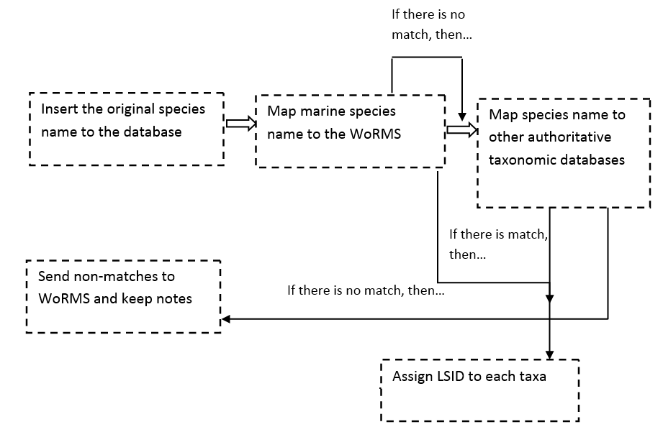

Figure 26: Taxonomic Quality Control Diagram

#### Spatial quality control.

The given coordinates should be checked for possible errors. The coordinate system is used to refer to a specific point on the Earth and its corresponding point on the projected map, and is expressed as longitude and latitude values. These values can take several forms (decimal degrees, degrees/minutes/seconds, degrees and decimal minutes etc). For their import in the database the coordinates should be converted in a specific form (decimal degrees expressed in WGS84 geodetic reference coordinate system) by using the appropriate formula.

Afterwards, all sampling locations should be plotted on a map (e.g. Google earth, lifewatch data services) to perform a visual check if a. all sampling locations are in the marine (or terrestrial) environment and b. all spots belong to the described sampling area. If the geographic coverage would e.g. be Aegean Sea, but a number of data points are outside of this area, then the data provider needs to be contacted to check on possible errors. If data would originate from two different areas, then this should be mentioned in the notes field of this section.

Next steps will be to check for depth and coordinates precision information. This means linking sampling locations to depth information available (grid‐like approach) and to coordinate precision, expressed in meters. It is important to flag records with impossible depths and ask the provider for more information.

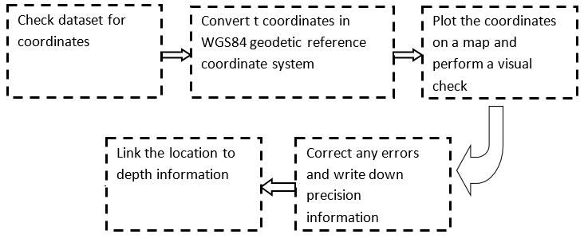

Figure 27: Special Quality Control Diagram

#### Station quality control

The information of each station needs to be validated. We search for this type of information in the dataset or the relevant papers, if any. We collect and import the original name of the station. As next step, we give a code name to each station as follows: DatasetID-original name. The purpose for this is to avoid duplications. For instance in many datasets the station name is referred as Station A, Station B etc. Attention should be given not to confuse the station names with the sample names given by the data providers. The station name refers to the certain point(s) which is (are) selected in order a specific sampling activity to be implemented. In other words it is a physical location, described by its coordinates and any other information such as its depth, area description, habitat description etc.

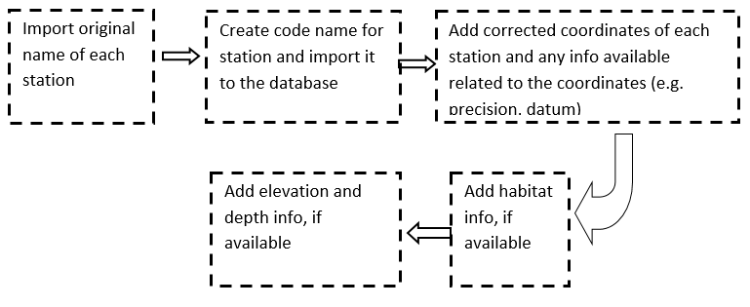

Figure 28: Station Information Quality Control

#### Date quality control

The dates included in the datasets need to be checked. We search for this type of information in the dataset or the relevant papers, if any. We collect and import the following data of sampling: start and end date, start and end time, start and end day of year and any remarks. Note that for date the ISO8601 is used.

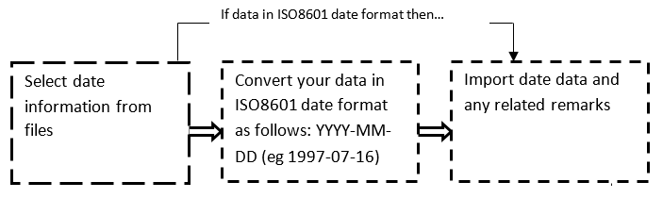

Figure 29: Date Quality Control Diagram

#### Sampling quality control

The protocol or method used for collecting the sample is useful information normally given to all datasets by the provider. A related piece of information is the surface area sampled. Check the dataset for this information and look for more details. For example, it is possible to have as information the persons who collected the sample and the steps followed and at which order for sampling analysis.

The collected sample could be accompanied by other information, such as sampling depth, sampling distance above surface and field notes. It is preferable to use as sample name not the original name, but an identifier for the sample e.g. Datasetid+sampleoriginal.

In some cases at the end of the code of the “sample name” field it is necessary to add the sampling date in order to distinguish the samples that are for example yearly or monthly distributed. For example add R1, R2 etc -to differentiate replicates-, add M1, M2, etc –to differentiate monthly distributions; in that case the number 1 corresponds to January, … and 12 s to December- , and finally add Y92,Y 94 etc- to differentiate yearly distributions-.

#### Measurements quality control.

During this step the environmental/ biological measurements are checked. A possible mistake with the units is to compare results with different units. While entering the result values is necessary to check with data provider if “0” is referring to presence/ absence or it is an actual value.

It is important, that validation tests do not uncritically delete data because they are found to be statistical outliers. Environmental data for example are notorious for records that appear to be outliers statistically but which are perfectly good records. This may be due to historical evolutionary patterns, changing climate regimes, a remnant following human activities, etc. The uncritical exclusion of outliers can remove valuable records from the dataset and skew future analyses (Chapman, A. D. 2005. Principles of Data Quality, version 1.0. Report for the Global Biodiversity Information Facility, Copenhagen, 2005)

## Biovel’s Data Refinement Workflow

Biovel’s Data Refinement Workflow[12] is being used for providing data quality improvement of the data to be uploaded. This workflow receives as input a data in *.csv format and uses a number of graphical user interfaces to view and interact with the data. Records in the CSV file essentially consist of either (a) a list of taxonomic names or (b) a set of occurrence observation records. The documentation and manual of the workflow are available online[13]. The data refinement workflow is composed of three distinct steps:

1. **Taxonomic Name Resolution / Occurrence retrieval**: A list of scientific names, using taxonomic checklists, can be resolved and this process has as a result the retrieval of taxonomic information related to each scientific name, like synonyms, rank, classification etc. This information can be used to improve the quality and enrich the datasets that are submitted to the infrastructure.
2. **Geo-temporal data selection**: At this step the user selects, filters, and refines data records according to spatial and temporal criteria. BioStif is used to provide this functionality.
3. **Data quality checks / filtering**: At this step the user can perform cleaning and filtering of the data. Google Refine is used to provide these functionalities. The functionalities that are provided by Biovel’s Data Refinement workflow regarding data cleaning and refinement are:
   * Taxonomic data cleaning of spelling errors
   * Taxonomic data cleaning
   * Taxonomic name resolution and add taxonomic classification to your species list
   * Taxonomic refinement to in/exclude certain groups
   * Geographic and temporal refinement
   * Ecological refinement

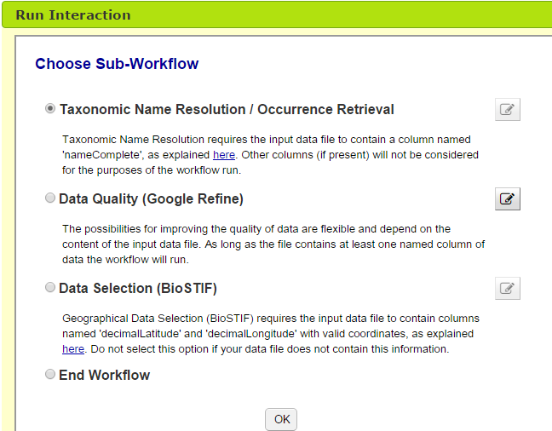

Figure 30: First Window of Interaction – Biovel’s DRW

#### Integration in LW Greece Infrastructure

The quality control service consists of four main components. The database, where the raw datasets are stored, can be either the providers databases or the Lifewatch Infrastructure Content Storage. The querying tools receive as input queries and provide us output information about how to access the required datasets. Biovel’s Data Refinement Workflow which receives as input *.csv files and provides as output the refined *.csv files after the execution of the sub-workflows such as data cleaning, taxonomic name resolution and geo – spatial data selection. The ingest tool receives as input the refine datasets and the related metadata, and stores the datasets into the data storage and the metadata into the directory and the metadata repository.

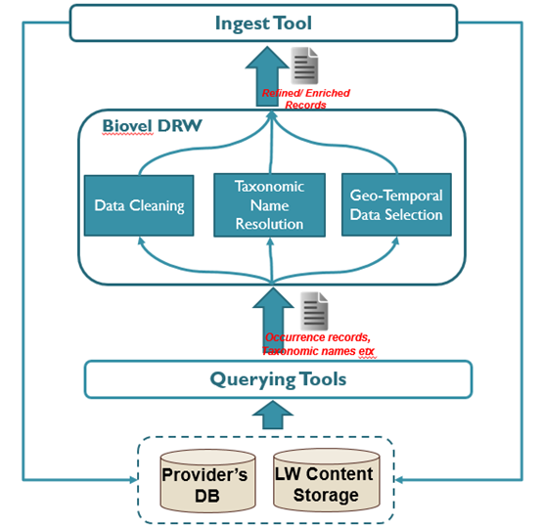

Figure 31: Quality Improvement Service Design

#### Usage

The user logins to the Lifewatch Portal and either searches the infrastructure for occurrence/taxonomic datasets either uses his/her own datasets as input to the Biovel’s Data Refinement Workflow. The user performs a number of actions such as Taxonomic data cleaning of spelling errors or Taxonomic name resolution. After the quality improvement/enrichement of the datasets finishes the user is able to download the refined *.csv dataset files and upload them in the infrastructure.

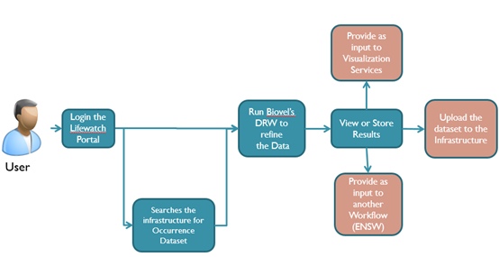

Figure 32: Quality Service User Scenario

# Morphological Characteristics Annotation Service

In this section we present the Morphological Annotation REST API, a service that allows the annotations of a species URIs using the morphological traits contained in the Polytraits**[14]** biological traits database.

This service is based on the current**[15]** working draft of the Web Annotation Data Model**[16]** as its data model that describes a structured model and format to enable annotations to be shared and reused across different hardware and software platforms. The Web Annotation Data Model, allows the modeling of common use cases in a simple and convenient manner, while at the same time enabling more complex requirements, including linking arbitrary content to a particular data point or to segments of timed multimedia resources. The specification provides both a conceptual model that accommodates these use cases, and the vocabulary of terms that represents it. For the creation and consumption of annotations, a specific JSON format (JSON-LD**[17]**) is recommended, which is what the implement services use as the default content type for requests and responses.

Additionally, when possible the Annotation REST services conform to the first draft version**[18]** of the Web Annotation Protocol**[19]**. The Web Annotation Protocol describes a series of transport mechanisms for creating, managing, retrieving and searching for annotations, as well as notifying systems of these events. Annotations in this specification follow the data model, vocabulary and serialization requirements of the Web Annotation Data Model.

The implementation of the Morphological Annotation REST API uses the anno4j**[20]** library for accessing the annotations. Specifically, anno4j is a library partially created in the context of the MICO**[21]** FP7 project that allows the programmatic access for reading and writing Web Annotation Data Model / Open Annotation Data Model annotations. The annotations can be persisted on either local or remote SPARQL endpoints while it provides an easy-to-use query API based on the path query language LDPath**[22]**. A number of contributions were also made in the anno4j project in the form of bugs and code submissions through its public github repository. The current implementation of the anno4j inserts annotations into the default graph. Unfortunately since the Virtuoso triple store doesn't have an explicit unnamed default graph, we have tested our implementation using the Blazegraph**[23]** triple store.

## Example of a Stored Morphological JSON-LD Annotation

An example of a Morphological Annotation stored in the triplestore is given in Figure 1. This specific annotation targets the [*http://dbpedia.org/page/Yellowfin_tuna*](http://dbpedia.org/page/Yellowfin_tuna) species. The important part of the annotation is the type of the annotation's body, which should be based on the Polytraits database (in our example "@type":"[*http://purl.obolibrary.org/obo/CMO_0000013*](http://purl.obolibrary.org/obo/CMO_0000013)", which is a measurement of the longest dimension of a body, typically between two distinct ends of the body) and its value, which should also be based on the available traits of the Polytraits database ( in our example "value":"[***http://polytraits.lifewatchgreece.eu/terms/BS_7***](http://polytraits.lifewatchgreece.eu/terms/BS_7)", i.e. it is bigger than 100mm). The rest information includes the user that created the annotation, the software agent that serialized it, the times of creation and serialization, etc.

## Description of Services

The API uses two resource types, the collection resource **annotations** and the individual **annotation** resources contained in these collections. These resources can be manipulated using HTTP methods.

|  |  |  |
| --- | --- | --- |
| Method | Resource | Functionality |
| POST | Collection | Create annotation |
| GET | Annotation | Retrieve annotation |
| GET | Collection | Retrieve {all, with specific UUID, of a specific user and/or target, of a specific type} annotations |
| PUT | Annotation | Update specific annotation |
| DELETE | Annotation | Delete specific annotation |

The default content type is application/ld+json, and the server accepts JSON-LD data and provides responses in JSON-LD.

The following status codes apply across methods:

* 200 - OK
* 201 - Created
* 400 - Bad Request on any client error (e.g. Malformed JSON-LD)
* 404 - Not Found if a referenced resource does not exist.

The following examples assume that the REST service has been deployed in **http://localhost:8084/LifeWatchAnnotation/**

#### Creation of Annotation

|  |  |
| --- | --- |
| **Action** | **Create Annotation** |
| **Resource** | **http://localhost:8084/LifeWatchAnnotation/annotations/** |
| **Method** | **POST** |
| **Input** | A Web Annotation annotation in JSON-LD format.  "@context":"https://raw.githubusercontent.com/w3c/web-annotation/gh-pages/jsonld/anno.jsonld",  "@type":"oa:Annotation",  "body":{  "@type":"http://purl.obolibrary.org/obo/CMO_0000013",  "value":"http://polytraits.lifewatchgreece.eu/terms/BS_7"},  "target":{  "@id":"http://dbpedia.org/page/Yellowfin_tuna"}  } |
| **Output** | **200 OK** Status and the stored annotation in JSON-LD format (like the one shown in the following figure if a valid JSON-LD input, else in case of a malformed JSON-LD input returns **400 Bad Request** Status. |
| **Description** | This method takes a JSON-LD annotation as an input and returns the stored JSON-LD if the input is a valid Polytraits Web Annotation. The creation of an annotation conforms to <http://www.w3.org/TR/annotation-protocol/#create-a-new-annotation> |

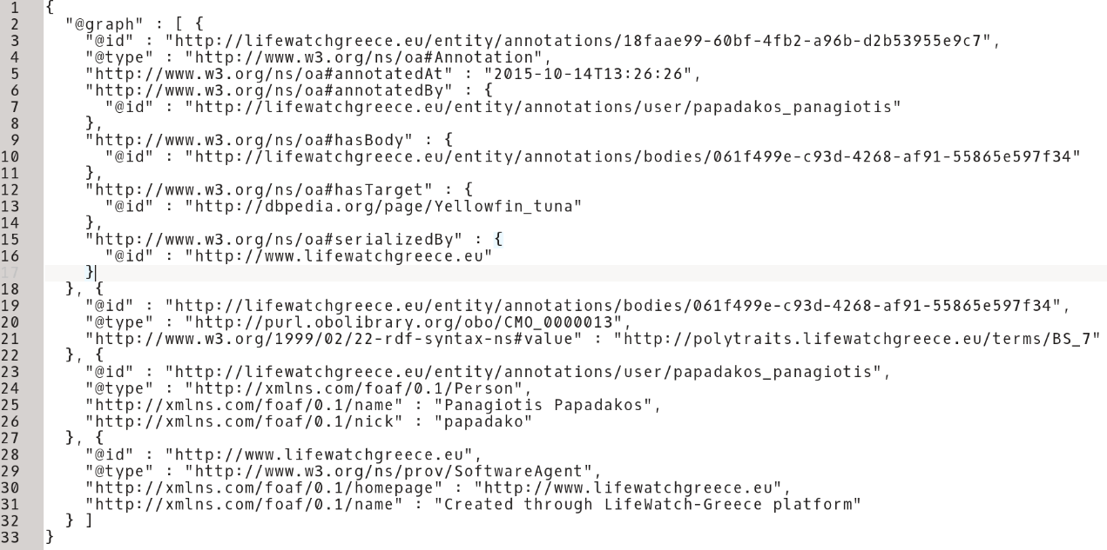

Figure 33: Example of a Morphological Annotation targeting http://dbpedia.org/page/Yellowfin_tuna

#### Retrieval of Annotations

|  |  |
| --- | --- |
| **Action** | **Retrieve All Annotations** |
| **Resource** | **http://localhost:8084/LifeWatchAnnotation/annotations/** |
| **Method** | **GET** |
| **Input** | - |
| **Output** | **200 OK** and all stored annotations in JSON-LD format |
| **Description** | This method returns a JSON-LD representation of all the annotations stored in the triple store. There is no corresponding action in the Web Annotation Protocol. |

|  |  |
| --- | --- |
| **Action** | **Retrieve Annotation with ID *“UUID”*** |
| **Resource** | **http://localhost:8084/LifeWatchAnnotation/annotations/*”f043a664-a2cf-4a6a-9018-4d1f45b47cd0”*** |
| **Method** | **GET** |
| **Input** | The “*UUID”* of an annotation. in this example “*f043a664-a2cf-4a6a-9018-4d1f45b47cd0”* |
| **Output** | **200 OK** and the stored annotation with “*UUID”* in JSON-LD format if annotation is found, else **404 Not Found** Status. |
| **Description** | This method takes the *“UUID”* of an annotation as an input and returns the stored JSON-LD representation if such an annotation exists. The retrieval of an annotation with specific “*UUID”* conforms to <http://www.w3.org/TR/annotation-protocol/#retrieve-a-known-annotation> |

|  |  |
| --- | --- |
| **Action** | **Retrieve Annotations of User with ID “*userID”*** |
| **Resource** | **http://localhost:8084/LifeWatchAnnotation/annotations/user/*”papadako”*** |
| **Method** | **GET** |
| **Input** | The “*userID”* of the user whose annotations we want to retrieve. In this example the userID is “*papadako”*. |
| **Output** | **200** **OK** and the stored annotations created by user with id *“userID”* in JSON-LD format if annotations are found , else **404 Not Found** Status. |
| **Description** | This method returns a JSON-LD representation of all the annotations stored in the triple store created by the user with “*userID*”. There is no corresponding action in the Web Annotation Protocol. |

|  |  |
| --- | --- |
| **Action** | **Retrieve Annotations with Target *“targetURI”*** |
| **Resource** | **http://localhost:8084/LifeWatchAnnotation/annotations/target/?uri=http%3A%2F%2Fdbpedia.org%2Fpage%2FYellowfin_tuna** |
| **Method** | **GET** |
| **Input** | The *“targetURI”* of which annotations we want to retrieve. In this example “[**http://dbpedia.org/page/Yellowfin_tuna**](http://dbpedia.org/page/Yellowfin_tuna)*”* |
| **Output** | **200** **OK** and the stored annotations targeting target with URI *“targetURI”* in JSON-LD format if annotations are found, else **404 Not Found** Status. |
| **Description** | This method returns a JSON-LD representation of all the annotations stored in the triple store, targeting the URI “*targetURI”*. There is no corresponding action in the Web Annotation Protocol. |

|  |  |
| --- | --- |
| **Action** | **Retrieve Annotations with Target *“targetURI” of* User with ID “*userID”*** |
| **Resource** | [*http://localhost:8084/LifeWatchAnnotation/annotations/user/papadako/target/?uri=http%3A%2F%2Fdbpedia.org%2Fpage%2FYellowfin_tuna*](http://localhost:8084/LifeWatchAnnotation/annotations/user/papadako/target/?uri=http%3A%2F%2Fdbpedia.org%2Fpage%2FYellowfin_tuna)  **OR**  [*http://localhost:8084/LifeWatchAnnotation/annotations/target/user/papadako/?uri=http%3A%2F%2Fdbpedia.org%2Fpage%2FYellowfin_tuna*](http://localhost:8084/LifeWatchAnnotation/annotations/user/papadako/target/?uri=http%3A%2F%2Fdbpedia.org%2Fpage%2FYellowfin_tuna) |
| **Method** | **GET** |
| **Input** | The *“”userID”* and the*“targetURI”* of the annotations we want to retrieve. In this example the target is *“*[**http://dbpedia.org/page/Yellowfin_tuna**](http://dbpedia.org/page/Yellowfin_tuna)*”* and the user is *“papadako”* |
| **Output** | **200** **OK** and the stored annotations targeting target with URI *“targetURI”* created by user *“userID”* in JSON-LD format, else **404 Not Found** Status. |
| **Description** | This method returns a JSON-LD representation of all the annotations stored in the triple store, targeting the URI “*targetURI”* and created by the user *userID”* . There is no corresponding action in the Web Annotation Protocol. |

|  |  |
| --- | --- |
| **Action** | **Retrieve Annotations of Type *“typeURI”*** |
| **Resource** | **http://localhost:8084/LifeWatchAnnotation/annotations/type/?uri=http%3A%2F%2Fpurl.obolibrary.org%2Fobo%2FCMO_0000013** |
| **Method** | **GET** |
| **Input** | The *“typeURI”* is the body type of the annotations we want to retrieve. In this example *“http://purl.obolibrary.org/obo/CMO_0000013”* |
| **Output** | **200 OK** Status and the stored annotations with body type of *“typeURI”* in JSON-LD format if annotations are found, else **404 Not Found** Status. |
| **Description** | This method returns a JSON-LD representation of all the annotations stored in the triple store that have a body type of “*typeURI”*. There is no corresponding action in the Web Annotation Protocol. |

#### Update of Annotation

|  |  |
| --- | --- |
| **Action** | **Update Annotation with ID “*UUID”*** |
| **Resource** | **http://localhost:8084/LifeWatchAnnotation/annotations/** |
| **Method** | **PUT** |
| **Input** | A Web Annotation annotation in JSON-LD format.  "@context":"https://raw.githubusercontent.com/w3c/web-annotation/gh-pages/jsonld/anno.jsonld",  “@id”:http://localhost:8084/LifeWatchAnnotation/annotations/7d3292b7-90c5-4a2a-bc1c-37555eb5126c  "@type":"oa:Annotation",  "body":{  "@type":"http://purl.obolibrary.org/obo/CMO_0000013",  "value":"http://polytraits.lifewatchgreece.eu/terms/BS_7"},  "target":{  "@id":"http://dbpedia.org/page/Another_Target"}  } |
| **Output** | **200 OK** Status and the new updated stored annotation in JSON-LD format if a valid JSON-LD input and annotation with “*UUID”* exists, **204** **No Content** Status if such an annotation does not exist, else in case of a malformed JSON-LD input returns **400 Bad Request** Status. |
| **Description** | This method takes a JSON-LD annotation as an input and updates the stored annotation if the input is a valid Polytraits Web Annotation and the annotation *“UUID”* is valid. The update of an annotation conforms to <http://www.w3.org/TR/annotation-protocol/#update-an-existing-annotation> |

#### Deletion of Annotation

|  |  |
| --- | --- |
| **Action** | **Delete Annotation with ID “*UUID”*** |
| **Resource** | **http://localhost:8084/LifeWatchAnnotation/annotations/7d3292b7-90c5-4a2a-bc1c-37555eb5126c** |
| **Method** | **DELETE** |
| **Input** | The *“UUID”* of the annotation to delete |
| **Output** | **200** **OK** Status on successful deletion and **204** **No Content** Status if annotation with id *“UUID”* does not exist. |
| **Description** | This method takes a JSON-LD annotation as an input and updates the stored annotation if the input is a valid Polytraits Web Annotation and the annotation *“UUID”* is valid. The deletion of an annotation conforms to <http://www.w3.org/TR/annotation-protocol/#delete-an-existing-annotation> |

# Fundamental Querying Interface

To allow the users to exploit the Fundamental Categories/Relationship a Fundamental Query User Interface had to be included in the infrastructure. Initially a simple user interface that was implemented by the LW Greece team was included. The tight cooperation of FORTH and Metaphacts[24] in other European projects lead to the usage of the FQI[25] that Metaphacts is developing.

The platform was installed in LW Greece Servers and it was configured to apply to the LW Greece Needs. The main changes that took place on the code, the interface and the usage of the LW Greece FQI is described in the next sections.

## Materialization Details

In order to use the FQI that was developed from Metaphacts a materialization of the triple store contents was mandatory. To enable the materialization, that will take place after any uploading to or updating of the triple stores the following actions were performed.

1. A FR/FC top level schema was created that had every FC as a class and every FR as an object property. For example the FC Thing has been represented as *http://www.lifewatchgreece.eu/fc/thing*  and the FQ thing has met place has been represented as *http://www.lifewatchgreece.eu/fr/has_met with domain http://www.lifewatchgreece.eu/fc/thing*  and range *http://www.lifewatchgreece.eu/fc/place* . This schema was implemented in owl and the produced file was uploaded to the triple store.
2. 5 Materialization rules were created in SPARQL for each fundamental category. For example every Country, Water Area, Station etc is a *http://www.lifewatchgreece.eu/fc/place*
3. 29 Materialization rules were created in SPARQL for each fundamental relationship. A simplified example of these rules is shown below:

*INSERT INTO <http:// MaterializationGraph>{   
?thing <http://www.lifewatchgreece.eu/fr/has_met> ?locality  
}  
 WHERE  
{{  
?OccurrenceEventURI <http://www.ics.forth.gr/isl/CRMsci/O21_has_found_at> ?locality .  
?OccurrenceEventURI <http://www.ics.forth.gr/isl/CRMsci/O32_has_found_object> ?thing .  
}  
UNION  
{   
?IdentificationEventIDURI <http://www.cidoc-crm.org/cidoc-crm/P7_took_place_at> ?locality .  
?IdentificationEventIDURI <http://www.cidoc-crm.org/cidoc-crm/P41_classified> ?thing .   
}}*

1. A Materialization function was added to the API to enable the execution of the materialization rules in the triple store
2. A Materialize button was added to the admin instance of the Data Services Web Application.

## Configuration and Implementation

The Metaphacts FQI was installed in the servers of HCMR. The platform have been configured and the code has been changed to:

* Operate on the LW Greece Data Services domain
* Support the LifeWatch Greece FQ/FR schema
* Support the Virtuoso Triple Store
* Allow LW Greece users to access it
* Search with SPARQL filtering
* Adjust the interface’s appearance to the needs of LW Greece

Furthermore the links of the returned results have been configured to direct to the Data Services Portal, browsing page, to allow the users to retrieve more information about the entity and to navigate the semantic network.

The FQI have been integrated in the Data Services Web Application of the LW Greece’s Portal.

## Usage

The FQI is highly user friendly and ease-to-use. The user selects from the main menu the domain Fundamental Category by clicking on the corresponding icon:

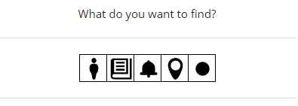

Figure 34: FQI Main Menu

Afterwards the user selects the range FC and the fundamental relationship between the domain and the range.

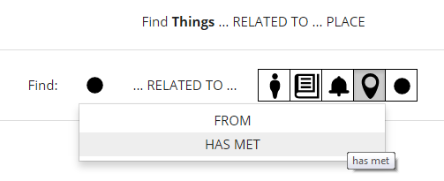

Figure 35: Selection of Fundamental Relationship

The user can type a range’s instance label, and it’s been autocompleted. After the selection of one of the labels the results are returned with links to the entities’ browsing pages. An example of searching about things that have met Greece is shown in the next figure.

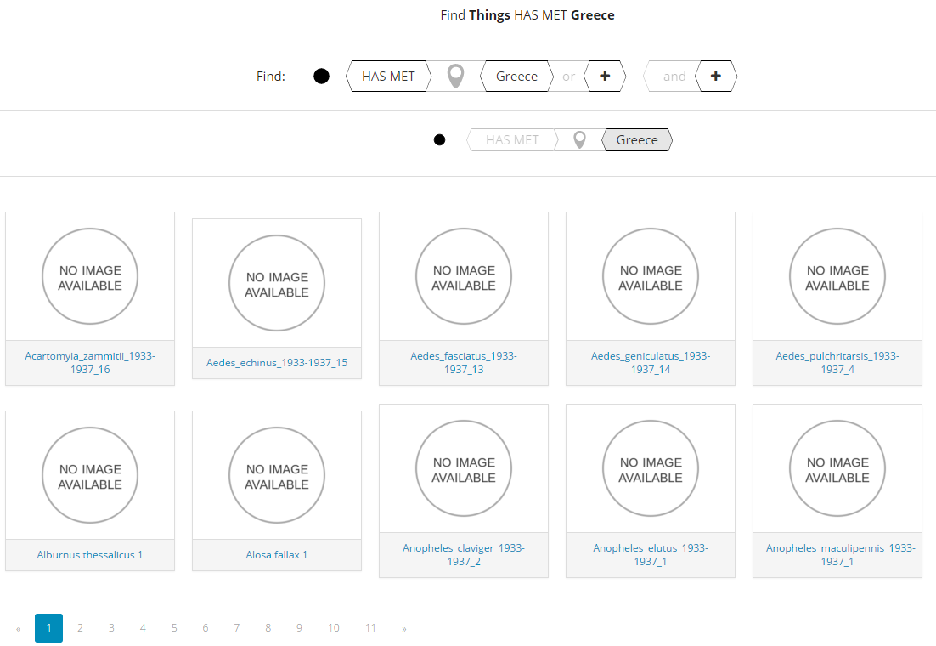

Figure 36: Things that have met Greece FQI results

# Data Services Web Application

To provide the users of LifeWatch Greece the functionalities of the Data Services, a Web Application has been developed using the Data Services API and has been integrated to the Portal of the infrastructure. The Web Application is mainly developed using JSP, SERVLETS and Javascript. To access the Web Application the users have to subscribe to LifeWatch Greece, visit the portal and click on the Data Services Icon:

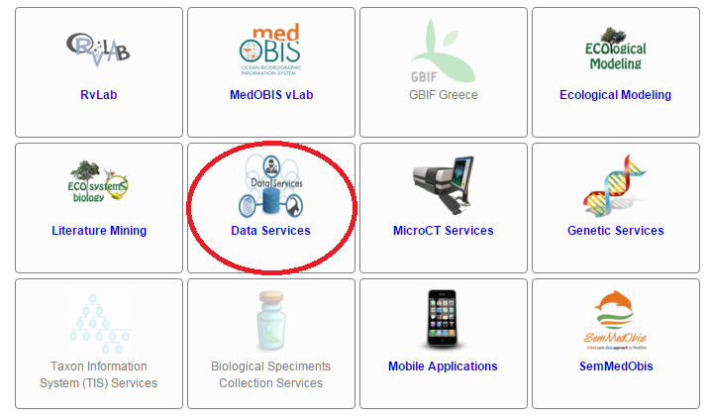

Figure 37: LW Portal – Data Services Link

The next sections describe the actions that can be performed in the Data Services Web Application.

## Data Publishing

The providers can publish their data and their metadata through the Data Services Web Application. To access the publishing interface the user has to click on the publishing button of the Web Application menu:



Figure 38: Web Application Menu

The first step of the publication process is the Directory Entry, the description of the data resource. This can be done by filling the Dataset Description form (Figure 35). The mandatory fields are the *Dataset Name, Access Method, Owner, Curator, Curator e-mail and Dataset Logo*.

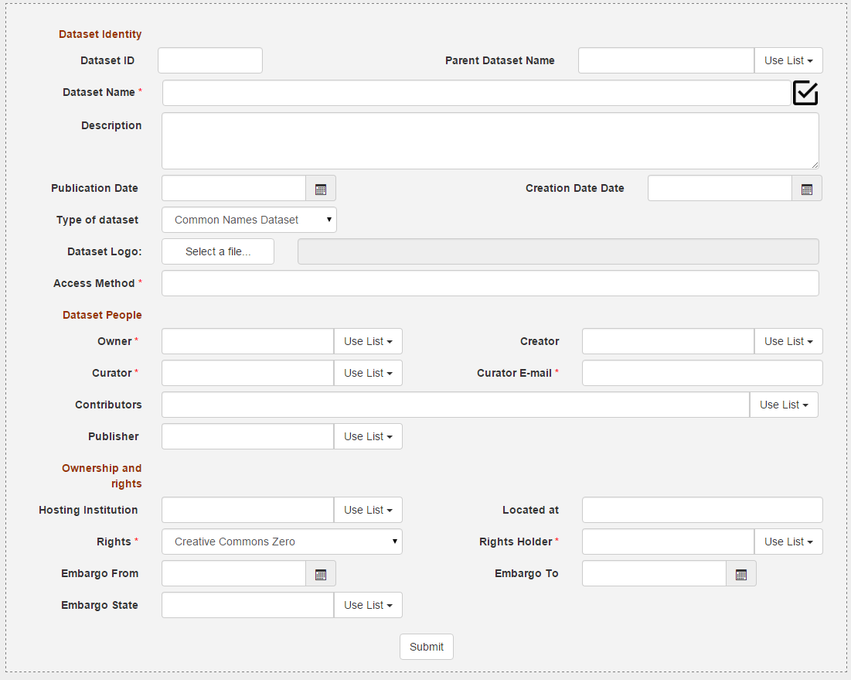

Figure 39: Dataset Description Form.

Alternatively the user can download the Data Collection template, fill it and then upload this template by the related form.

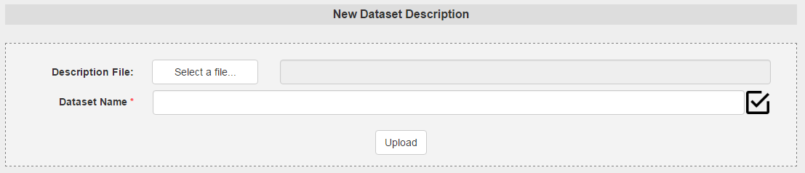

Figure 40: Data Description Template Upload Form

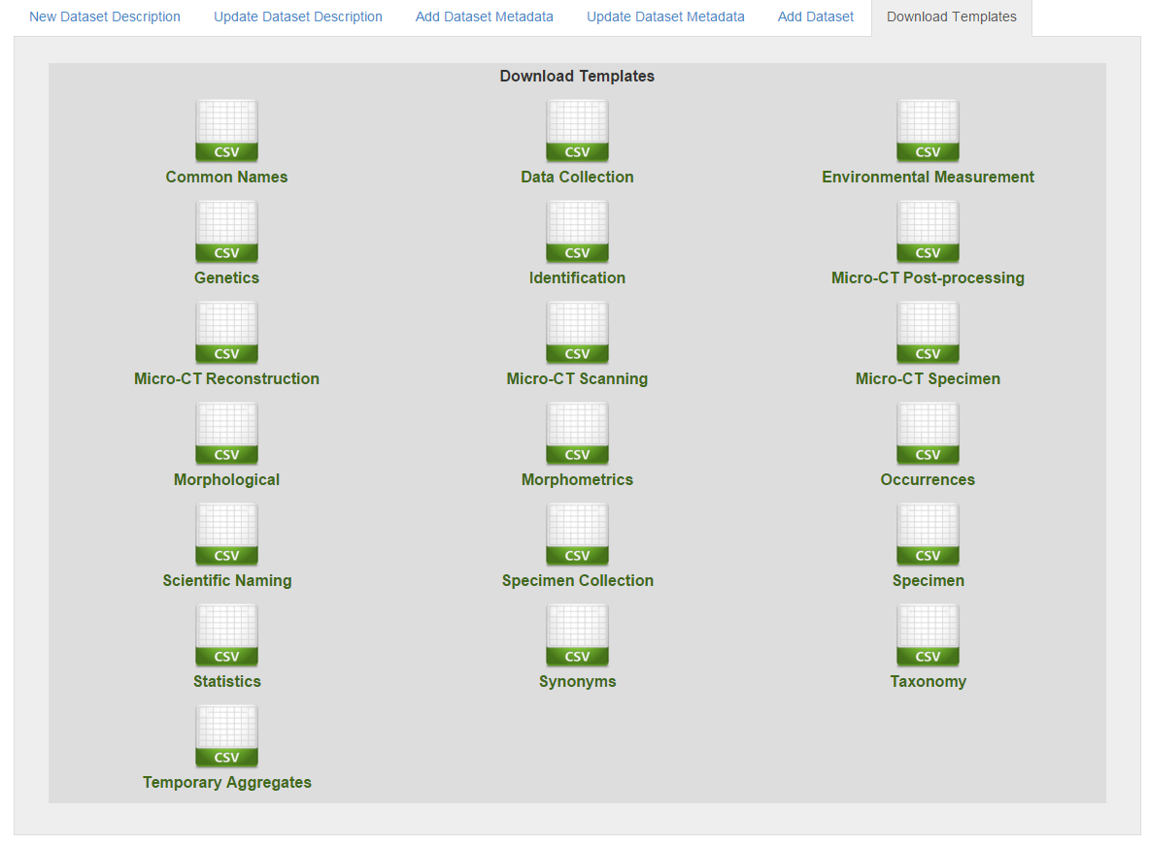

Figure 41: Metadata Templates

The second step is the publication of the metadata that enrich the information about the data resource. The user has to click on the Add Dataset Metadata tab, select the name of the Dataset that the metadata will refer to and the category of the metadata, and to upload the corresponding metadata template.

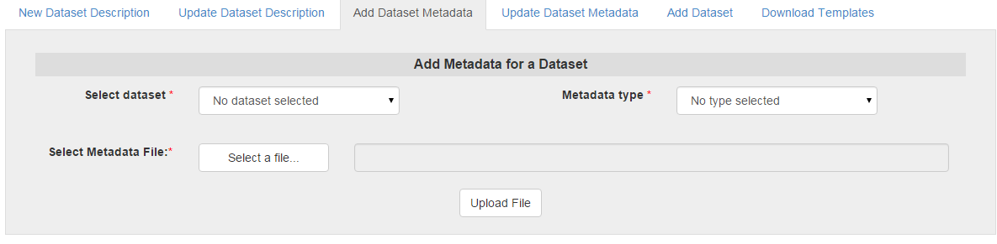

Figure 42: Dataset Metadata Uploading Form

The third step of the publishing workflow, is the publishing of the actual data resource, that can be done by uploading the dataset using the Add Dataset Form.

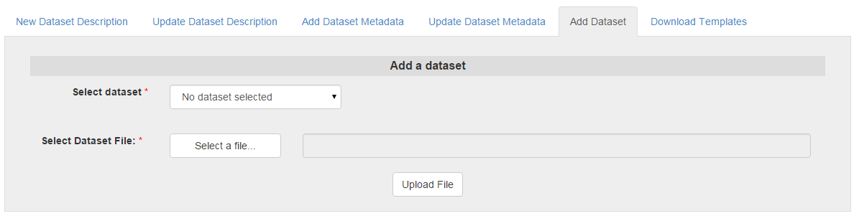

Figure 43: Add Dataset Metadata Form

## Data Updating

The users can update the metadata of the dataset by clicking on the Update Dataset Description tab, and choose the dataset of interest. The dataset description form will auto-complete and the users can change the desired information by click on the Submit button.

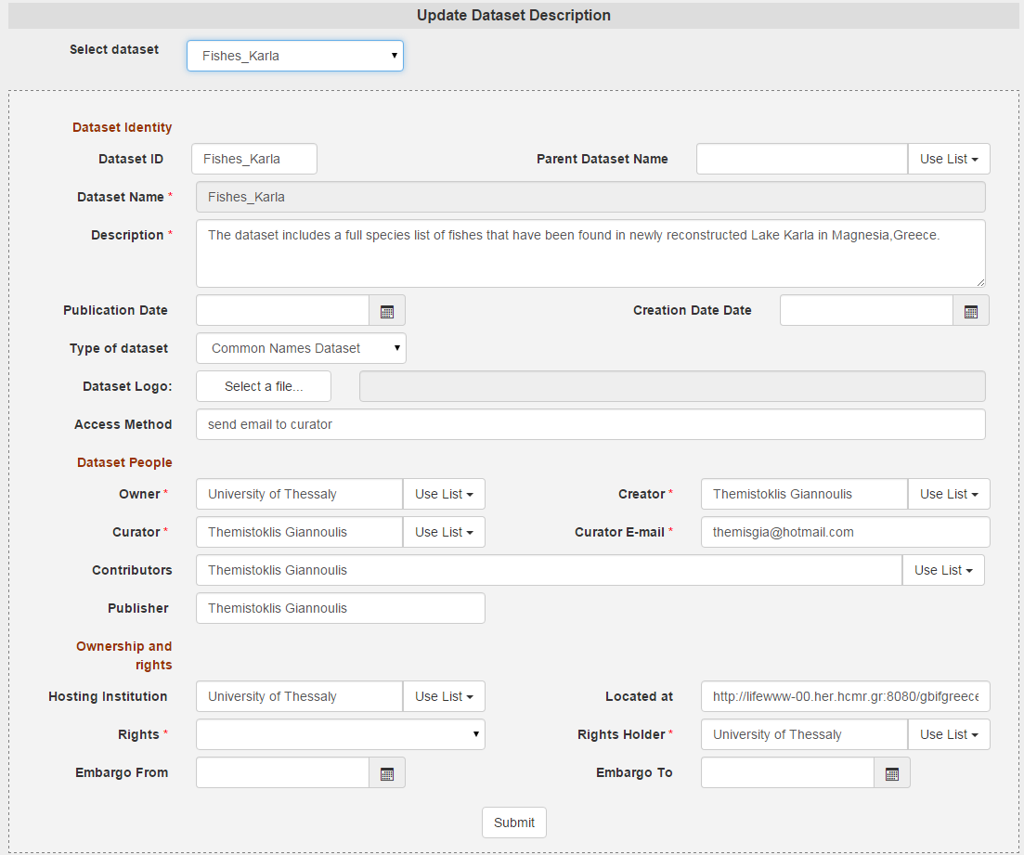

Figure 44: Update Dataset Description Form

## Data Searching

The Data Services web Application provides a number of search capabilities to the users. These are the Basic Search, which is actually a search on the Directory, the Advanced Search which gives the capability to the users to search on the Metadata Repository by selecting a metadata category, the Fundamental Search, which is exposing the Fundamental Relationships/Categories querying mechanisms, the browsing which takes as input a URI and enables a semantic graph navigation, the SPARQL querying execution on the SPARQL endpoint and the textual description production. All these functionalities are presented in details it the next sections.

#### Directory Search

The first searching functionality that is provided to the users through the Data Services Web Apllication is the Directory Search (Basic Search), which is the searching on the main metadata of a data resource. The users can search by :

* the name of the resource
* the owner
* the dataset type
* the dataset URI

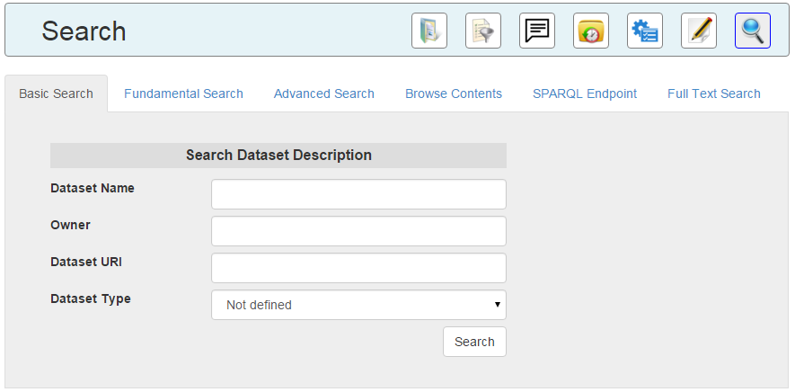

Figure 45: Directory Search Form

By clicking on search, the results are returned in a list, that uses paging, with the a subset of the information about each data resource. By clicking the download option the user can download the resource if it is available and if the user has the permissions.

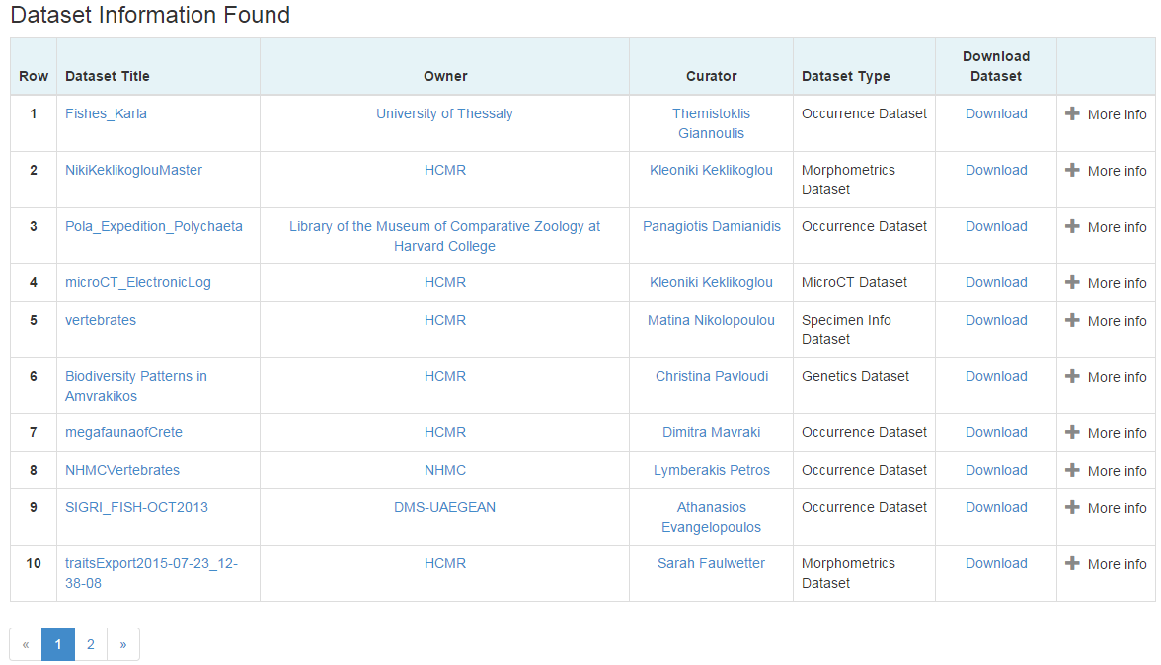

Figure 46: Directory Search Results

By clicking on the more info option all the information about the dataset is presented.

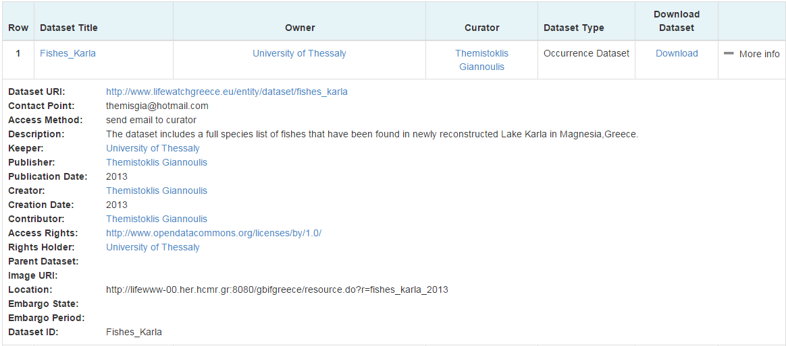

Figure 47: Directory Search Result Complete Information

#### Advanced Search

By using the advanced search option the users can search the directory by selecting one of the metadata categories, and filling the related form. For example for searching about occurrences the users can select the Occurrence metadata type, and search by the scientific name, the location and/or the year.

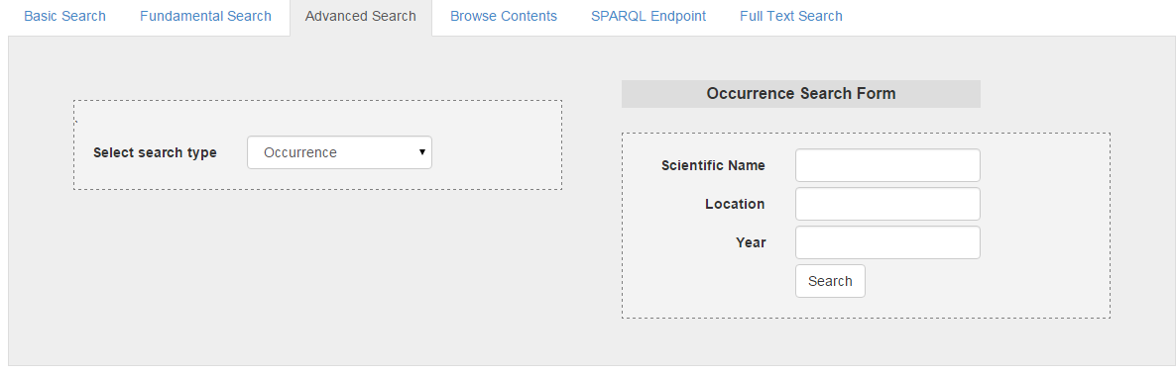

Figure 48: Occurrences Search Form

The results are returned in a list, using paging, with a subset of the information. By clicking the visit dataset option the users can be directed to the Directory Entry about the Dataset that the returned metadata refer to.

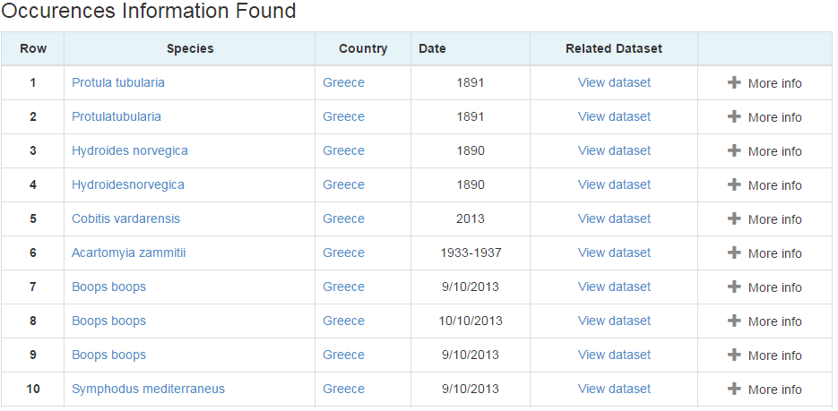

Figure 49: Occurrence Search Results

By clicking on more info all the information about the occurrence is returned:

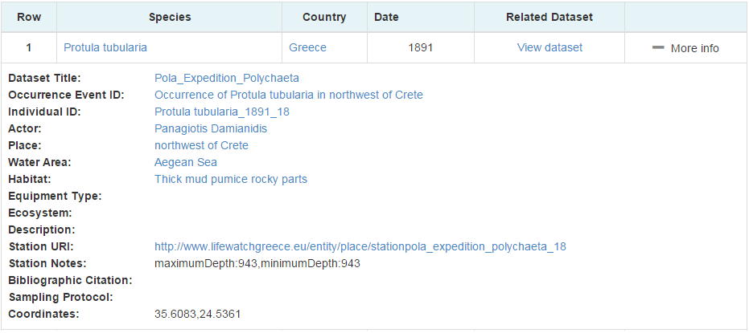

Figure 50: Occurrence Result Complete Information

Except from the occurrence search the users can search for:

* Common Names Information by:
  + Scientific Name
  + Common Name
  + Place of usage
  + Language
* Environmental Measurement Information by:
  + Dimension
  + Place
* Genetics Sampling/Sequencing by:
  + Scientific Name
  + Place
  + Dataset
  + Sample
* Identification Event Information by:
  + Scientific Name
  + Location
  + Actor
  + Date
  + Individual ID

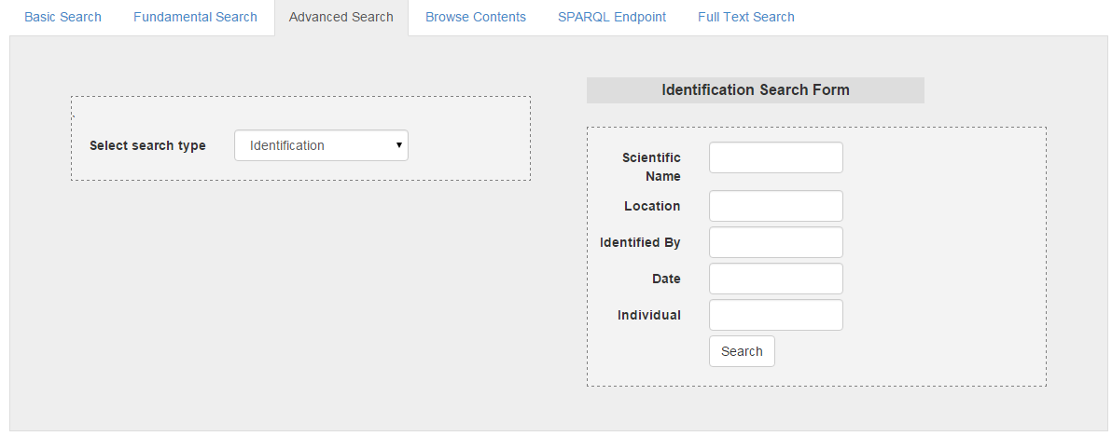

Figure 51: Identification Search Form

* Morphometrics Measurement Information by:
  + Scientific Name
  + Specimen ID
  + Dimension
* MicroCT Specimen Information by:
  + Scientific Name
  + Specimen ID
  + Collection
  + Provider
* MicroCT Scanning Information by:
  + Device
  + Scientific Name
  + Specimen ID
  + Enhancement Contrast Method

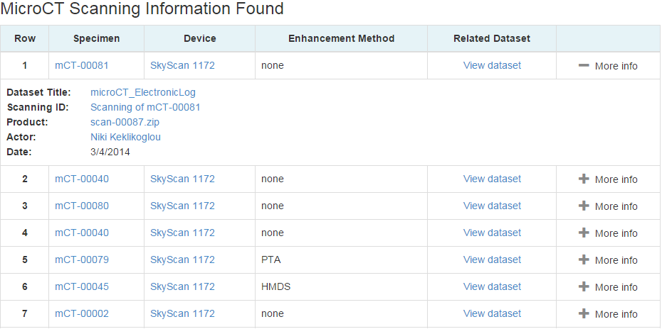

Figure 52: Micro CT Scanning Results

* MicroCT Reconstruction Information by:
  + Scientific Name
  + Specimen ID
  + Input
* MicroCT PostProcessing Information by:
  + Scientific Name
  + Specimen ID
  + Input
* Morphological Characteristics Information by:
  + Scientific Name
  + Attribute
* Scientific Name Information by:
  + Scientific Name
  + Species ID
  + Name
  + Authority
* Specimen Collection Information by:
  + Collection Name
  + Owner
* Specimen Information by:
  + Scientific Name
  + Specimen ID
  + Collection Name
* Statistical Information by:
  + Scientific Name
  + Dimension
* Synonyms Information by:
  + Scientific Name
  + Species ID
  + Synonym
* Taxonomic Information by:
  + Species
  + Genus
  + Class
  + Family
  + Phylum
  + Kingdom

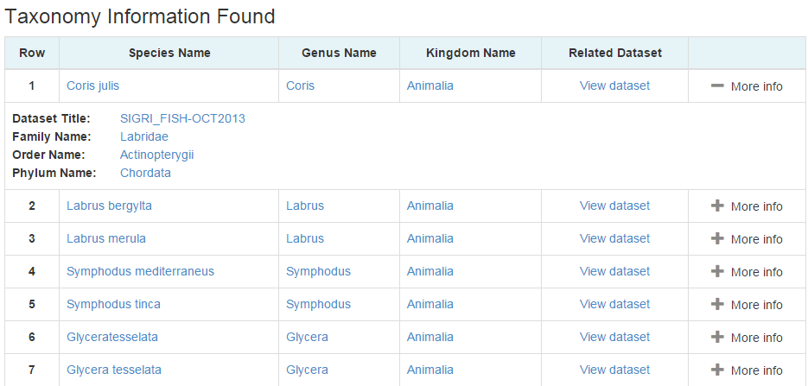

Figure 53: Taxonomic Information Results

#### Browsing – Navigating the Semantic Graph

Almost every result that is returned by the searching functions is a link. These links are created by using the unique identifiers that we produced and by using a number of browsing functions that we implemented by clicking it someone can find more information about the entity and navigate the semantic graph. So, for example by clicking on the individual id Protula tubularia_1891_18 of the related occurrence event more information about this entity are returned, such as the type of it, the label, the events that it participated etc. The results are returned as incoming and outgoing relationships to and from the entity of interest, along with the types of the objects/subjects. These results, of course, are also clickable giving the users the capability to navigate the semantic graph and the contents of the infrastructure’s databases.

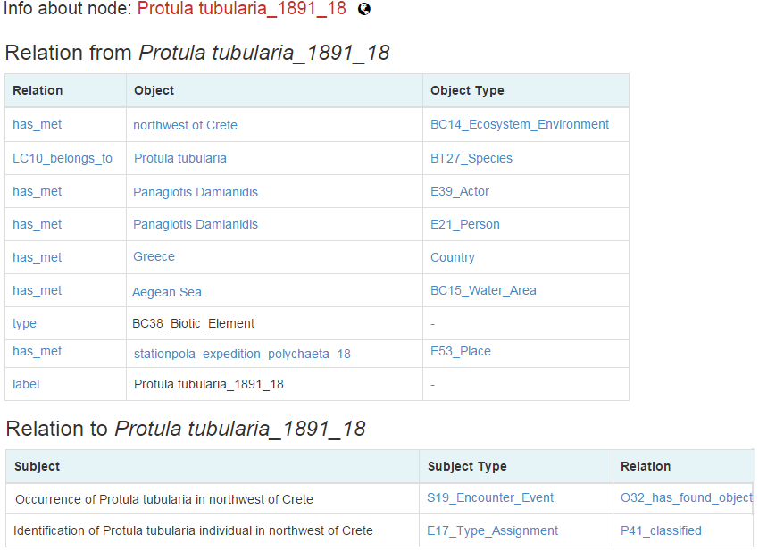

Figure 54: Browsing the Semantic Graph Result

Furthermore, a form has been added to the Web Application to allow the users to enter a URI of a resource and start browsing the semantic graph, without having to perform another search previously.

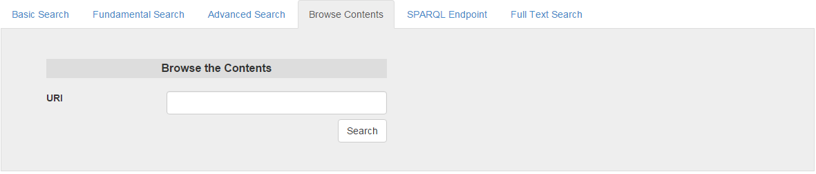

Figure 55: Browse the Semantic Graph Form

#### Fundamental Search

The Fundamental Searching has been also integrated to the Web Application, enabling fundamental relationships/categories based search. The fundamental search user interface has been described in details in section 8.

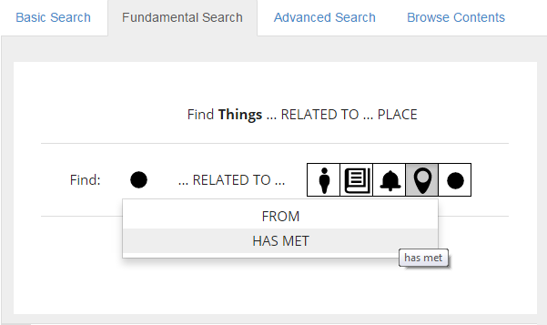

Figure 56: Fundamental Querying Interface in the Portal

#### Textual Description Representation

By using standard templates it was made possible to return information about a specific concept in **natural** language. The user can insert a scientific name and take back as a story or as a Wikipedia entry the aggregated information. All this text is produced automatically. For example if a user enters the name alburnus thessalicus the result that is shown in the next figure will be returned. Every link is an entity that is extracted by our databases and is clickable allowing browsing the same way that was described in the section 9.3.4.

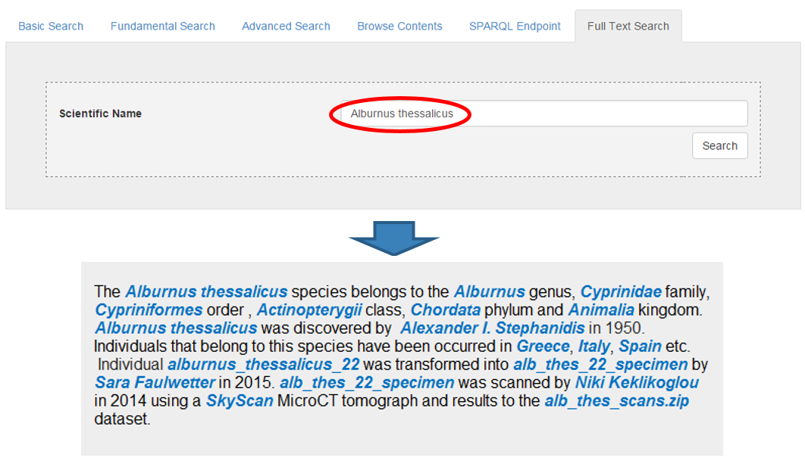

Figure 57: Textual Description Example

#### SPARQL Endpoint

The SPARQL endpoint is also available to the users through the Web Application. The users can formulate and run their own SPARQL queries and retrieve any results that they desire from the Directory and the Metadata repository, independently by the searching functions that the infrastructure provides.

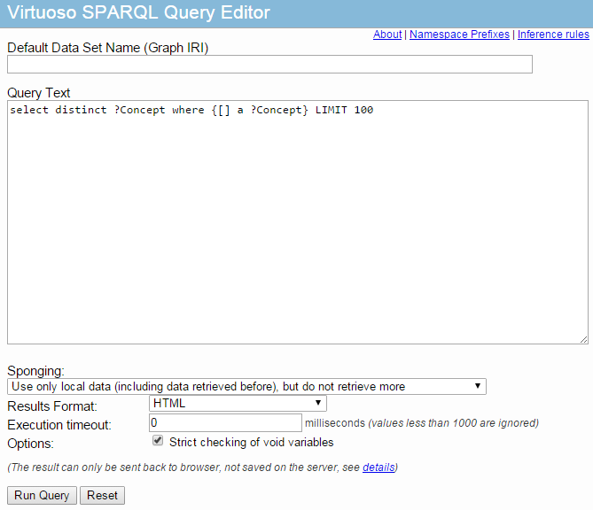

Figure 58: SPARQL endpoint

## Morphological Characteristics Data Annotation

By clicking on the Annotate button of the menu the users can annotate species by selecting a number of morphological characteristics. The annotation service is described in Section 7.

## Data Refinement

By clicking on the Data Refine button of the menu the users can use the biovel’s Data Refinement Workflow to perform data refinement actions on their datasets before uploading them to the infrastructure. These Actions include:

* **Taxonomic Name Resolution / Occurrence retrieval**: A list of scientific names, using taxonomic checklists, can be resolved and this process has as a result the retrieval of taxonomic information related to each scientific name, like synonyms, rank, classification etc. This information can be used to improve the quality and enrich the datasets that are submitted to the infrastructure.
* **Geo-temporal data selection**: At this step the user selects, filters, and refines data records according to spatial and temporal criteria. BioStif is used to provide this functionality.
* **Data quality checks / filtering**: At this step the user can perform cleaning and filtering of the data. Google Refine is used to provide these functionalities. The functionalities that are provided by Biovel’s Data Refinement workflow regarding data cleaning and refinement are:
  + Taxonomic data cleaning of spelling errors
  + Taxonomic data cleaning
  + Taxonomic name resolution and add taxonomic classification to your species list
  + Taxonomic refinement to in/exclude certain groups
  + Geographic and temporal refinement
  + Ecological refinement

The detailed documentation and user manuals of the workflow are available at: https://wiki.biovel.eu/display/doc/Data+Refinement+Workflow;jsessionid=3A7E1196FBF30C29A84C2D51A08FBE8B

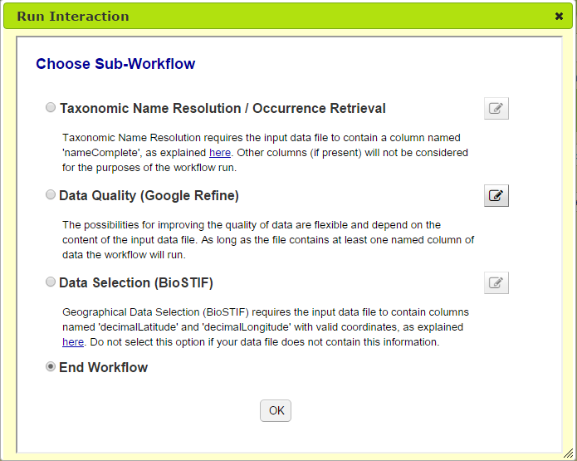

Figure 59: Biovel’s DRW – refinement selection

## Administrator Actions

To assist the administrator with tasks such as the managing of the infrastructure’s main components, configuring the system, recovering from failures, materializing the triple stores, and furthermore to make the infrastructure as generic as possibly, decoupled from the underlying components, a number of pages visible exclusively to the administrators have been included in the Web Application.

In the system configuration page the administrator can change parameters as, the metadata repository’s graph and port, the triple store’s credentials, the content storage’s paths, the temp folders names, the number of paging results etc.

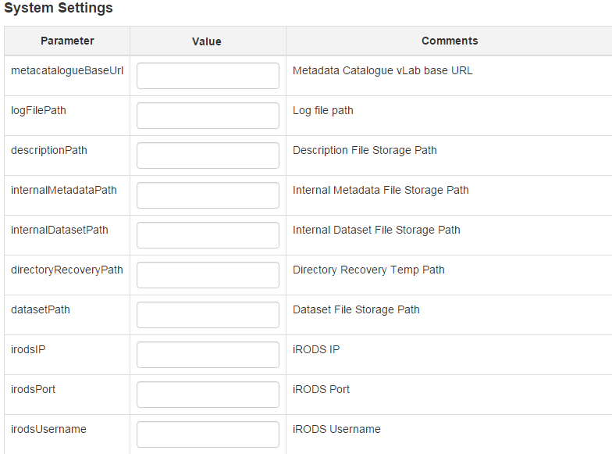

Figure 60: System Configuration Form

The administrator can also choose to rebuild the Directory or the Metadata Repository in case of failure or to materialize the triple store based on the materialization rules.

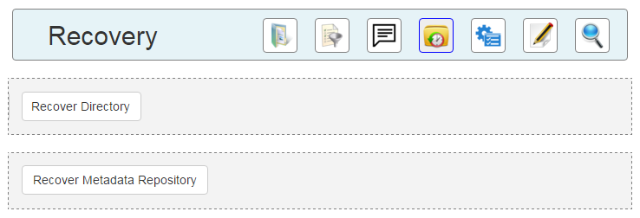

Figure 61: Recovery Actions

## Documentation

By clicking on the Documentation button of the menu the users can download, manuals, presentations and detailed documentation of the Data Services API, Web Services, Web Application, Modelling, Schemata, Publications etc.

# Usage and Evaluation

This section describes the evaluation, testing and the usage of the Data Services, and the usage of Data Services API, Web Services and Web Application. Specifically the integration of information, the performance and the scalability of the Data Services have been tested except the junit testing that has been included in the API. The main usage of the Data Services is through the LifeWatch Portal, but also other e-services of the infrastructure are exploiting the functionality that the data services offer, and a number of European Projects have adopted design principles, and implementation specifications.

## Population

The Data Services Web Application that has been integrated in the LW Greece Portal have been populated with datasets and metadata coming from the Greek Biodiversity Community. This was the main scalability and functionality test of the Data Services since it is based on real data and scenarios. Specifically in the infrastructure, that is continuously being populated are contained information about almost:

* 100 datasets
* 700 Occurrence Events
* 100 Identification Events
* 100 Micro CT Scannings
* 100 Micro CT Reconstructions
* 50 Micro CT Posprocessings
* 100 Specimens
* 30 Environmental Measurement Events
* 200 Common Names
* 100 Scientific Names
* 200 Taxonomic Classifications
* 170 Synonyms

And a small number of genetic sampling and sequencing events, occurrence statistics, statistical evaluations, morphometric measurements, morphological characteristic assignments and specimen collections.

After the population of the infrastructure that was achieved by using the data publication services (testing them in the process), the search services have been testing performing in a the desired recall regarding both the recall rates and the response times.

## Integration Testing

The information integration that is being achieved by the semantic web technologies and the semantic models was tested in the earlier stages of the design and development by creating an integration examples and in the final stages by using the browsing capabilities that the Data Services web application offers.

#### Information Integration Initial Example

To test the information integration mechanisms 27 input files were used/created. The input files that were used to test the infrastructure consist of 13 biodiversity datasets and 14 metadata files, one for each dataset and one containing the data records metadata (Directory Services Entries). Specifically the biodiversity datasets that were used were:

* An occurrence records dataset
* An environmental measurements dataset
* A specimen measurement dataset
* A dataset about specimen collections
* A dataset about specimens
* An identification events dataset
* A micro CT scanning dataset
* A micro CT reconstruction dataset
* A micro CT postprocessing dataset
* A scientific names dataset
* A common names dataset
* A synonyms dataset
* A morphometrics dataset

These datasets were connected by a unique identifiers as shown to the following figure:

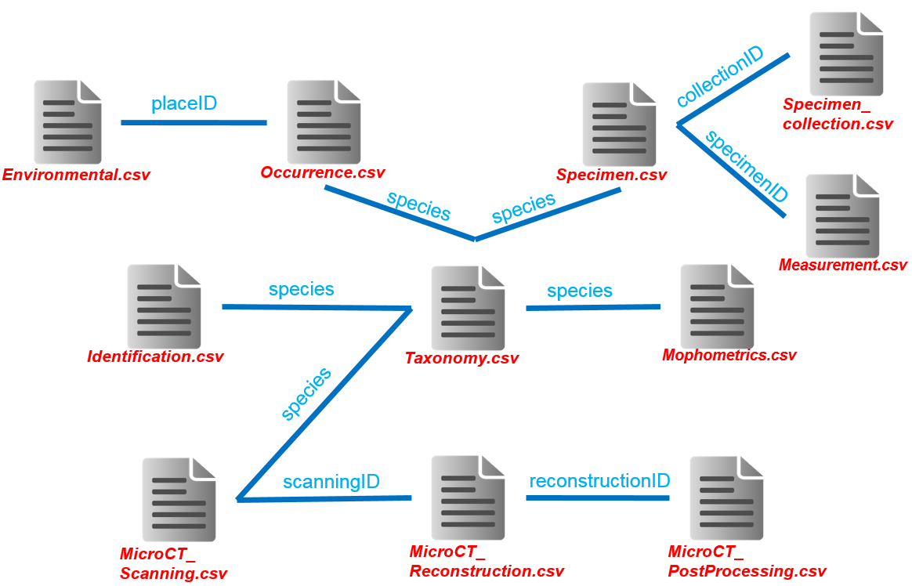

Figure 62: Biodiversity Datasets Linking

All these datasets were uploaded in the infrastructure and complex queries that combine information from different datasets were performed to test the information integration, the semantic models expressivity and the efficiency of the services.

#### Information Integration Last Example

The final test of information integration that was based on the Data Services Web App followed the scenario that a user searches for datasets that contain information about occurrences of species in the Mediterranean Sea.

The first action of the user is the selection of Occurrence Metadata category on the Advanced Search form and the filling of Mediterranean Sea in the location field.

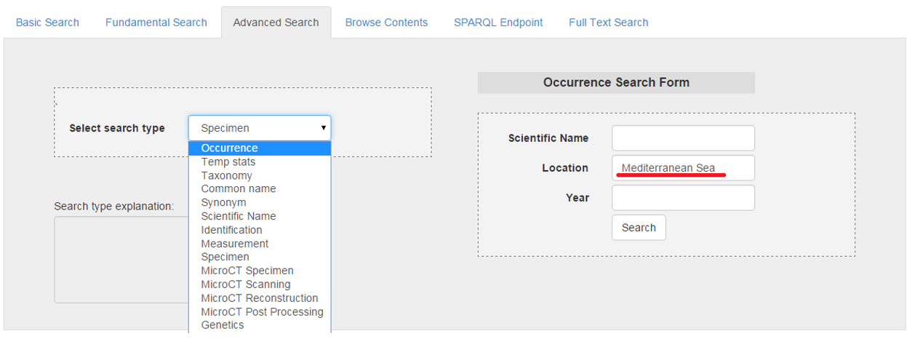

Figure 63: Selection of Occurrences of Species in the Mediterranean Sea

A list of all the Occurrence Events that took place in Mediterranean Sea are returned.

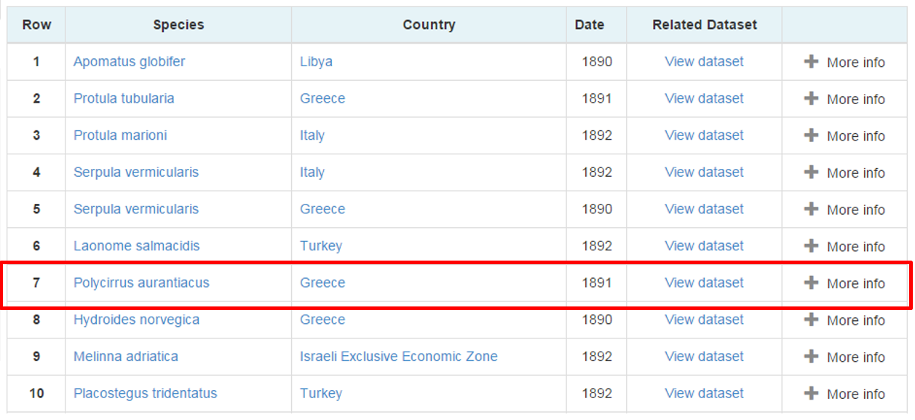

Figure 64: Occurrences in the Mediterranean Sea Search Results

We suppose that the user is interested in the Polycirrus aurantiacus occurrence event so by clicking more info more information about the event is returned to the user. By clicking on the view dataset the user will be redirected to the directory entry, find more information about the dataset that this event is described to and download it or access the curators/creators.

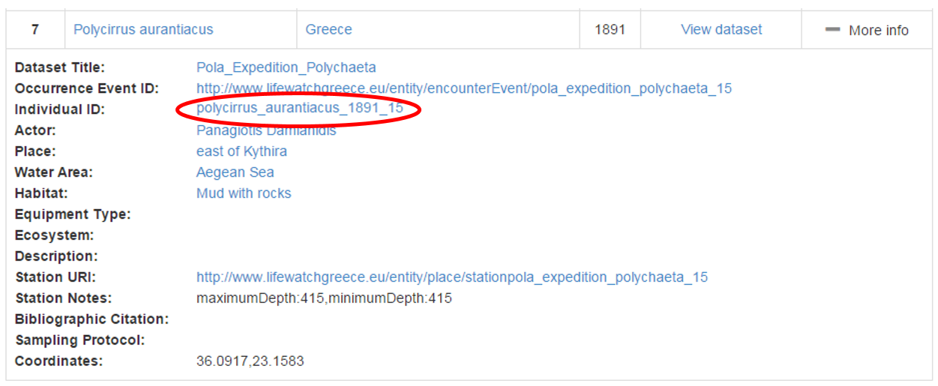

Figure 65: Occurrence’s Complete Information List

We further suppose that the user is also interested in the individual that was found during the occurrence event. So by clicking on its identifier (Polycirrus_aurantiacus_1981_15) the user is being directed to the entities browsing page.

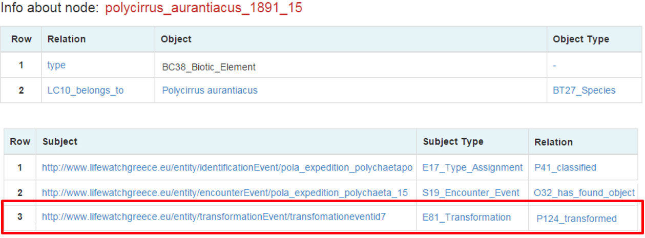

Figure 66: Polycirrus_aurantiacus_1981_15 browsing page

More data related to the individual is returned such as other events that it participated like an identification event. But the user is interested in a transformation event that the individual had participated.By clicking it the user is directed to a page about this event.

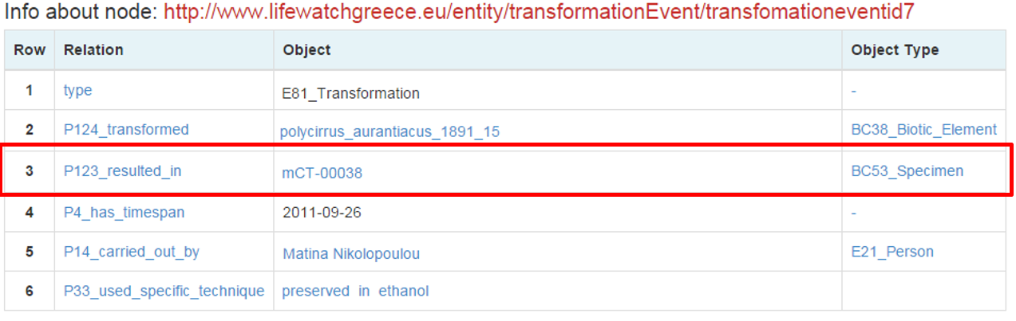

Figure 67: Transformation of Polycirrus_aurantiacus_1981_15 event

The user notices that the individual was transformed into a specimen by using a preservation in ethanol method and the new name is mCT-00038.

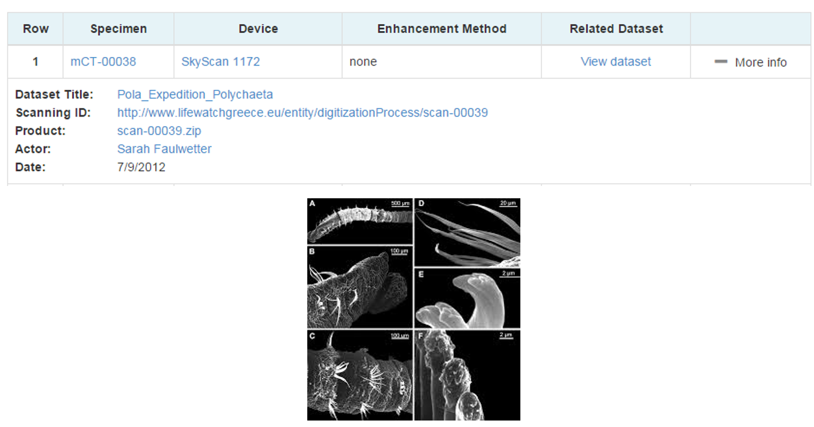

Figure 68: Scanning of Polycirrus_aurantiacus_1981_15’s specimen

By clicking on the specimen’s id the user finds out that it was scanned by a Skyscann MicroCT tomograph by Sarah Faulwetter in 2012 and a dataset was produced. The user can retrieve information about this dataset and download it.

Summarizing, the user initially desired to find datasets that contained information about occurrence events of species in Mediterranean Sea. He was able easily to discover the requested information but also by browsing the semantic network the user was able to find microCT scannings about the species of interest that come from a different institution, dataset and time and most probably the user ignored its existence. This was just a simple example of information integration, navigation to the semantic graph, unique identifier assignment and efficient discovery of dataset that we achieve in LW Greece data services.

## Performance Testing

In order to test the performance of the data services, synthetic data was produced based on biodiversity pattern templates. The size of the data was 10 Million triples which is ten times the expected size of the LifeWatch Greece data size. The triples were uploaded in the Directory and the Metadata repository and complex (fundamental) queries were executed. The results showed that the response times varied from some milliseconds to maximum 10 seconds and the recall rates to almost 90%.

## Synergies

Except from Lifewatch Greece and Lifewatch Europe, the Data Services Architecture, Design and Implementation Details have been or will be exploited by a significant number of other European Projects. Specifically the prototypical 3 Component Architecture and the efficiency discovery has been presented for PARTHENOS***[26]*** project and Blue Bridge***[27]***. VRE4IRC and Ariadne***[28]*** are also two projects that consider the adoption of the Data Services main ideas as well as a variety of new proposals and synergies.

# Progress Report

*Starting Date:* 1/1/2013

*Ending Date:* 30/9/2015

*Deliverable First Version Date:* 1/3/2015

*FORTH Participants:* Athina Kritsotaki: 1/1/2014 – now

Nikos Minadakis: 1/4/2013 – now

Vasiliki Tsimbida: 1/10/2014 – now

Yiannis Marketakis: 1/1/2015 - now

*Final Version Progress:* 60%

**1/1/2013 – 1/3/2015 Progress Report:**

During months 1-12 the collection of the datasets, the competency queries and the functional requirements took place. For this purpose, a number of meetings, mainly between FORTH and HCMR took place. The collected content was analyzed and the main metadata categories were identified, the data – flow workflow was designed and a metadata catalogue was created. Furthermore, a number of semantic models was selected or extended to be used as the centralized schemata and the fundamental categories of the biodiversity domain were defined. The first design of the components of the Architecture and the selection of the technologies to be used took place. Finally, the Lifewatch Reference Model was taken into account and was used at a degree during the design phase.

During months 13-27 the Architecture was finalized, each component was designed and the implementation of the Directory Service, the Metadata Repository and the Content Storage initiated. A Java API and a number of web services were developed for this purpose and the main components were installed in HCMR servers. Finally, 40 Fundamental Queries, 14 metadata templates and a testing Web Application were implemented and the Quality Control Services was designed.

**Next Steps until 31/10/2015:**

Until 31/10/2015 the implementation of the JAVA API and the web services will have been finished. The last additions to the semantic models along with the necessary changes to the components, the final formulation of the metadata templates and the fundamental queries will take place. The data quality service and an annotation service will have been developed and tested. Moreover, there is the intention of standardizing the mapping processes, and creating versioning and backup mechanisms. A web interface will be developed in cooperation with the HCMR developers and the whole Data Services capabilities will be tested and evaluated.

1. Lifewatch Greece, Deliverable 2.3: Data Flow
2. http://www.hcmr.gr/en/
3. http://www.nhmc.uoc.gr/
4. Lifewatch Greece, Deliverable 2.2 : Metadata Catalogue
5. http://www.cidoc-crm.org/
6. http://www.ics.forth.gr/isl/MarineTLO/
7. http://rs.tdwg.org/dwc/
8. https://github.com/delving/x3ml/blob/master/docs/x3ml-language.md
9. Plain Java Object File, that contains a set of instance variables and setter/getter methods.
10. Plain Java Object File, that contains a set of instance variables and setter/getter methods.
11. Each map contains key-value pairs. This allows returning aparts from the required entity (e.g. the actor), more information about it.
12. https://wiki.biovel.eu/display/doc/Data+Refinement+Workflow
13. https://wiki.biovel.eu/display/doc/Data+Refinement+Workflow;jsessionid=3A7E1196FBF30C29A84C2D51A08FBE8B
14. http://polytraits.lifewatchgreece.eu/
15. Draft version of 15 October 2015
16. http://www.w3.org/TR/annotation-model/
17. http://json-ld.org/
18. Working Draft 02 July 2015
19. http://www.w3.org/TR/annotation-protocol/
20. https://github.com/anno4j/anno4j
21. http://www.mico-project.eu/
22. http://marmotta.apache.org/ldpath/
23. https://www.blazegraph.com/
24. http://www.metaphacts.com/
25. https://rs.metaphacts.com/resource/rsp:SearchDemo
26. http://www.parthenos-project.eu/
27. http://www.bluebridge-vres.eu/
28. http://www.ariadne-infrastructure.eu/